**S-97**



Published by the

International Hydrographic Organization

4b quai Antoine 1er

Principauté de Monaco

Tel: (377) 93.10.81.00

Fax: (377) 93.10.81.40

info@iho.int

www.iho.int

Published by the

International Hydrographic Organization

4b quai Antoine 1er

Principauté de Monaco

Tel: (377) 93.10.81.00

Fax: (377) 93.10.81.40

info@iho.int

www.iho.int

**IHO Guidelines for Creating S-100 Product Specifications**

**Edition 2.0.0**

|  |
| --- |
| © Copyright International Hydrographic Organization 2026 |
| This work is copyright. Apart from any use permitted in accordance with the [Berne Convention for the Protection of Literary and Artistic Works](http://www.wipo.int/treaties/en/ip/berne/trtdocs_wo001.html) (1886), and except in the circumstances described below, no part may be translated, reproduced by any process, adapted, communicated or commercially exploited without prior written permission from the International Hydrographic Organization (IHO). Copyright in some of the material in this publication may be owned by another party and permission for the translation and/or reproduction of that material must be obtained from the owner. |
| This document or partial material from this document may be translated, reproduced or distributed for general information, on no more than a cost recovery basis. Copies may not be sold or distributed for profit or gain without prior written agreement of the IHO Secretariat and any other copyright holders. |
| In the event that this document or partial material from this document is reproduced, translated or distributed under the terms described above, the following statements are to be included: |
| *“Material from IHO publication [reference to extract: Title, Edition] is reproduced with the permission of the IHO Secretariat (Permission No ……./…) acting for the International Hydrographic Organization (IHO), which does not accept responsibility for the correctness of the material as reproduced; in case of doubt, the IHO’s authentic text shall prevail. The incorporation of material sourced from IHO shall not be construed as constituting an endorsement by IHO of this product.”* |
| *“This [document/publication] is a translation of IHO [document/publication] [name]. The IHO has not checked this translation and therefore takes no responsibility for its accuracy. In case of doubt, the source version of [name] in [language] should be consulted.”*  The IHO Logo or other identifiers shall not be used in any derived product without prior written permission from the IHO Secretariat. |

**Document History**

Changes to this Specification are coordinated by the IHO S-100 Working Group. New editions will be made available via the IHO website. Maintenance of the Specification shall conform to IHO Resolution 2/2007 (as amended).

|  |  |  |  |
| --- | --- | --- | --- |
| Version Number | Date | Author | Purpose |
| 0.1 | 31 Jan 2018 | EM, RM | First draft |
| 0.2 | 31 Aug 2018 | EM, RM | Comments from NIPWG and S-100WG; multiple updates to conform to S-100 Edition 4.0.0; miscellaneous editorial updates |
| 1.0.0 RC1 | 11 Mar 2019 | RM; JW | IHO Secretariat editorial changes and styling; S-100 WG4 decisions; references updated following publication of S-100 4.0.0, S-122, S-123. |
| 1.0.0 | May 2019 | S-100WG | First Edition. |
| 1.1.0 | June 2020 | S-100WG | Substantive editorial amendments for readability. First Edition published on IHO website. |
| 2.0.0-20250815 | 15 Aug 2025 | RM | Updates for Draft 1 of Edition 2.0.0 |
| 2.0.0 | January 2026 | RM | Apply review comments |
|  |  |  |  |
|  |  |  |  |
|  |  |  |  |
|  |  |  |  |

Page intentionally left blank

**Contents**

Part A - Content 1

A-1 Overview 1

A-2 Introduction 1

A-3 References 1

A-4 Terms and abbreviations 2

A-4.1 Terms 2

A-4.2 Abbreviations 5

A-5 S-100 Readiness Levels and Compliancy Categories 6

A-5.1 Introduction 6

A-5.2 Readiness levels 7

A-5.3 Compliancy categories 8

A-6 S-100 Product Specification template and its components 9

A-6.1 General S-100 concepts important to the readability of the product specification 10

A-6.1.1 Mandatory versus optional requirements 10

A-6.1.2 CamelCase and its use in S-100 10

A-6.2 Main parts of an S-100 Product Specification 11

A-6.2.1 The overview section and its sub-elements 11

A-6.2.2 Version numbers 13

A-6.2.3 Specification scopes 14

A-6.2.4 Dataset identification 16

A-6.2.5 Data content and structure (Application Schema) 16

A-6.2.6 Data product format 17

A-6.2.7 Data content and structure 22

A-6.2.8 Feature Catalogue 23

A-6.2.9 Dataset 23

A-6.2.10 Dataset loading and unloading 24

A-6.2.11 Geometry 24

A-6.2.12 Reference systems 25

A-6.2.13 Object identifiers 25

A-6.2.14 Data quality 26

A-6.2.15 Data capture and encoding instructions 26

A-6.2.16 Maintenance 26

A-6.2.17 Data product delivery 27

A-6.2.18 Dataset naming rules 29

A-6.2.19 Metadata 30

A-6.2.20 Portrayal 31

A-6.2.21 Supporting multiple languages 32

A-6.2.22 Interoperability identifiers 32

A-6.2.23 Display scales 32

A-6.2.24 Additional information 33

A-7 IHO S-100 infrastructure 33

A-7.1 IHO Geospatial Infrastructure (GI) Registry 33

A-7.1.1 Use of registers in Product Specification development 34

A-7.1.2 Additions and Amendments 34

A-7.1.3 Testbed 35

A-7.2 Feature Catalogue Builder 35

A-7.3 DCEG Builder 35

A-7.4 Portrayal Catalogue Builder 37

A-7.5 Symbol Editor 38

A-7.6 Line Pattern Editor 39

A-7.7 S-100 Toolkit 40

A-7.8 Repositories 41

A-7.9 Viewers 42

A-7.10 Digital signatures 42

A-7.11 Basic Portrayal Catalogue 42

A-7.12 Schema servers 42

A-7.13 Other resources 43

A-7.14 Product specification development with Metanorma 43

A-8 Related specifications 43

A-8.1 Validation 43

A-8.2 Structure and usage of MRN identifiers 43

A-8.3 Test datasets 43

A-8.4 ECDIS readiness 44

A-8.5 Digital signatures and data protection 44

A-8.6 Procedures 44

Part B – Steps, Activities, and Practices 45

B-1 Introduction 45

B-2 References 45

B-3 Terms and abbreviations 46

B-3.1 Terms 46

B-3.2 Abbreviations 48

B-4 Overview of steps for development 49

B-4.1 Basic development process 49

B-4.2 Review cycle for S-100-based Product Specifications 53

B-4.3 Process for extending a Specification 53

B-4.4 New overarching procedures (informative) 54

B-5 Initiation 55

B-6 Develop data model (Application Schema) 57

B-6.1 Introduction 57

B-6.2 Steps in model development 57

B-6.3 Relationship to the General Feature Model 59

B-6.4 Rules for Application Schemas 60

B-6.4.1 Application Schemas for vector data 60

B-6.4.2 Application Schemas for coverage data 61

B-6.4.3 Re-use of association and role names 61

B-6.4.4 Additional rules 61

B-6.5 Other conventions and recommendations 62

B-6.5.1 Reuse and harmonization 62

B-6.5.2 Features and information types 62

B-6.5.3 Superclasses and subclasses 63

B-6.5.4 Associations and association classes 64

B-6.5.5 Attributes in general 65

B-6.5.6 Codelist and enumeration attributes 66

B-6.5.7 Labels and definitions for listed values 67

B-6.5.8 Data types 67

B-6.5.9 Codes for listed values 68

B-6.6 Recommended practices 68

B-6.6.1 Reviews of model elements and structure 68

B-6.6.2 Diagram layout 68

B-6.6.3 Colour coding of model elements 68

B-6.6.4 Documentation tables 68

B-6.6.5 Recommended software tools 68

B-6.6.6 Identification of models 69

B-7 Data Classification and Encoding Guide 69

B-8 IHO GI Registry 69

B-9 Feature Catalogue 69

B-10 Data transfer modes and packaging 70

B-11 Metadata 70

B-11.1 Metadata for exchange set products 70

B-11.1.1 Generic metadata model 71

B-11.1.2 Use of the IHO S-100 generic metadata model and schemas in Exchange Catalogues 72

B-11.1.3 Extensions in ISO metadata files 76

B-11.1.4 Data protection, authentication and encryption 76

B-11.1.5 Metadata for imagery and gridded data 77

B-11.1.6 Embedded metadata 77

B-11.1.7 Discovery metadata case-by-case instructions 77

B-11.2 Metadata for services 78

B-11.2.1 Generic metadata for services 78

B-11.2.2 Use of the IHO S-100 metadata model and schemas 78

B-11.2.3 Data protection, authentication and encryption 78

B-11.2.4 Embedded metadata 78

B-12 Define data encoding format 79

B-12.1 Selection of encoding format 79

B-12.2 Data format definition artefacts for GML 80

B-12.3 Finalisation of GML schemas 81

B-12.4 Data formats of codelist typed attributes 82

B-12.4.1 GML and other XML data formats 83

B-12.4.2 ISO 8211 encodings 83

B-12.4.3 Dictionary formats 84

B-12.4.4 Dictionary distribution and discovery 84

B-13 Portrayal elements and rules 84

B-14 Registration of portrayal elements 85

B-15 Portrayal Catalogue 85

B-16 Reference systems 85

B-17 Data product delivery 86

B-17.1 Delivery content and structure 86

B-17.1.1 Exchange sets 86

B-17.1.2 Services 88

B-17.2 Dataset updates and cancellations 89

B-17.2.1 General considerations for updates 89

B-17.2.2 Format-specific update considerations 89

B-17.2.3 Cancellations 89

B-17.2.4 Time-series datasets 90

B-17.3 Supporting information 90

B-18 Validation checks 91

B-18.1 Validation checks for datasets 91

B-18.2 Validation checks for packages 92

B-18.3 Common validation checks 92

B-18.4 Validation checks for base versus update datasets 92

B-19 Preparing for interoperability (informative) 92

B-20 Sample data / test datasets 93

B-21 Testing and feedback 93

B-22 Work processes 94

B-22.1 Registration and requesting an S- number 94

B-22.2 Project Teams 94

B-22.3 Iterative refinement as a development process 94

B-22.4 Maintenance of Product Specifications 95

B-22.5 Review by Data Quality Working Group 95

B-22.6 Verification process for feature and portrayal catalogues 95

B-23 Other guidance 96

B-23.1 Guidance on Unique Identifiers 96

B-23.2 Dealing with overlapping data 97

B-23.3 Datums 97

B-23.4 Product Specification name and identifier in datasets 98

B-23.5 Support for validation 98

B-23.6 Support for relating modelled types to real world entities 98

Part C – Data Quality 100

C-1 Introduction 100

C-2 References 100

C-3 Terms and abbreviations 101

C-3.1 Terms 101

C-3.2 Abbreviations 102

C-4 Overview of data quality measures 102

C-4.1 Data quality measures 103

C-5 Recommendations for Product Specification developers 104

C-5.1 Completeness > Commission / Omission 105

C-5.2 Logical Consistency > Conceptual Consistency 105

C-5.3 Logical Consistency > Domain Consistency 105

C-5.4 Logical Consistency > Format Consistency 105

C-5.5 Logical Consistency > Topological Consistency 106

C-5.6 Positional Accuracy 106

C-5.7 Thematic Accuracy 107

C-5.8 Temporal Quality 107

C-5.9 Aggregation 107

C-5.10 Usability 108

C-5.11 Introduction to data quality 108

C-6 Data quality measures 108

C-7 Recommended template for the data quality section of Product Specifications 113

C-7.1 Introduction to data quality 113

C-7.2 Completeness 113

C-7.2.1 Commission 114

C-7.2.2 Omission 114

C-7.3 Logical consistency 114

C-7.3.1 Conceptual consistency 114

C-7.3.2 Domain consistency 115

C-7.3.3 Format Consistency 115

C-7.3.4 Topological consistency 115

C-7.4 Positional uncertainty and accuracy 117

C-7.4.1 Absolute or external accuracy 117

C-7.4.2 Relative or internal accuracy 118

C-7.4.3 Gridded data positional accuracy 118

C-7.5 Thematic accuracy 119

C-7.5.1 Thematic classification correctness 119

C-7.5.2 Non-quantitative attribute accuracy 119

C-7.5.3 Quantitative attribute accuracy 119

C-7.6 Temporal quality 120

C-7.6.1 Temporal consistency 120

C-7.6.2 Temporal validity 120

C-7.6.3 Temporal accuracy 121

C-7.7 Aggregation 121

C-7.8 Quality measure element 123

C-8 Minimum standard for data validation 123

LIST OF ANNEXES 125

Page intentionally left blank

Part A - Content

1. Overview

S-100, the Universal Hydrographic Data Model, is a hydrographic geospatial data standard that can support a wide variety of hydrographic-related digital data sources; and is fully aligned with mainstream international geospatial standards, in particular the ISO 19000 series of geographic standards. This alignment enables easier integration of hydrographic data and applications into geospatial solutions. S-100 is inherently more flexible than S-57 and makes provision for such things as the use of imagery and gridded data types, enhanced metadata and multiple encoding formats. It also provides a more flexible and dynamic maintenance regime for features, attributes and portrayal via a dedicated online Registry. S-100 provides a framework of components that enables the building of standardized Product Specifications for the modelling of hydrographic data, thus providing true interoperability between different data standards and systems.

S-97 is a Guideline intended for developers and maintainers of Product Specifications that utilize the IHO framework standard S-100 (Universal Hydrographic Data Model).

1. Introduction

Developing S-100-based Product Specifications can be a challenge for those with little experience with S-100, especially since S-100 is a framework standard that covers a wide range of applications that that may not be utilized in every Product Specification. S-97 was created by the International Hydrographic Organization to help Product Specification developers to better understand S-100 and to provide additional guidance on how to create and extend an S-100-based Product Specification.

A core aim of S-97 is to assist in the creation of harmonized Product Specifications that are used within the e-Navigation eco-system. The term e-Navigation eco-system is meant to encompass all Product Specifications created for use in IMO-defined e-Navigation systems, both on shore and at sea, such as ECDIS; but S-100 also has a wide range of applications that can extend beyond e-Navigation.

This guideline serves as a cookbook for anyone planning to develop or extend an S-100-compliant Product Specification and consists of three parts:

* Part A is an in-depth description of the various components of an S-100-based Product Specification;
* Part B describes the typical steps and activities involved in creating an S-100-based Product Specification. Part B describes the overall process; specific activities and tasks; and includes hints for solving specific problems while the Product Specification is being developed; and
* Part C describes the data quality measures deemed appropriate for use in S-100-based Product Specifications.

1. References

ISO 8211 Specification for a data descriptive file for information interchange structure implementations. ISO/IEC 8211, 1994.

ISO 646 Information technology – ISO 7-bit coded character set for information interchange. ISO/IEC 646, 1991.

ISO 10646 Information technology – Universal Coded Character Set (UCS). ISO/IEC 10646, 2017.

ISO 19101-1 Geographic information — Reference model – Part 1: Fundamentals. ISO 19101-1:2014, 2014.

ISO 19103 Geographic information – Conceptual schema language. ISO 19103, 2005.

ISO 19110 Geographic Information – Methodology for feature cataloguing. ISO 19110, 2005.

ISO 19115-1 Geographic information – Metadata – Part 1 – Fundamentals. ISO 19115-1, 2014, as amended by Amendment 1, 2018.

ISO 19131 Geographic information – Data product specifications. ISO 19131, 2007.

ISO 19136 Geographic information – Geography Markup Language (GML). ISO 19136, 2007. (Also available as OGC 07-036 Geography Markup Language (GML) Encoding Standard. Open Geospatial Consortium Inc., 2007.)

ISO/IEC 80000-13 Quantities and units, Part 13: Information science and technology. ISO/IEC 80000-13, 2025.

ROADMAP Roadmap for the S-100 Implementation Decade (2020 – 2030), Version 4.0, October 2024. International Hydrographic Organization. URL: <https://iho.int/en/s-100-implementation-strategy> (retrieved 31 July 2025).

S-57 IHO Transfer Standard for Digital Hydrographic Data, Edition 3.1, November 2000.

S-98 IHO S-98 – S-100 ECDIS and Interoperability Specification, Edition 2.0.0, October 2025.

S-99 IHO S-99 – Operational Procedures for the Organization and Management of the S-100 Geospatial Information Registry, Edition 2.0.0, October 2022.

S-100 IHO S-100 – Universal Hydrographic Data Model, Edition 5.2.0, June 2024.

S-100_5.2.1 IHO S-100 – Universal Hydrographic Data Model, Edition 5.2.1, December 2025.

S-123 IHO S-123 – Maritime Radio Services, Edition 2.0.0. In preparation, 2026.

S-158 Validation Checks – Introduction and Structure, Edition 1.0.0, February 2025.

S-158:100 Universal Hydrographic Data Model Validation Checks, Edition 1.0.0, February 2025.

S-164 IHO Test Data Sets in ECDIS - Instruction Manual for the Use of IHO Test Data Sets in ECDIS, Edition 1.0.0, March 2023.

XMLCAT XML Catalogs V. 1.1. OASIS Standard V1.1, 7 October 2005. Document identifier: std‑entity‑xml‑catalogs‑1.1. URL: https://groups.oasis‑open.org/higherlogic/ws/public/document?document_id=14810 (retrieved 2025-08-15).

Note: In this document, “S-100” means both S-100 Edition 5.2.0 and Edition 5.2.1 unless a particular edition is explicitly identified.

1. Terms and abbreviations
   1. Terms

abstract class

an object class which cannot be instantiated, or is designated in an information model as not allowed to be instantiated

NOTE: Subclasses of an abstract class may be either abstract or non-abstract.

aggregation

special form of association that specifies a whole-part relationship between the aggregate (whole) and a component part (see **composition**) [ISO 19103]

application

manipulation and processing of data in support of user requirements [ISO 19101‑1:2014]

application schema

**conceptual schema** for data required by one or more **applications** [ISO 19101‑1:2014]

association

semantic relationship between two or more classifiers that specifies connections among their instances [ISO 19103]

attribute

(1) named property of an entity [ISO/IEC 2382-17:1999]

NOTE: Describes a geometrical, topological, thematic or other characteristic of an entity.

(2) UML: feature within a classifier that describes a range of values that instances of the classifier may hold [ISO/IEC 19501:2005 (Adapted)]

(3) XML: name-value pair contained in an element [ISO 19136]

base64

an encoding designed to represent arbitrary sequences of octets in a form that allows the use of both upper- and lowercase letters but that need not be human readable [IETF RFC 4648 (restyled)]

code

representation of a label according to a specified scheme [ISO 19118:2011]

codelist

value domain including a code for a permissible value [ISO 19136]

codespace

rule or authority for a code, name, term or category [ISO 19136]

EXAMPLE: Examples of codespaces include dictionaries, authorities, codelists, etc.

composition

form of aggregation association with strong ownership and coincident lifetime as part of the whole [ISO 19103]

conceptual model

**model** that defines concepts of a universe of discourse [19101‑1:2014]

conceptual schema

formal description of a **conceptual model** [ISO 19101-1:2014]

data client

an end-user receiving encrypted S-100-based data; the data client will be using a software application (for example, ECDIS) to perform many of the operations detailed within the S-100 protection scheme [S-100 Part 15 (adapted)]

EXAMPLE: An ECDIS user.

data permit

file containing encrypted product keys required to decrypt the licensed products, normally created specifically for a particular **data client** [S-100 Part 15 (adapted)]

data server

an organization producing encrypted data files or issuing **data permits** to **data clients** [S-100 Part 15, (adapted)]

feature

abstraction of real world phenomena [ISO 19101-1:2014]

NOTE: A feature may occur as a type, class, or an instance. Feature type or feature instance should be used when only one is meant. **Feature class** should be used in the context of a model or application schema.

EXAMPLE: The phenomenon named 'Eiffel Tower' may be classified with other phenomena into a feature type 'tower'.

feature association

**relationship** that links instances of one feature type with instances of the same or a different feature type [ISO 19110]

feature attribute

characteristic of a feature [ISO 19101-1:2014]

NOTE: A feature attribute type has a name, a data type and a domain associated to it. A feature attribute instance has an attribute value taken from the value domain of the feature attribute type.

EXAMPLE 1: A feature attribute named ‘colour’ may have an attribute value “green”, which belongs to the data type “text”.

EXAMPLE 2: A feature attribute named ‘length’ may have an attribute value “82.4”, which belongs to the data type “real”.

feature catalogue

a catalogue containing definitions and descriptions of the **feature types**, **feature attributes** and **feature associations** occurring in one or more sets of geographic data [ISO 19110]

feature class

a class in an **application schema** or **model** that represents a **feature**

identifier

a linguistically independent sequence of characters capable of uniquely and permanently identifying that with which it is associated [adapted from ISO/IEC 11179-3:2003]

information type

an identifiable unit of information in a dataset with only thematic attribute properties [S-100 3-5.1.2 (adapted)]

EXAMPLE: An information type might be a used to carry a Chart Note.

NOTE Information types can also be associated with each other. This could be done where there is further supplementary information that is relevant to the information type or where there is a need to translate the information. For example, a primary information object carrying a Chart Note may contain text in English and an associated supplementary information object may carry the same text in German**.**

instantiate

represent by a concrete instance [Merriam-Webster Online <https://www.merriam-webster.com/dictionary/instantiate>]

interface

named set of **operations** that characterize the behaviour of an entity [ISO 19119:2005]

metadata

information about a **resource** [ISO 19115-1]; data that defines and describes other data [ISO 11179-3:2013]

model

abstraction of some aspects of reality [ISO 19109-2015]

operation

specification of a transformation or query that an object may be called to execute [ISO 19119:2005]

NOTE: An operation has a name and a list of parameters.

register

set of files containing identifiers assigned to items with descriptions of the associated items [ISO 19135]

NOTE: Descriptions may consist of many types of information, including names, definitions and codes.

registry

information system on which a **register** is maintained [ISO 19135]

relationship

semantic connection among **model** elements [ISO 19103]

resource

identifiable asset or means that fulfils a requirement [ISO 19115-1]

EXAMPLES: Dataset, dataset series, service, document, initiative, software, person or organization.

scheme administrator

organization solely responsible for maintaining and coordinating the protection scheme specified by S-100 [S-100 Part 15 (adapted)]

service

distinct part of the functionality that is provided by an entity through **interfaces** [ISO 19119:2005]

spatial object

object used for representing a spatial characteristic of a feature [ISO 19107:2003]

stream

in online data exchange: a continuous sequence of fragmented data to be transported by a communication system [S-100]

universe of discourse

view of the real or hypothetical world that includes everything of interest [19101‑1:2014]

vocabulary

terminological dictionary which contains designations and definitions from one or more specific subject fields [ISO 1087-1:2000]

* 1. Abbreviations

AIS Automatic Identification System

DPS Data Product Specification

DQWG Data Quality Working Group

ECDIS Electronic Chart Display and Information System

ECS Electronic Chart System

ENC Electronic Navigational Chart

FC Feature Catalogue

GML Geography Markup Language

GFM General Feature Model

GI registry Geospatial Information registry

HDF Hierarchical Data Format

HTTP Hypertext Transfer Protocol

HTTPS HTTP Secure

IALA International Association of Lighthouse Authorities

IEC International Electrotechnical Commission

IHO International Hydrographic Organization

IMO International Maritime Organization

ISO International Organization for Standardization

NIPWG Nautical Information Provision Working Group

PC Portrayal Catalogue

RENC Regional ENC Coordinating Centre

REST Representational State Transfer

S-100WG S-100 Working Group

SOAP Simple Object Access Protocol

SOS Sensor Observation Service

SSL Secure Sockets Layer

SVG Scalable Vector Graphics

TCP/IP Transmission Control Protocol/ Internet Protocol

VTS Vessel Traffic Service

WSDL Web Services Description Language

WFS Web Feature Service

XML eXtensible Markup Language

XSD XML Schema Definition

XSLT eXtensible Stylesheet Language Transformations

1. S-100 Readiness Levels and Compliancy Categories
   1. Introduction

A key issue when developing new Product Specifications within the S-100 framework is the ability to communicate to the wider community the completeness of the Specification and its readiness for operational use. This is further complicated by the many different types of operational settings for Product Specifications under development, not all of which require all S-100 components; thus the concept of S-100 Readiness Levels has been adopted by the Hydrographic Services and Standards Committee (HSSC).

In addition, a discovery metadata attribute was introduced in S-100 to indicate the “compliancy category” of an S-100 based Product Specification and products based on it. S-100 Part 4a defines four compliancy categories ranging from “Category 1” (conformance with the S-100 General Feature Model, spatial model, and feature catalogue specification) to “Category 4”, which is the fullest compliance with S-100.

The concepts of “readiness level” and “compliancy category” have orthogonal meanings. Broadly, the readiness level indicates to what degree the Product Specification is ready for operational use, while the compliancy category indicates to what extent the Product Specification adheres to the relevant components of the S-100 framework.

* 1. Readiness levels

The readiness levels concept shows a progression from an idea to regular use, and allows the IHO community to gain a clear understanding of whether the Specification is ready for endorsement and approval. This will also allow other non-IHO stakeholder organizations who are leveraging the S-100 framework to gauge when their Product Specifications meet an appropriate readiness level for transition to live operation.

The following table indicates the components required or recommended at each S-100 Readiness Level. Note that “required or recommended” must be modulated by the intended compliancy category – if the intended compliancy category does not require a component it may be omitted.

Table A-5-1 – Readiness levels

|  |  |  |  |  |  |
| --- | --- | --- | --- | --- | --- |
| Product Specification component | Level 1  v1.0.0 | Level 2  v1-2.0.0 | Level 3  >v2.0.0 | Level 4  >v2.0.0 | Level 5  >v2.0.0 |
| Main Document (Defines the relevant parts of S-100 that are required for the Product Specification) | X | X | X | X | X |
| *Data format*  *(including GML schema if applicable)* | X | X | X | X | X |
| S-100 Compliant Feature Catalogue | X (draft) | X (updated) | X (stable) | X | X |
| *Data Classification and Encoding Guide* | X (draft) | X | X (final) | X | X |
| Exchange Catalogue specification  (Product-specific constraints on S-100 Exchange Catalogue model) | X | X | X | X | X |
| Exchange Catalogue specific XSD** | R | R | R | R | R |
| S-100 Compliant Portrayal Catalogue NOTE: Not every Specification will need a Portrayal Catalogue – this should be determined as part of the development process and stakeholder feedback. | R  (draft) | X | X | X | X |
| ‍Validation checks (S-158:1xx) | R  (draft) | X | X | X | X |
| Data Quality Measures |  | X | X | X | X |
| ‍Sample dataset(s), exchange catalogue(s), and exchange sets(s)  (may be partial and/or unsigned) | R | X | X | X | X |
| Test Data Sets *(S-164:1xx)* |  | X | X | X | X |
| Encryption† |  |  | R | R | R |
| Digital Signatures |  | R | X | X | X |
| Interoperability (S-98, S-158:98)  Includes cross-product validation |  | R* | X* | X* (tested) | X* |
| Alerts and Indications |  | R* | R* | X* | X* |
| Operational data |  |  |  |  | X |
| ‍(R = recommended; X = required; * = only for ECDIS product); † = if needed for data product; ** = added in S-100 Edition 5.2.1 | | | | | |

Level 1: Contains the minimum number of components needed to commence the development of test datasets and system prototypes. This should be considered the final stage of development before demonstration begins, and would typically be Edition 1.0.0 of a Product Specification.

Level 2: Includes additional items such as data quality checks and test data sets so that the Product Specification can be demonstrated in prototype environments. This would typically map to Edition 1.n.n - 2.0.0 of a Product Specification. Depending on the end-user requirements of the Product Specification, Level 2 can be implemented in an operational context. Subsequent S-100 Readiness Levels are then dependent on operational requirements of the product within navigation systems.

Level 3: Builds on Level 2 and includes a largely stable feature catalogue (implying a stable domain model and Application Schema), compliance with interoperability requirements described in S-98, digital signatures, and (optionally, if needed for the data product) an encryption layer for the data and implementing system. At this level, prototype systems, products or processes should be demonstrated in a real-world environment.

Level 4: Intended only for use in vessel navigation systems such as ECS and ECDIS. At this level, the developer of the Product Specification needs to ensure that documented considerations have been given to interoperability as specified in S-98 and alerts and indications functionality. At this level, there should be a baselined and compliant system, process or product that is shown to operate or function as expected.

Level 5: System, process or product is deployed and used routinely. At this stage, data and compliant systems are readily available for operational use. This stage includes functionality for a machine-based check of up-to-dateness (that is, automatic warnings and Update Status Reports). The functionality required for up-to-dateness could be provided within individual Product Specifications or through the S-128 Catalogue of Nautical Products.

The details that must be provided in a Product Specification for each included component from Table A-5-1 vary. For components where little or no variation from S-100 or another specification is possible (such as digital signatures) it suffices to state that the data product uses the component as described in the relevant specification and provide a citation, including the locality (clause, section, etc.) in the cited specification.

* 1. Compliancy categories

Compliancy categories are described in S-100 clause 4a-5.5 and summarized in Table A-5-2 below.

Table A-5-2 – Compliancy categories

| **Category** | **Description** | **Reference** | **Implications for Product Specification** |
| --- | --- | --- | --- |
| 1 | IHO S-100 object model compliant | S-100 Part 4a clause 4a‑5.5.1 | Object model and application schema conforming to S-100 Part 3.  Feature catalogue conforming to S-100 Part 5 and available from IHO GI Registry.  Spatial model conforming to S-100 Part 7 or 8 depending on whether it is a vector or coverage product. |
| 2 | IHO S-100 compliant with non-standard encoding | S-100 Part 4a clause 4a‑5.5.2 | Compliance with requirements for category 1, with additional restrictions and requirements described below.  Data format conforming to Part 10a/10b/10c, or a different format mapped to the S-100 General Feature Model.  Metadata conforming to S-100 metadata. Extensions as described in Part 4a-D are permitted. |
| 3 | IHO S-100 compliant with standard encoding | S-100 Part 4a clause 4a‑5.5.3 | Compliance with requirements for category 2, with additional restrictions and requirements described below.  Must use one of the data formats described in Part 10a/10b/10c. |
| 4 | IHO S-100 and IMO harmonized display compliant | S-100 Part 4a clause 4a‑5.5.4 | Compliance with requirements for category 3, with additional restrictions and requirements described below.  Extensions to S-100 metadata are prohibited.  Portrayal Catalogue required unless the data product does not have its own portrayal symbology or portrayal requirements. (The latter will be the case if the data product is intended to be used only to adjust information contained in a different data product.)  Alert Catalogue required unless the product is not used to generate alerts and indications.  Defined method for digital signatures required.  Defined method for encryption if the product can be encrypted.  Test material included in Product Specification or available in a separate package (nominally S‑164:1xx).  Uses CRS from the EPSG registry and complies with the requirements of S-100 Part 6 and the selected data format.  The S-100 requirement for compliance with the applicable Interoperability Catalogue is suspended pending implementation of interoperability catalogues as described in S-100 Part 16. |

Product Specifications intended for navigation use on ECDIS must be “Category 4” (IHO S-100 and IMO harmonized display compliant).

1. S-100 Product Specification template and its components

A data Product Specification is a precise technical description that defines a geospatial data product. It describes all the features, attributes and relationships of a given application and their mapping to a dataset. It includes general information for data identification as well as information for the following:

* data content and structure;
* reference system;
* data quality aspects;
* data capture;
* portrayal;
* maintenance;
* delivery; and
* metadata.

Part 11 of S-100 describes how a Product Specification for geographic data products utilizing S-100 should be formatted. The aim of Part 11 is to provide a clear and consistent structure for all S-100-based Product Specifications. A Product Specification has several components – typically a main document that provides the human-readable documentation; and machine-readable files for information such as the Feature Catalogue and Portrayal Catalogue.

* 1. General S-100 concepts important to the readability of the product specification
     1. Mandatory versus optional requirements

In order to be compliant to S-100, Product Specifications must contain specific mandatory items. For example, inclusion of a Feature Catalogue is mandatory, while a Portrayal Catalogue is optional. S-100 utilizes the multiplicity field to aid in determining which elements are mandatory within each product specification. Table A-6-1 below is an example of such a table.

Table A-6-1 – Example of S-100 table (Informal Description of the Data Product, S-100 Table 11-1)

|  |  |  |  |
| --- | --- | --- | --- |
| **Name** | **Description** | **Mult** | **Type** |
| title | Official designation of the data product | 1 | CharacterString |
| abstract | Informal description of the data product | 1 | CharacterString |
| acronym | Any acronyms for the title of the data product | 0..* | CharacterString |
| content | Textual description of the content of any dataset which conform to the specification | 1 | CharacterString |
| spatialExtent | Description of the spatial extent covered by the data product | 1 | EX_Extent (ISO 19115-1) |
| temporalExtent | Description of the temporal extent covered by the data product | 0..1 | EX_Extent (ISO 19115-1) |
| specificPurpose | Specific purpose for which the data shall be or has been collected | 1 | CharacterString |

In the above example, the Mult (short for “Multiplicity”) column indicates which elements are mandatory and which are optional. S-100 uses the following notation to indicate types of multiplicity:

* 1 – Mandatory
* 1..* – At least one or many
* 0..1 – Either optional or only one
* 0..* – Either optional or many
  + 1. CamelCase and its use in S-100

S-100 uses camelCase extensively, and is based on principles from ISO 19103. Camel case (stylized as camelCase or CamelCase) is the practice of writing compound words or phrases such that each word or abbreviation in the middle of the phrase begins with a capital letter, with no intervening spaces or punctuation. Common examples include "iPhone ", "eBay", "FedEx", "DreamWorks", "HarperCollins", "iCarly", "WordWorld", and "WordGirl". S-100 makes use of camelCase as a method to construct distinct identifiers or names of elements used within S-100 and the IHO Geospatial Information (GI) Registry.

According to S-100 clause 2a-4.2.3, the camelCaseIdentifier must meet the following specifications:

* Be compound words in which the words are joined without spaces and are capitalized within the compound;
* Be unique within the Registry; and
* Conform to ISO 10646[1] with uppercase characters A-Z, 0-9, ”_”, and lowercase characters a-z.

In addition:

* Features and Information types must begin with uppercase A-Z; and
* Complex and Simple Attributes, Codelists, Enumerated and Codelist values must begin with lowercase a-z.

EXAMPLE 1: CardinalBeacon is the Camel Case identifier for the feature “Cardinal Beacon”.

EXAMPLE 2: categoryOfLandmark is the Camel Case identifier for the attribute “Category of Landmark”.

* 1. Main parts of an S-100 Product Specification

This section provides a highlight of the parts that make up an S-100 Product Specification.

* + 1. The overview section and its sub-elements

The Overview section of a Product Specification provides a reader with general introductory information about the data product together with Product Specification metadata. S-100 states that the Overview shall include the following parts (except “References” and “Use of Language”, but this guidance recommends inclusion of these sections too):

* Introduction
* References
* Terms, definitions and abbreviations
  + Use of Language
  + Terms and Definitions
  + Abbreviations
* General data product description
* Data Product Specification metadata
* Product Specification maintenance
  + - 1. Introduction

This section gives information about the creation of the Product Specification, which includes the subject matter and intent of the Product Specification.

* + - 1. References

This section should list standards which define integral elements of the Product Specification; or on which implementations depend, such as normative ISO or other standards. Other standards or documents containing useful information which is not an integral part of the Product Specification may be listed as informative references.

* + - 1. Use of language

Although optional, it can be beneficial to add a Use of Language section to elaborate the intended meaning of specific words used within the Product Specification documentation, including appendices and annexes. The purpose is to remove as much ambiguity as possible so that the Specification is clear regarding what is a mandatory requirement, what is highly recommended and what is optional. Within S-100, the following has been adopted for use of language:

* “Must” indicates a mandatory requirement.
* “Should” indicates an optional requirement that is the recommended process to be followed, but is not mandatory.
* “May” means “allowed to” or “could possibly”, and is not mandatory.
  + - 1. Terms and definitions

Terms and definitions are useful references that reflect the content of the Specification as well as the context for its intended use.

* + - 1. Abbreviations

Any abbreviations used in the Specification should be listed with their full meaning in a separate abbreviations section within the introductory parts of the Product Specification.

* + - * 1. Acronyms

It is customary to give an acronym for the name of the data product; for example AML (Additional Military Layer) or ENC (Electronic Navigational Chart). Acronyms may also be used throughout the Specification for a variety of reasons; these should be collected in an acronym paragraph at the beginning of the document to serve as a quick reference for the reader.

* + - 1. General data product description

This section is an informal description of the data product, which can read like an abstract of the Specification, its purpose and intended use context. See also clause A-6.2.4.

* + - 1. Product specification metadata

The data product specification metadata shall provide information to uniquely identify the data product specification. The metadata for S-100 based Product Specifications is defined in S-100 Table 11-2.

The fields in S-100 Table 11-2 do not provide for spatial representation, geographic description, topic category, or supplemental information, thereby diverging from the ISO 19131 model. The absence of geographicDescription in particular makes it impossible to specify any geographic limits for the Product Specification as a whole (as opposed to the scopes of designated portions of the Product Specification). A workaround to this is to describe the general scope (as well as other scopes, if any) with a restricted area of applicability, which has the effect that the Product Specification has nothing to say about areas outside the extent of its general scope. Approaches to geographically limiting scopes are described in clause A-6.2.3.

* + - 1. Product specification maintenance

Changes to a Product Specification issued by the IHO will be released as a New Edition, a Revision, or as a document that includes Clarifications. Which level is used depends on the nature of the change. It is likely that other issuing authorities will follow IHOs example. Generally, this text follows the guidance given in S-100 Part 12, where three types of change are described: New Edition, Revision and Clarification. These changes are defined in the following sub-clauses.

* + - * 1. New Editions

New Editions introduce significant changes. New Editions enable new concepts, such as the ability to support new functions or applications, or the introduction of new constructs or data types. New Editions are likely to have a significant impact on either existing users or future users of a Product Specification.

* + - * 1. Revisions

Revisions are defined as substantive semantic changes. Typically, Revisions will introduce changes to correct factual errors or introduce necessary changes that have become evident as a result of practical experience or changing circumstances. A Revision must not also be classified as a Clarification. Revisions could have an impact on either existing users or future users of the Specification. All accumulated Clarifications will be included with the release of approved Revisions.

Changes in a Revision ensure backward compatibility with the previous versions within the same Edition. Newer Revisions, for example, introduce new features and attributes. Within the same Edition, a dataset of one version could always be processed with a later version of the Feature and Portrayal Catalogues. In most cases a new Feature or Portrayal Catalogue will result in a Revision of the Specification.

* + - * 1. Clarifications

Clarifications are non-substantive changes. Typically, Clarifications remove ambiguity; correct grammatical and spelling errors; amend or update cross references; and/or insert improved graphics, spelling, punctuation and grammar. Clarifications must not cause any substantive semantic changes.

Changes in a Clarification are minor and ensure backward compatibility with the previous versions within the same Edition. Within the same Edition, a dataset of one Clarification version could always be processed with a later version of the Feature and Portrayal Catalogues; and a Portrayal Catalogue can always rely on earlier versions of the Feature Catalogue.

* + 1. Version numbers

The associated version control numbering to identify changes (***n***) in S-100 and derived Product Specifications generally follow this format (S-100 clause 12-3):

* New Editions denoted as ***n***.0.0. Each new edition approved at a single point in time shall increment ***n*** by 1. The clarification and revision version control numbers reset to 0.
* Revisions denoted as n.***n***.0. Each revision or set of revisions approved at a single point in
* time increments ***n*** by 1. The clarification control number resets to 0. The edition control number does not change.
* Clarifications denoted as n.n.***n****.* Each clarification or set of clarifications approved at a single point in time shall increment ***n*** by 1. The edition and revision control numbers do not change.

The same format for versioning has also been adopted for other IHO S-100 related publications.

The first two components of the version number must remain the same in all Product Specification components (documents, FC, PC, and schema) until a new Edition or Revision of the Product Specification is created as indicated in Table A-6-2.

FC/PC clarifications must always be backwards compatible with all datasets having the same edition and revision numbers. For catalogue (FC or PC) clarifications (2.1.1, 2.1.2 and so on) it is always the latest available clarification version with matching edition and revision numbers that should be used by application software, as the clarifications will always be backwards compatible.

The “schema version” in a GML schema is the *version* attribute of the root schema element, this is distinct from the namespace which is indicated in the *targetNamespace* attribute (Figure A-6-1).

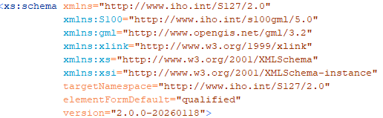

Figure A-6-1 GML schema *targetNamespace* and *version* attributes

Table A-6-2 - Version numbering for changes

|  |  |  |  |  |  |  |
| --- | --- | --- | --- | --- | --- | --- |
| **Type of Change** | **Example** | **DPS** | **FC** | **PC** | **Schema** | |
| **Namespace** | **Schema version** |
| Major Change including an S-100 version change | New Concept in S-100, used in S-1XX | **X**.0.0 | **X**.0.0 | **X**.0.0 | **update** | **X**.0.0-**YYYYMMDD** |
| New content | Attribute value / Feature added or removed | A.**X**.0 | A.**X**.0 | A.**X**.0 | **update** | A.**X**.0-**YYYYMMDD** |
| FC correction, no content or portrayal impact, compatible schema change | Clarification of definition | A.B.C | A.B.**X** | A.B.C | no update | A.B.C-**YYYYMMDD** |
| Schema correction | Correct discrepancy with FC | A.B.C | A.B.C | A.B.C | no update | A.B.**X**-**YYYYMMDD** |

* + 1. Specification scopes

Specification scopes indicate the applicability of designated portions of the Product Specification to either the entire product or to parts of the product. For example, a coordinate reference system will generally apply to the complete product, while maintenance regimes may be different for navigational features versus contextual features. This difference would be described using specification scopes. Depending on the type of Product Specification, the scope may include items in Table A-6-3.

Table A-6-3 - Specification Scope Information (S-100 Table 11-3)

|  |  |  |  |
| --- | --- | --- | --- |
| **Name** | **Description** | **Mult** | **Type** |
| scopeIdentification | Specific identification of the scope | 1 | CharacterString |
| Level | Hierarchical level of the data specified by the scope | 0..1 | MD_ScopeCode (ISO 19115-1) |
| levelName | Name of the hierarchy level | 0..1 | CharacterString |
| levelDescription | Detailed description about the level of the data specified by the scope | 0..1 | CharacterString |
| coverage | Subtype of a feature that represents real world phenomena as a set of attributes | 0..1 | CharacterString |
| extent | Spatial, vertical and temporal extent of the data | 0..1 | EX_Extent (ISO 19115-1)  EX_GeographicBoundingBox or EX_BoundingPolygon or EX_GeographicDescription |

If a Specification is homogeneous across the whole data product, it is only necessary to define a general scope (root scope) to which each section of the Product Specification applies. This general scope may look something like the following example:

Scope identification: Global scope  
Level: 006- series

Level name: Dataset

Level description: Level applies globally to all ENC datasets

Coverage: All features in the ENC Feature Catalogue

Extent: EX_GeographicBoundingBox

westBoundLongitude: -180

eastBoundLongitude: 180

southBoundLatitude: -90

northBoundLatitude: 90

The Level attribute is a codelist found in ISO 19115-1 called MD_ScopeCode comprising the major components of a Specification. The Extent attribute is a class that can be any combination of the following: description string; a geographical extent (like in the example above); vertical extent; or temporal extent.

The Product Specification may specify a partitioning of the data content of the product on the basis of one or more criteria. Such partitioning may be different for different parts of the Product Specification. Each such part of the data content is described by a specification scope that may inherit or override the general scope specification. In principle, any or all of the remaining sections of the Product Specification may have variants that apply to the scopes within the product. Each variant must identify the scope(s) to which it applies.

EXAMPLE: Data products to support navigation often contain two sets of feature types: those that provide navigation information that changes rapidly and the presence of which is essential for safety of navigation; and those that provide background reference information. Maintenance and delivery information would be partitioned on the basis of these groupings; essential information would be maintained and delivered whereas reference system information would not.

* + - 1. Scope with limited extent

Scopes limited to a particular area must define the extent using the extent field in Table A-6-3. The type is the ISO type EX_Extent, which allows specification of geographic, vertical, and temporal information about extents. To limit the geographic scope to less than worldwide extent, one of the following methods must be used:

* If the smaller extent is described by a polygon, use EX_BoundingPolygon instead of EX_GeographicBoundingBox and specify the polygon as a polygon object conforming to the rules for polygons in S-100 Part 7.
* If the smaller extent can be described by a bounding box, specify the extent as a bounding box with the appropriate bounding latitudes and longitudes.
* If the only (or best?) specification of the extent is an identifier from a widely disseminated controlled list of geographic identifiers (such as METAREAs or NAVAREAs, or ISO 3166-1/2), specify it using EX_GeographicDescription instead of EX_GeographicBoundingBox. In this case the alphanumeric code in the controlled list must be provided if it is defined, and the authority responsible for the codelist, an identifier for the list itself, and a natural language description should be provided if available. Since not all gazetteers or similar lists make all this information available in ISO 19115-1 format or clear mappings to the ISO format, improvisations or omissions as to these fields are permitted if equivalent cannot be determined from the source of the controlled list.

EXAMPLE:

EX_GeographicDescription>geographicIdentifier>MD_Identifier>

code= ...

authority= ...

namespace=...

description=...

EX_Extent also provides for specifying an extent by excluding a specified area thereby describing the extent in terms of only where the Product Specification does not apply; this can be done by adding extentTypeCode= 0 (exclusion) to the extent field.

The full model of EX_Extent specified by ISO TC211 is moderately complex and if the extent needs to be encoded in machine-readable format the ISO standard describing EX_Extent (ISO 19115-1) and the ISO XML schema specifying the structure should be used. The example above elides intermediate tags for simplicity.

* + 1. Dataset identification

In addition to the informal description of the data product (see also clause A-6.2.1.6), S-100 also calls for a section that describes information that uniquely identifies any dataset as being created in accordance with a specific Product Specification series.

Different from the general information about the data product which describes the general purpose and use context of the data product, the dataset identification is for the individual dataset. For example, the value contained in the Purpose attribute may be common among all datasets created from a particular Specification. Other attributes may benefit from following a common model or schema, while other attributes are codelist types that are defined elsewhere, such as in ISO 19115-1. These attributes are limited to the values given in those codelists and there may be cases where it is beneficial to restrict the given codelists to a subset of values.

This information (identification, purpose, etc.) is stored in the metadata that is associated with the dataset. Therefore, it is important to ensure that appropriate metadata attributes are available; and to harmonize this section with the metadata section.

Some Product Specifications have merged the informal description of the data product with the dataset identification section, into a common section. This is an allowed option.

* + 1. Data content and structure (Application Schema)

An Application Schema defines the data content and structure of products under S-100. Application Schemas are expressed using the Unified Modelling Language (UML) as described in S-100 Part 1 (Conceptual Schema Language) and allow developers to implement S-100 Product Specifications in a consistent and maintainable way. The General Feature Model of S-100 (Part 3) specifies the rules for developing an Application Schema, which includes the conceptual model for features and their characteristics and associations.

The S-100 Product Specification Template stipulates that specifications that have large Application Schemas need contain only specific examples in UML in the Specification document, since the Application Schema is realized in full in the Feature Catalogue. Because Application Schemas generally become too big to remain easily readable in one page, it may be beneficial for overall readability to split up the Application Schema into sections based on functions and elements.

* + - 1. Feature based data content structure

The data content of a geographic application is defined with a view of real world features and the requirements of a particular application. The content is structured in terms of objects. S-100 considers two types of objects or features, which are defined in S-100 Part 3, clause 5.1. They are defined as follows:

1. Features – Features are defined together with their properties. Features are abstract representations of real world phenomena. The word ‘feature’ can be used in two senses: feature type and feature instance. A feature type is a class and is defined in the Feature Catalogue (for example, the type for “Isolated Danger Buoy” defined in the S-101 feature catalogue). A feature instance is a single occurrence of the feature type and is represented as an object in a data set (for example, the ISO 8211 record for a particular isolated danger buoy in an S-101 dataset).
2. Information – Information types are used to share information among features and other information types. An information type is a class of object that is defined in the Feature Catalogue (for example, the type for “Nautical Information” in the S-101 feature catalogue). An instance of an information type is an identifiable unit of information in a data set (for example, the ISO 8211 record for a particular “Nautical Information” object in an S-101 dataset). Information types have only thematic attribute properties. An instance of an information type may be associated with one or more feature instances or one or more instances of other information types. Information types can be thought of as shared attributes.

The General Feature Model (GFM) provides a conceptual model for these objects. The definitions for feature types are held in the Feature Catalogue. The GFM also acts as a conceptual model for the Feature Catalogue. Spatial information is defined in S-100 Part 7, Spatial Schema, and consists of simple geometry which can be expressed in multiple configurations. The Application Schema must define the spatial components used in a Product Specification and the relationship to the feature classes.

* + - 1. Coverage-based data content structure

S-100 also defines imagery, gridded and coverage data as feature-oriented data. In the simplest form, an image or any set of gridded data can be considered as a single feature. Thus, Application Schema rules for feature data also apply to imagery and gridded data. However, care must be taken to ensure that the Application Schema defines the coverage types in accordance with S-100 Part 10c (‘data coding formats”), which limits the permitted coverage types to a subset of those defined in the underlying ISO standard.

For coverage data products, the attributes of geographic feature classes defined in the Application schema are mapped to values records in the coverage encoding described in Part 10c.

Information types and associations are not used in application schemas for coverage data products.

Complex attributes are not used except potentially with a single coverage type (“feature oriented regular grid”) and then only to describe the “feature attribute table” (this is still being discussed as of August 2025).

* + 1. Data product format

S-100-based Product Specifications shall define the format (encoding) in which each scope within the data product is delivered. This includes a description of file structures and formats where applicable, or the format of a data stream if so applicable. The encoding structure could be specified completely in the Specification, or by reference to a separate profile or standard. Currently, S-100 includes profiles of three encodings: ISO 8211 binary encoding; GML (ISO 19136) encoding; and HDF5 encoding. A Product Specification may reference these profiles along with a description of how to use them within the specific Product Specification. For example, a given product would have a specific GML Application Schema, expressed in one or more XML Schema Definition Language files.

Specialized products may use other encodings by specifying the whole encoding within the Product Specification (or by referencing an established external standard, or an appropriate combination of the two). It should be noted that in such cases, implementation costs may be higher than for systems using the standard S-100 encodings. Products that use encodings not defined in S-100 must set the compliancyCategory metadata attribute in metadata to the appropriate value.

A brief description of the S-100 profiled encodings is provided in the following clauses.

* + - 1. ISO 8211

The ISO/IEC 8211 Specification is a data descriptive file format for information interchange. S-100 Part 10a specifies the structure of an exchange set at the record and field levels. It further specifies the contents of the physical constructs required for their implementation as ISO/IEC 8211 data records, fields, and subfields. The grouping of records into ISO/IEC 8211 files is considered application specific and, therefore, must be described in the relevant Product Specification. Figure A-6-2 below depicts an example of such a description. In S-100 only the binary ISO/IEC 8211 format is used.

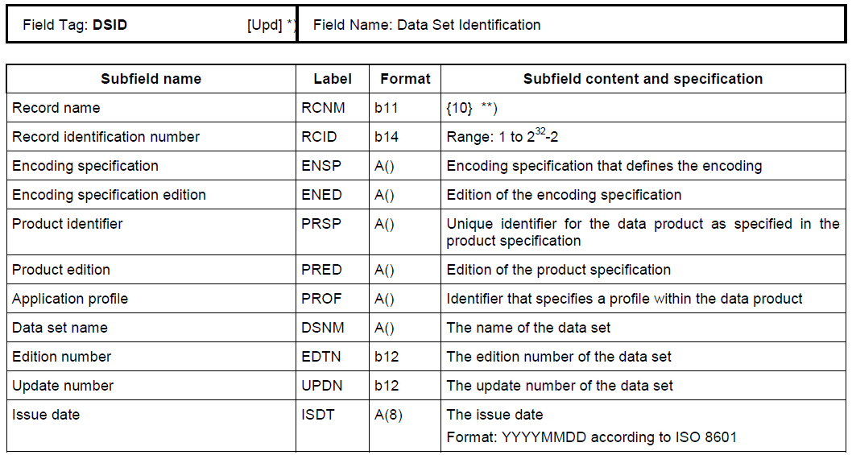

Figure A-6-2 – Example of Field Tables

* + - 1. GML

The Geography Markup Language (GML) is an XML grammar defined by the Open Geospatial Consortium (OGC)/ISO 19136 to express geographical features. GML serves as a modelling language for geographic systems as well as an open interchange format for geographic transactions on the Internet. It should be noted that the concept of feature in GML is a very general one and includes not only conventional "vector" or discrete objects, but also coverages and sensor data. The ability to integrate all forms of geographic information is the key to the utility of GML.

S-100 Part 10b specifies a profile of GML that is used as a basis for the development of GML application schemas for S-100-based data products. The GML Application Schema for each data product defines a file format for the machine-to-machine exchange of information structured in conformance with the Application Schema for the data product, as defined in the appropriate Product Specification.

The S-100 GML profile defines the core GML components that are used in GML encodings for S-100-based data products. This profile defines a restricted subset of XML and GML types that excludes GML features not required by S-100 GML datasets. This subset of GML is then used to create the specific GML encoding for a Product Specification. This approach is described in Figure A-6-3 below.

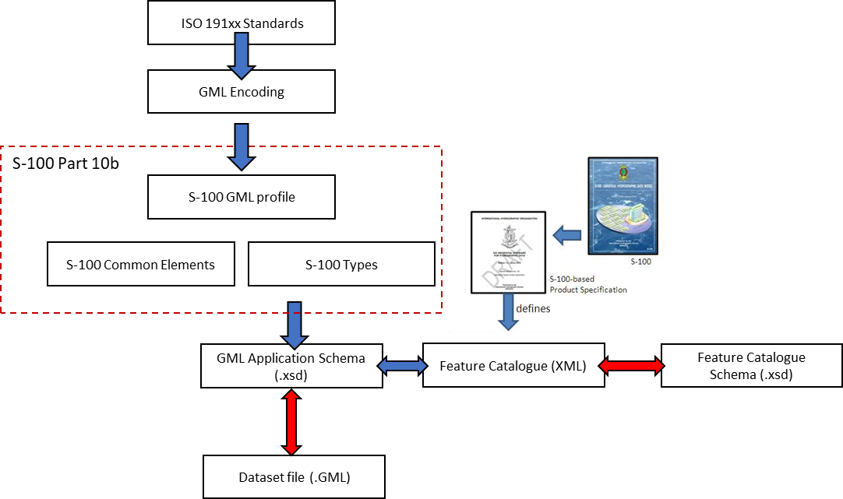

Figure A-6-3 – Derivation of the GML profile and its use by a data product

* + - * 1. Schema locations and XML Catalogs

GML Product Specifications should require or at least encourage producers of GML datasets to include the XML schema *schemaLocation* attribute in the root element of the dataset. Experience to date has been that misunderstandings about the use of XML schemas in GML datasets are frequent and made worse by the complexity of the XML and XML Schema specifications, shortcuts taken in off-the-shelf XML software tools and libraries, and dependency chains in XML schemas, especially the ISO metadata schemas.

Product specifications should also remind implementers that schemaLocation values can be overridden by application software including validators, which means that a local copy of the schema file can be used to validate or process the dataset.

Product Specification authors are recommended to also refer implementers to the OASIS XML Catalogs specification listed in the references.

Adding the *schemaLocation* attribute allows XML software that needs run-time access to the schema (XML validators and some types of applications) to know where the XML schema can be obtained. In the absence of *schemaLocation* (or if the wrong location is provided in that attribute), XML libraries frequently attempt to use heuristics like:

* Treating the namespace as the actual location of the schema, which is frequently the wrong guess, and leads to a failure to locate the schema at all.
* Using a “standard” location, which results in a cascade of errors and misunderstandings detected only downstream.

For example, failing to provide the location of the S-100 GML profile schema causes some software to use the OGC GML schemas by default, which in turn allows data creators to create, and validators to pass, data that uses constructs excluded from the S-100 GML profile. This error in particular is frequently detected only downstream when someone explicitly uses the S-100 GML profile to validate the dataset.

The schemaLocation attribute takes the minimal general form

schemaLocation=”<ns><space><url>” where <ns> is a namespace and <url> the location of the XML schema defining the XML vocabulary for that namespace.

EXAMPLE: The XML vocabulary for namespace http://www.iho.int/S131/1.0 is located at the URL https://staging.s100dev.net/schemas/S131/1.0.0/20221231/S131.xsd



Additional namespace/location pairs can be specified after the first by separating namespace/location pairs with whitespace:

schemaLocation=”<ns1><space><url1><space><ns2><space><url2>”

Note that a file name or a path to a file is a valid URL, which means that specifying schemaLocation as

schemaLocation=”http://www.iho.int/S131/1.0 S131.xsd”

would also be valid, but if and only if the S131.xsd file is located in the same folder (directory) on the file system as the dataset.

* + - * 1. Spatial reference system information

Product specifications must require all datasets to indicate the spatial reference system for coordinates. The currently agreed convention in the S-100 WG and NIPWG consists of including the GML attribute srsName in every spatial primitive in the dataset and indicating the spatial reference system by means of the “long form” EPSG URL:

srsName="http://www.opengis.net/def/crs/EPSG/0/4326"

The GML specification however allows spatial reference system properties to be inherited by feature properties or members of a feature collection to any depth, so the agreed convention may in the future be relaxed to allow srsName to be indicated only at the top level. Product Specification developers should monitor developments in this regard in the S-100WG, NIPWG, and the S-100 standard itself. (or the published version of S-97). In any event, the requirement for srsName to be indicated in every dataset is likely to persist whatever form that indication takes.

* + - * 1. Coordinate order

Coordinate order should be explicitly indicated in the product specification and should be compatible with the axis order in the CRS definition. Suggested language: “Coordinate order is per CRS, which as an example for EPSG 4326 is always latitude followed by longitude”.

* + - * 1. Encoding for spatial primitives

The <posList> tag or successive <pos> tags in the same block should be recommended. In other words:

<posList>1.0 1.0 2.0 2.0 3.0 3.0 4.0 4.0</posList>

or

<pos>1.0 1.0</pos><pos>2.0 2.0</pos><pos>3.0 3.0</pos><pos>4.0 4.0</pos>

are preferred over

<gml:LineStringSegment><pos>1.0 1.0</pos><pos>2.0 2.0</pos></gml:LineStringSegment>

<gml:LineStringSegment><pos>3.0 3.0</pos><pos>4.0 4.0</pos></gml:LineStringSegment>

In general where the S-100 GML profile allows multiple ways of encoding the same type of spatial primitive, one way should be recommended.

The S-100 GML profile already excludes many of GML’s possible variations (for example, the <coordinates> tag is excluded from the S-100 GML profile) – such exclusions need not be explicitly excluded again within the Product Specification. Instead a caution to implementers to ensure that they are using the S-100 GML profile and not the standard GML schemas should be included in the Product Specification.

* + - 1. HDF5

The Hierarchical Data Format 5 (HDF5) HDF has been developed by The HDF Group as a file format for the transfer of data that is used for imagery and gridded data. HDF5 is particularly good at dealing with data where complexity and scalability are important. Data of virtually any type or size can be stored in HDF5, including complex data structures and data types. Figure A-6-4 below depicts the structure of a typical HDF5 file.

S-100 Part 10c specifies a profile of HDF5 that is adopted for S-100. It specifies how to use HDF5 in a way that is compliant with the GFM and how to consistently specify the data formats for the types of coverages and point sets supported by S-100.



Figure A-6-4 – Image showing (left side) the structure of the file and (right side) the two-dimensional compound array of values for regularly gridded data

* + - 1. Other encodings and encoding profiles

When the encodings in S-100 as profiled are not sufficient for the intended use of a Product Specification, a different encoding may be specified within the Product Specification itself. If an encoding that is not part of S-100 is used, then sufficient detail should be given to permit implementers an easy understanding of the chosen encoding.

NOTE: If a non S-100-based encoding is chosen, then systems that support S-100 may not be able to handle data products that utilize this encoding (for example, ECDIS). An alternative is to request additional encoding profiles be added to S-100, which can then be added to systems that comply with S-100.

If a non S-100 encoding is used, then the metadata must be correctly encoded to indicate that the Product Specification contains the encoding format for the data product. This is done using the *undefined* value of the S100_DataFormat attribute in the discovery metadata of every compliant data product and setting compliancyCategory to an appropriate value. See S-100 Part 17 for further details.

* + 1. Data content and structure

This section describes the different type of data model elements that are used within a Product Specification. S-100 defines a variety of different elements, but it is up to the individual Specification to specify which elements are allowed to be used. The following is an example of how a subset of elements would be defined within a Product Specification.

*Example:*

*Feature Types*

*<The following clauses describe the different feature types that may be used in the Feature Catalogue.>*

*Geographic*

*<Geographic (geo) feature types form the principal content of the dataset and are fully defined by their associated attributes and information types.>*

*Meta*

*<Meta features contain information about other features within a data set. Information defined by meta features override the default metadata values defined by the data set descriptive records. Meta features must be used to their maximum extent to reduce meta attribution on individual features.>*

*Feature Relationship*

*<A feature relationship links instances of one feature type with instances of the same or a different feature type. There are three common types of feature relationship: Association, Aggregation and Composition. >*

*Information Types*

*<Information types are identifiable pieces of information in a dataset that can be shared between other features. They have attributes but have no spatial attribute; information types may reference other information types.>*

An additional option to describe the model elements included in a Product Specification is to group elements according to some logical scheme, and then describe those groupings. This method allows a combination of the type description and at the same time links it with the usage within the Specification. Figure A-6-5 below shows an example of this method, describing all information types in a specific Product Specification.

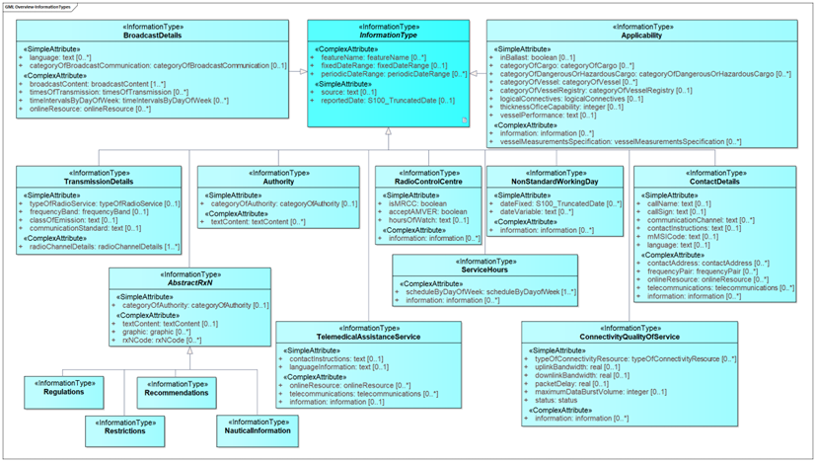

Figure A-6‑5 – Example of an overview of Information Types in an S-100 data product, from S-123.

* + 1. Feature Catalogue

ISO 19110 defines a Feature Catalogue as a catalogue that contains definitions and descriptions of the feature types, feature attributes and feature associations occurring in one or more sets of geographic data. Therefore, the Feature Catalogue acts as a machine-readable representation of the Application Schema, and gives a system the means to describe the elements of a dataset that conforms to the Feature Catalogue.

When a data model is too big to be fully reproduced in UML within a Product Specification, the Feature Catalogue in combination with specific subsets of the overall UML Application Schema can serve as a substitute to the requirement of full Application Schema being described in the Product Specification.

Product Specifications that are endorsed by the IHO under the S-1XX numbering system must use the IHO’s Feature Catalogue Builder to ensure compliance to S-100. It is possible to create feature catalogues external to the IHO Feature Catalogue Builder (FCB); however, the Feature Catalogue should then be validated against the S-100 Feature Catalogue schema.

* + 1. Dataset

This section specifies rules for the dataset. Types of rules may be related to dataset size limitations or types of data coverage and if the data may or may not overlap each other.

If a size limit is defined for the dataset, the units must be expressed using Binary prefix defined by the IEC standard ISO/IEC 80000-13:2025, Quantities and units, Part 13: Information science and technology (as amended). Table A-6-4 lists specific unit prefixes and Table A-6-5 lists examples of conversion.

Table A-6-4 – Specific units of IEC 60027-2 A.2 and ISO/IEC 80000:13-2025 (extract from ISO 80000-13:2025)

|  |  |  |  |  |  |
| --- | --- | --- | --- | --- | --- |
| **Name** | **Symbol** | **Base 2** | **Base 1024** | **Value** | **Base 10** |
| kibi | Ki | 210 | 10241 | 1 024 | = 1.024×103 |
| mebi | Mi | 220 | 10242 | 1 048 576 | ≈ 1.049×106 |
| gibi | Gi | 230 | 10243 | 1 073 741 824 | ≈ 1.074×109 |
| tebi | Ti | 240 | 10244 | 1 099 511 627 776 | ≈ 1.100×1012 |

Table A-6-5 – Typical conversions

|  |  |  |
| --- | --- | --- |
| 1 Mebibytes (MiB) = | 1048576 | bytes |
| 1048.576 | Kilobytes |
| 1024 | Kibibytes |
| 8388608 | bits |
| 8388.608 | Kilobits |
| 8192 | Kibibits |

Coverage products using gridded data formats may limit dataset sizes indirectly, by limiting the grid size in terms of the number of grid cells.

* + 1. Dataset loading and unloading

If data products provide multiple datasets or data coverages for a given geographic area at different scales a loading and unloading strategy should be considered.

Data products intended for ECDIS must use the loading/unloading strategy described in S-98, in which case the Product Specification should limit this section to a statement saying the strategy described in S-98 should be used and may optionally add material explaining how the S-98 loading/unloading strategy applies to the data product.

Data products not intended for EDCIS or similar systems which also use the S-98 strategy may either use the S-98 loading strategy or define a loading strategy. Use of the S-98 strategy is recommended. If a loading strategy is defined in the Product Specification, authors must consider the context of use so that systems are not expected to apply a variety of loading strategies to different data products. There should be sufficient details to give system implementers enough information to know how to create or load datasets in the correct manner. The content of the “Dataset Loading and Display (Rendering) Algorithms” Appendix in S-98 may be used as a guide.

* + 1. Geometry

This section describes the geometry rules that apply within a given Product Specification. For vector data the description should include which S-100 Level of Geometry is used, as well as any exceptions to the rules as stated in S-100 Part 7, clause 7-4.3. For coverage data, there should be a description of which spatial model and grid from S-100 Part 8 is used. Any grid, point set or TIN (Triangulated Irregular Network) structure rules and characteristics should be included. Summary figures depicting the derivation from Part 8 and ISO types may be included, as in the figure below, which depicts a class for the coverage feature at the extreme left, its spatial type (regular grid), and its derivation from the S-100 grid type and ISO types. This figure depicts a product which uses only one of the coverage types described in Part 8 and 10c, the regular grid coverage type. (Attributes are not shown to reduce diagram clutter.)

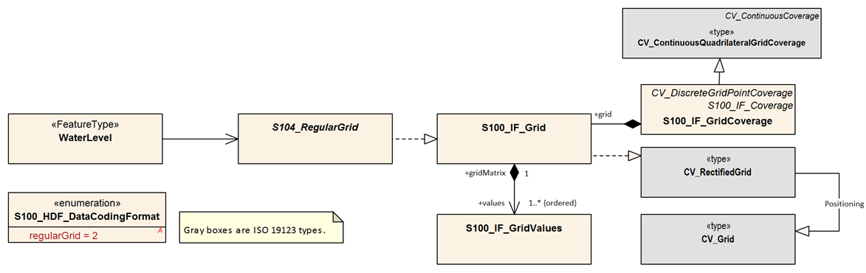

Figure A-6-6 - Derivation in coverage product specification (from S-104 Edition 2.0.0).

* + 1. Reference systems

All S-100-based Product Specifications that include georeferenced information will have a horizontal reference system, while vertical reference systems are for Specifications that yield data products that include height information or bathymetry. A Product Specification may include more than one vertical reference system, such as one for sounding data and one for height data.

Part 6 of S-100 provides information on how to describe and specify a reference system. The more common method of simply referencing an already specified reference system is generally used instead by establishing a convention in the Product Specification by stating the reference system, or list of reference systems used; and then by adding the information in the metadata of the resulting dataset. Figure A-6-7 below is an example from specifying horizontal and temporal reference systems.

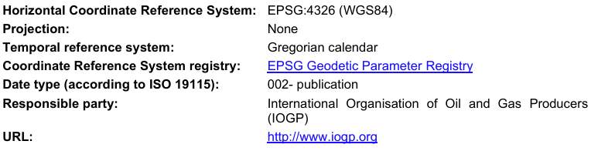

Figure A-6-7 – Example of specification of CRS in Product Specification

The EPSG Register is a useful Register of horizontal datums (the current URL is https://www.epsg.org). The codelist value for WGS84, the most commonly used horizontal datum, is 4326. For vertical datums and sounding datums, S-100 includes an enumerated list named S100_VerticalAndSoundingDatum (now in Part 10c).. The most commonly used vertical and sounding datums are included in this list. The enumerated list can be extended by requesting the IHO S-100 Working Group to include additional values and a GI Registry proposal to register the new datum.

* + 1. Object identifiers

It is recommended that rules for persistent global identifiers for feature and information objects are included within a Product Specification. Identifiers may be omitted where the physical realities dictate otherwise or it is known that a reference to the object will not be needed. For example, identifiers need not be defined for cartographic objects.

Identifiers of instances should utilize the Maritime Resource Name (MRN) concept and namespace. The MRN namespace is administered by the International Association of Lighthouse Authorities (IALA) through the website https://www.iala.int/technical/data-modelling-mrn/, which also contains references to the full set of rules that apply to the MRN concept. The topmost namespace urn:mrn remains fixed, with subsequent namespaces separated by colons, and available through the application process explained on the website. Any organization wishing to issue MRN conformant identifiers should apply for a namespace from IALA, or from an organization that already has a namespace registered, such as IHO. Guidance about the structure and principles of MRNs for S-100 data and products is being prepared by the IHO.

Guidance should be included on preserving persistent global identifiers on objects throughout their lifecycle, including when they are reused in other products. Maintaining persistent global identifiers between products can help with interoperability and assist users and systems in identifying identical features between data products.

* + 1. Data quality

All S-100-based Product Specifications should include comprehensive ways of capturing information about the quality of the data. Part C of this Guideline includes comprehensive guidance on how to address aspects of data quality.

* + 1. Data capture and encoding instructions

Any S-100-based Product Specification should provide information on how data conforming to the Product Specification is to be captured. This information should be as detailed and specific as necessary. To this end, the S-100 Product Specification Template recommends the development of a Data Classification and Encoding Guide (DCEG). The DCEG is used to link real world examples to the data model. For example, the DCEG can explain how different types of underwater rock are to be encoded using a specific data model, including which feature type should be used; what attributes; and their expected values that correspond to the different types of underwater rock.

The data capture guide is mostly used by the data producers and serves as a collective instructional document of globally common rules on how to create data according to a specific Product Specification. The document will grow with experience as more special cases get resolved into a globally agreed-upon process. This also improves overall consistency among producers and products, leading to more stable user systems as all stakeholders gain a common understanding of how to use the data products.

* + 1. Maintenance

Generally, data created from an S-100-based Product Specification will not remain valid indefinitely. Therefore, it is necessary to specify how data created in accordance with a Product Specification will be maintained, including the updating of datasets and support files.

There are two main types of updating routines:

* As needed: Datasets are updated when there is a need to do so, and are to be considered current information until there is a further update. Electronic Navigational Charts and Nautical Publications are two types of data that are generally maintained in this manner.
* By schedule: Datasets are updated on a fixed schedule or interval; and users can always anticipate when new datasets become available. Surface current and water level information are two types of data that are generally maintained in this manner.

Once updating routines have been established for products, it is necessary to establish the means by which to achieve these updates. Again, there are two main options: incremental updates; and whole dataset replacement, both of which are elaborated upon in the next two sections.

* + - 1. Incremental update

This type of updating method is when a previously issued dataset is partially updated by inserting new or modifying information. This method is useful where there are bandwidth considerations and the changes are relatively minor within the scope of the whole dataset.

An example is the addition of two features to a dataset that contains thousands of other features; the incremental update would then be a much smaller dataset that contains only the revision instructions to the main product data, or base dataset. Once the revision instructions are applied, the updated dataset will include the additional two objects.

It should be noted that with incremental updates there may come a point when there are so many changes that it makes sense to re-issue the dataset. This will include all the changes applied previously via incremental update, thereby replacing the original base dataset with a new fully updated base dataset. Subsequent changes will then be issued as new incremental changes.

* + - 1. Whole dataset update

This type of updating is a method of updating a previously issued dataset by replacing it wholesale with a new dataset. This method makes most sense when the replacement data alters all or a sufficiently large portion of the previous dataset – for example, when forecasted data of a certain natural phenomenon is replaced with updated forecast data and the update data invalidates the replaced data by virtue of being more recent. All encodings in S-100 support this method of updating.

* + - 1. Support file maintenance

Updating support files in S-100-based Product Specifications is done by providing a replacement with the same name and updating the metadata for the support file in the exchange catalogue to set revisionStatus=replacement. The issue date and management information is included in the exchange catalogue file that is part of the exchange set. Below is an example of instructions for updating support files. Cancellation is done by setting revisionStatus=deletion.

*Example:*

*The status of a support file is indicated in the “revisionStatus” field of the discovery metadata. Support files whose metadata has been updated with revisionStatus=deletion flag must be removed from the system. The dataset referencing the support file must simultaneously be updated to remove or update the reference to the deleted file. When a feature pointing to a text, picture or application file is deleted or updated so that it no longer references the file, the system software must check to see whether any other feature references the same file, before that file is deleted.*

To avoid complex management routines, it may be advantageous to specify that each support file should only be used once in the exchange set and to store the support files in a separate folder within the exchange set.

* + 1. Data product delivery

The Product Specification may define the delivery medium (such as DVD or a web service) for each identified scope in the Specification. This is an optional section, but it includes the structure of delivered data products, and is therefore important where data is delivered to systems that include a level of data automation where standardized delivery structures may be automated. It is also useful to specify when data products are delivered in different formats. Data being delivered to ECDIS and similar systems generally expects exchange sets. S-100 includes a description of an S-100 exchange set for the interchange of geospatial data and its relevant metadata (reproduced in Figure A-6-8 below), and details can be found in S-100 Part 17.

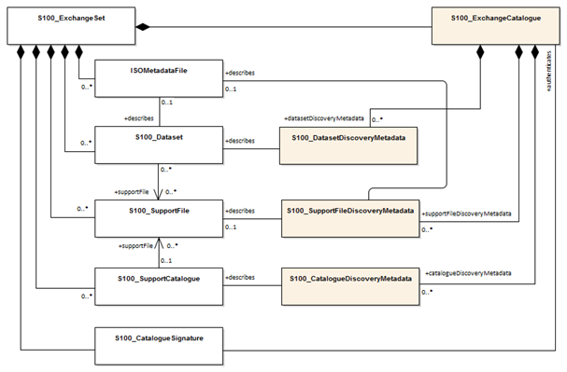

Figure A-6-8 – S-100 Exchange Set (S-100 Figure 17-2)

Within an exchange set, there are datasets; but it may also carry support files. There are two types of supporting files within the exchange set: support files for the individual dataset; and support files for the exchange set. Support files that are associated with the individual dataset usually include file types such as text files and image files; while support files that are associated with the exchange set are usually Feature and Portrayal Catalogues.

* + - 1. Services and data streams

S-100 includes an alternative distribution method called online data exchange, which is described in Part 14. This method can be used for a set of data or data that have a continuous nature. The latter is also known as “streaming data” and is used where the circumstances require a more dynamic information flow to be available.

Online data exchange between applications or devices can follow different communication patterns to support the variety of maritime operational needs. Multiple clients can interact with a service to interchange data that is modelled with S-100 and can be distinguished between unidirectional message streams like AIS and interactive information exchange like a web feature service (WFS). Context for a communication can be given by using the concept of session-oriented communication, which is when the communication between distinguished communication partners is assigned to a logical entity – a session. This permits metadata to be defined for the interactions assigned to the session.

The means of communication for the use of a service should be defined in a communication stack. Specifying a communication stack ensures that communication for the service is harmonized and makes implementation easier.

The communication is organized by a stack as defined by the ISO-OSI Reference Model:

* Session protocols (for example, WSDL, SOAP, REST, SOS) to define message types;
* Encoding and compression (for example, GML, XML, ISO 8211, HDF, ….) to serialize data;
* Communication protocol (for example, HTTP) with encryption (for example, HTTPS) to define interaction between gateways; and
* Transportation Layer (for example, TCP/IP) with encryption (for example, SSL) to define the transportation node between gateways.

The stack is depicted in Figure A-6-9 below.



Figure A-6-9 – Communication Stack

S-100 Part 14 only addresses the concepts in the application and presentation layers. The lower layers are out of scope of S-100.

Product Specifications that use the online exchange method must describe the concepts that are used to structure a session; and must explain how the data is transferred within sessions. A session-oriented service typically contains three components, each handling different types of data:

* Session component: Describing the handling of the session data (service request, service response, login, login response, logout).
* Service component: Describing the information to maintain the service (for example keep alive messages, service status).
* Data component: Describing the data itself (for example, Vessel Traffic Image data (objects)).

Any Metadata required for each component should be detailed in the Product Specification.

* + 1. Dataset naming rules

Dataset naming must follow a standard pattern to give implementers greater predictability of incoming datasets.

XXXYYYYØØØØØØØØØ.EXT

XXX is the product code (for example, 123 is for Marine Radio Services; 101 for ENC)

YYYY is the producer code according to the Producer Code Register

ØØØØ is an arbitrary length unique code in alphanumeric characters

EXT is the file extension, determined by the data format

If useful, the Product Specification can include a differentiating character or code (for example, the underscore (_) character) in the ‘ØØØØ’ space of the file name. Differentiating characters can be used to distinguish update datasets from the base dataset (for example, XXXYYYYABCDE12345_0000 for the base dataset, XXXYYYYABCDE12345_0001 for the first update, etc).

Support files must follow a similar naming convention.

A maximum length for file names must be specified; while current Product Specifications use different maximum lengths, the highest current limit specified for maximum length of file names including the extension, update number if any and any differentiating characters is 64 characters.

This Guidance recommends 64 as the maximum limit for file names, including all characters, including extension, separator, and distinguishing characters. Product Specifications may set a lower limit.

* + 1. Metadata

Metadata is data about data. In S-100 the primary purpose of metadata is to provide information about the identification; spatial and temporal extent; quality; application schema; spatial reference system; and distribution of digital geographic data. Metadata is applicable to the cataloguing of datasets; clearinghouse activities; and the full description of geographic and non-geographic resources.

Metadata can satisfy a number of uses: data discovery; distribution and on-line references (URL) for on-line viewing; data use; details of data creation; data fitness; data sharing; data management; etc. Figure A-6-10 below depicts some typical purposes and audiences for metadata.

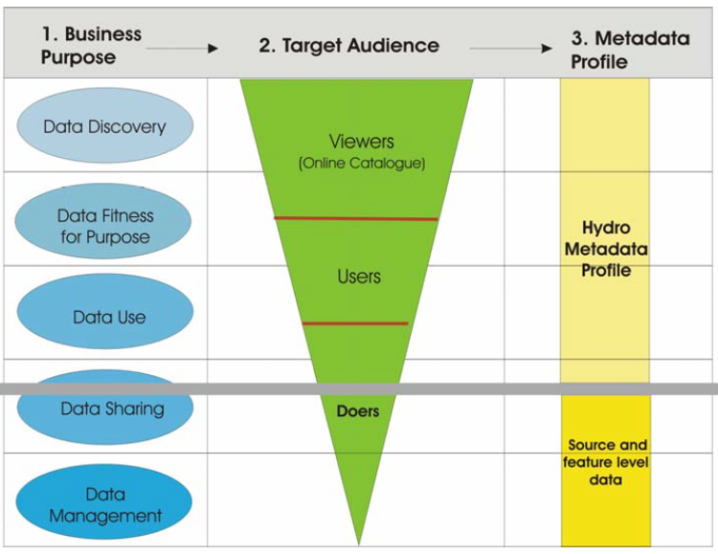

Figure A-6-10 – Example levels of metadata

S-100 Part 4 (Metadata) specifies the minimum metadata elements that must be included with a conformant data product. For S-100 products conformance to Part 17 is sufficient. S-100 requires that Discovery and Quality metadata are structured as per S-100 Parts 17 and 4c, respectively. Any additional metadata items required for a particular Product Specification must be documented in the Specification; and these should be defined using ISO 19115-1 and ISO 19115-3, with extensions or restrictions if required. S-100 Part 4, Appendix 4a-D contains the rules that apply when extending or restricting the minimum metadata.

The Product Specification Application Schema shall specify how metadata is packaged in conformant datasets. This information shall be specified for each identified scope within the Product Specification. Furthermore, where the resulting data product is intended for a standardized user environment, like ECDIS, it should be noted that any significant deviation (for example, addition or reduction to the standard metadata) may not be readily useable in the system depending on how the standard S-100 schemas have been implemented. Extensions to the exchange catalogue to accommodate product-specific metadata are therefore not permitted for Product Specifications intended for ECDIS.

* + - 1. Discovery Metadata

For information exchange, there are several categories of metadata required: metadata about the overall exchange catalogue; metadata about each of the datasets contained in the catalogue; and metadata about the support files that make up the package. These are called Discovery Metadata in S-100 and they are used within the exchange set to enable users to learn about the content without having to open each dataset or support file.

* + - * 1. Discovery Metadata for datasets

S-100 specifies that Discovery Metadata for datasets distributed in exchange sets is contained within an external XML file named CATALOG.XML created in accordance with the S-100 exchange catalogue schema. More information about Discovery Metadata for datasets can be found in S-100 Part 17.

* + - * 1. Discovery Metadata for support files

S-100 specifies that Discovery Metadata for support files distributed in exchange sets is contained within an external XML file named CATALOG.XML created in accordance with the S-100 exchange catalogue schema. More details can be found in the S-100 Part 17.

* + - * 1. Metadata for streamed data and services

Metadata for streamed data or services is described in S-100 Part 4a. S-100 Part 14 specifies additional and other metadata. Part 4a and Part 14 have yet to be reconciled. Product Specification developers should, at this time, use the metadata from Part 14; and according to need, supplement with metadata from Part 4, including using the principles of metadata extension detailed in Part 4, Appendix 4a-D.

* + 1. Portrayal

Portrayal is an optional part of a Product Specification. However, if consistent portrayal across all user platforms is important to an S-100-based data product, then specifying how portrayal is done becomes mandatory. Within S-100 Product Specifications, this is done by including a Portrayal Catalogue. The Portrayal Catalogue is a collection of defined portrayal instructions for a Feature Catalogue; and includes portrayal functions, symbols and portrayal context.

Two types of Portrayal Catalogues are possible in S-100: XSLT and Lua. Part 9 of S-100 provides instructions for how a Product Specification can include an input Schema derived from the abstract schema provided; a set of mapping rules (defined in XSLT or Lua); a set of symbols (defined in SVG format); line styles, colours, etc; and makes it available for use with product datasets. Portrayal Catalogues can be created in a variety of ways, including manually and by using a Portrayal Catalogue Builder (see clause A-7.4 of this Guideline for more details).

Portrayal Catalogues can be provided, for example, in an exchange set and may be combined with a Feature Catalogue and datasets. The exact method for distribution should be defined in the Product Specification, but consideration should be given to efficient distribution and the aim of reducing data volume wherever possible. It may therefore be beneficial to consider some form of central distribution of Portrayal Catalogues.

The Product Specification should include instructions for implementers in the use of the Portrayal Catalogue, including context for the use of the data.

Many of the IHO Product Specifications will be used in systems that have some degree of type approval requirements (for example, ECDIS). Instructions for the classification society conducting the type approval should be added to Product Specifications where appropriate.

* + - 1. Special portrayal requirements

Certain products may have portrayal requirements which the portrayal model in S-100 Part 9 cannot express or which S-100 portrayal catalogues cannot encapsulate. Examples of such special portrayal requirements are:

* The ability to suppress display of selected features.
* Listing, sorting, and searching of features or information types outside the navigation display, according to user-determined criteria.
* Indicators when new data is received.
* Means for entering filtering criteria such as time and distance from own ship, monitored route or planned route.
* Abbreviated displays for certain features or information types.
* Display of dynamic features.
* Thinning of symbol density when the user zooms out to a smaller viewing scale. for gridded data that uses symbol-based portrayal.

Special portrayal requirements must be described in the portrayal section since they may require product-specific implementation.

* + 1. Supporting multiple languages

S-100 Part 17 describes how exchange catalogues can support multiple languages. Part 18 describes multilingual support for Feature Catalogues by means of a translations file (called a “language pack”). Product Specifications supporting language packs must treat language packs as support files, designating their format as “XML” (see S100_SupportFileFormat) and “resourcePurpose” as languagePack (see S100_ResourcePurpose) in support file discovery metadata in the exchange catalogue.

* + 1. Interoperability identifiers

S-100 Product Specifications may implement an attribute called interoperabilityIdentifier. This attribute is intended to provide a persistent and unique identifier, to be expressed as an MRN, between features in datasets of different Product Specifications. In an S-100 ECDIS context, for instance, this would allow feature interrogation to include related features from different Product Specifications. Implementation of interoperabilityIdentifier is optional, see S-100 Part 3, clause 3-10.1.

* + 1. Display scales

Products with curve and surface features and where the product can be expected to be viewed over large scale ranges should consider developing a policy for specifying maximum and minimum scales for features and datasets. Such products when intended for use primarily along with specific other scale-dependent products should consider harmonizing scale ranges for example to avoid apparent relative displacement of features when one product changes to a dataset at a different scale range.

For coverage products, grid cell size and total extent will obviously visually interact with each other and with the defined portrayal symbology, if any, in a manner that is dependent on display scale when the product displayed on a screen. While displays of gridded products can be thinned to reduce displayed symbol density, excessive thinning will make the product less useful at extreme viewing scales compared to grid cell size. Scale ranges should therefore be calculated for grid coverage products as well, taking into account at least grid extent, grid cell size, and symbol sizes, if product portrayal is based on symbol rather than on area fill.

* + 1. Additional information

The Product Specification should contain all information at a sufficient level of detail for easy implementation by the intended stakeholders. However, there may be additional considerations that impact implementers, users and other stakeholders. These additional considerations can be added to a section or appendix called an Implementation Guide, or another appropriate title. Such a section can be used to give context of intended use, or used to elaborate on special circumstances that impact stakeholders, and so forth.

1. IHO S-100 infrastructure

This section describes IHO Infrastructure that has been developed to support the S-100 framework and the e-Navigation concept.

* 1. IHO Geospatial Infrastructure (GI) Registry

A Registry is the entire information system (or location) in which a collection of Registers is located. A Register is a collection of tables in a database containing identifiers assigned to items with descriptions of the associated items. Descriptions may consist of many types of information including names, definitions and codes.

In the case of S-100, the IHO is hosting an online Registry engine called S-100 Geospatial Information (GI) Registry. The IHO GI Registry can be accessed at https://registry.iho.int. This Registry provides the facility to access and maintain the various S-100 Registers. The S-100 GI Registry contains subordinate Registers, depicted in Figure A-7-1 below.

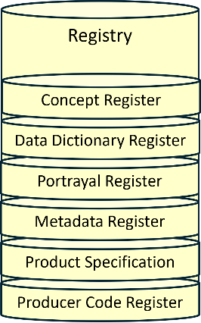

Figure A-7-1 – IHO GI Registry (Version 3)

Each Register type can be further sub-divided into Domains (for example, Hydrographic, Inland ENC, AtoN, etc). The administration of the IHO GI Registry is governed by the IHO Publication S-99 – Operational Procedures for the Organization and Management of the S-100 Geospatial Information Registry.

A major benefit of the Registry and Register concept is its flexibility, which allows multiple versions of similar entries in the Concept Register using unique identification and classification. An entry is classified as being either:

* valid (latest version);
* superseded (previous versions);
* retired (no longer recommended for use); or
* not valid (proposed but not accepted or no longer acceptable).

Due to this classification and time stamps, a version of a Feature Catalogue references items that will always be legitimate even if a newer version of the referenced item is registered at a later date. This means that if a new item is registered or an existing item is amended, a new version of a Product Specification is not automatically required as a consequence. The category of “not valid” items is included in the Registers specifically to help identify the inappropriate reintroduction of previously rejected proposals.

* + 1. Use of registers in Product Specification development

Of the registers included in the Geospatial Information Registry, Product Specification developers can expect to make most use of the following for Product Specification development.

* + - 1. Data Dictionary Register

This register contains entries for types which can be included in feature catalogues. This register includes sub-registers for feature and information types, complex and simple attributes, enumerated values for both enumerations and codelists, feature and information associations and the roles used in associations, and a sub-register of units of measure.

Product Specification developers must consult this register when developing their Application Schemas to find out if relevant types have already been defined. This register is used by the Feature Catalogue Builder (FCB) when feature catalogues are created using the IHO S-100 Toolkit. Attribute and sub-attribute bindings and multiplicities in the register are advisory only. Application Schemas can use different attributes and multiplicities from those in the register entries, as well as exclude listed values from enumerations and codelists. However, adding a listed value must be preceded by a registry proposal to add it as a permitted listed value for the attribute or codelist type. Association roles specified in the registry should not be changed in Application Schemas, in the interest of maintaining semantic consistency; however, the FCB does permit selection of roles for associations.

The Units of Measure sub-register is to be used for adding unit of measure information in feature catalogues. At present this needs to be done manually after the feature catalogue is created.

* + - 1. Portrayal Register

This register contains entries for symbols, line styles, area fills, colour tokens, viewing groups and viewing group layers, etc. As of August 2025 there are also lists of portrayal schemas, however the portrayal schemas are provided as part of generic S-100 schemas from the schema server and the lists of schemas in the Registry can be expected to be unpopulated or outdated.

Product Specification developers must consult this register when developing the Portrayal sections of their Product Specifications and Portrayal Catalogues, for the purposes of both re-use of portrayal for the same feature types across different data products as well as avoiding overly alike portrayal of very different concepts.

* + - 1. Concept Register

This register contains concept definitions from which types in the Data Dictionary register are defined. Proposals for new entries in the data dictionary register or modifications of definitions or remarks must be preceded by a proposal to make the modification in this register.

* + 1. Additions and Amendments

Proposal for new entries or amendments to existing entries in the Concept, Data Dictionary, Portrayal or Metadata register must be submitted through a Submitting Organization via the “Proposal” facility in the GI Registry. Access is limited to Submitting Organizations.

The proposal processes for all registers are described in S-99.

* + 1. Testbed

The Testbed section of the GI Registry contains a register of Product Specifications in advanced stages of development intended for Product Specification developers to distribute advanced drafts of specifications to receive feedback from relevant stakeholders and provide an opportunity to prepare for system improvement.

* 1. Feature Catalogue Builder

A Feature Catalogue is a machine-readable expression of the data model for a Product Specification. It can either be constructed with off-the-shelf XML editors or by a Feature Catalogue Builder (FCB). Either case must comply with the structure of S-100 Part 5 and the S-100 Feature Catalogue Schema. There is a FCB available from IHO (as part of the S-100 Toolkit, which can be downloaded from the IHO GI Registry site) for anyone wishing to utilize it in the creation of a Feature Catalogue for an S-100-based Product Specification. The software interacts with the IHO GI Registry and provides a mechanism for binding elements available in the Registry together to form features and attributes; enumerated lists with their available values; and so forth. Figure A-7-2 below illustrates the concept of the IHO FCB.

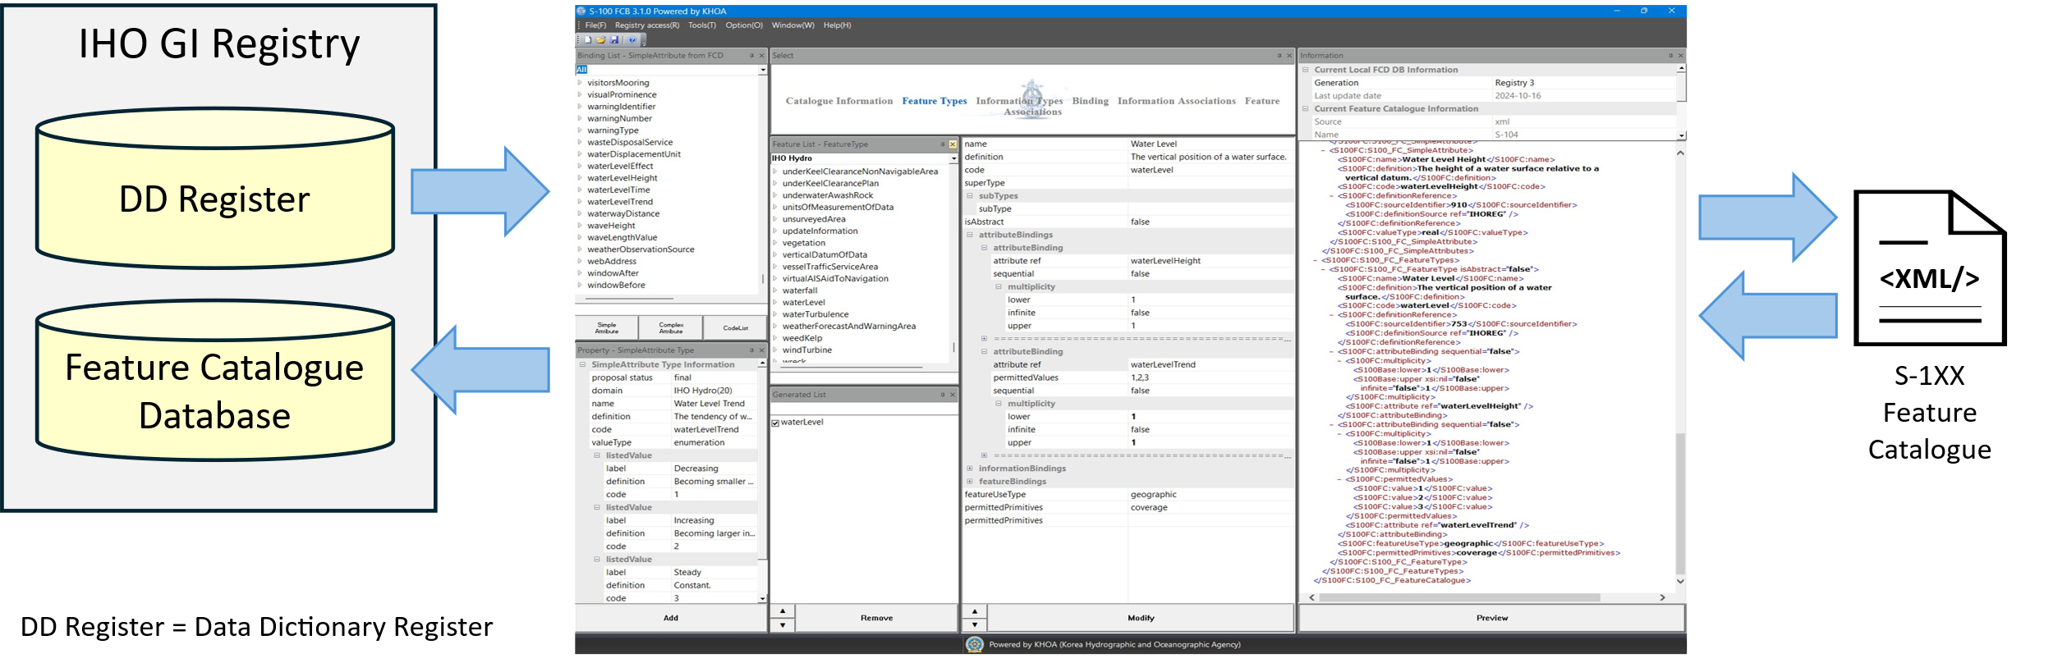

Figure A-7‑2 - S-100 Feature Catalogue Builder

The FCB also contains a function for working with proposals that have yet to be added to the Registry.

Product Specification developers must review the resulting Feature Catalogue created using the FCB for conformance and update it manually where required. Aspects that need to be checked and updated are detailed in Part B (B-13 – Define data encoding format).

* 1. DCEG Builder

To simplify the creation of the Data Classification and Encoding Guide (DCEG) for a Product Specification, a DCEG Builder has been created (available as part of the S-100 Toolkit, which can be downloaded from the IHO GI Registry site). This tool utilizes the Feature Catalogue to create the bindings and inputs for the DCEG tables. It is then a manual process to add images and specific text to the encoding part of the DCEG tables. Figure A-7-3 below shows a high-level overview of the process to create a DCEG via the DCEG Builder. An Application Schema is required to make the Feature Catalogue, which equates to an XML representation of the Application Schema. The use of the Feature Catalogue can be described in the DCEG.

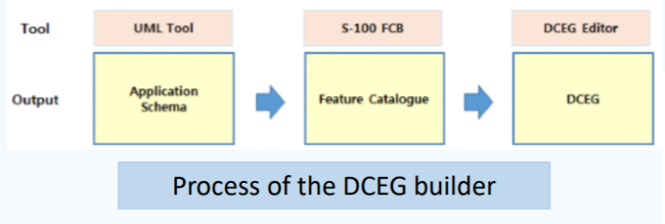

Figure A-7‑3 – Process of creating a DCEG using the DCEG Builder

Use of the DCEG Builder is optional in the preparation of the Product Specification. Any S-100-based Product Specification must include sufficient instructions for how to encode information in a manner that conforms to the Specification, but these instructions do not have to follow a specific DCEG style. However, the DCEG style is simple to understand and by utilizing the DCEG builder, it is also possible to generate tables[2] of feature and information types, attributes, associations and encoding instructions; and to ensure that these tables are consistent with the Feature Catalogue. The IHO-style feature tables (or equivalent) can be prepared and maintained using ordinary office word processing software, but experience shows that ensuring initial and continued conformance to the XML Feature Catalogue may be a significant task requiring much effort to maintain and keep current. Figure A-7-4 below shows how the DCEG Builder is connected to the IHO GI Registry; and shows how the DCEG Builder is integrated in the process of creating a Feature Catalogue. Using the Builder can greatly simplify the development process and increase consistency with the Feature Catalogue. The DCEG Builder can load the Feature Catalogue from the Feature Catalogue Database or from an external file.

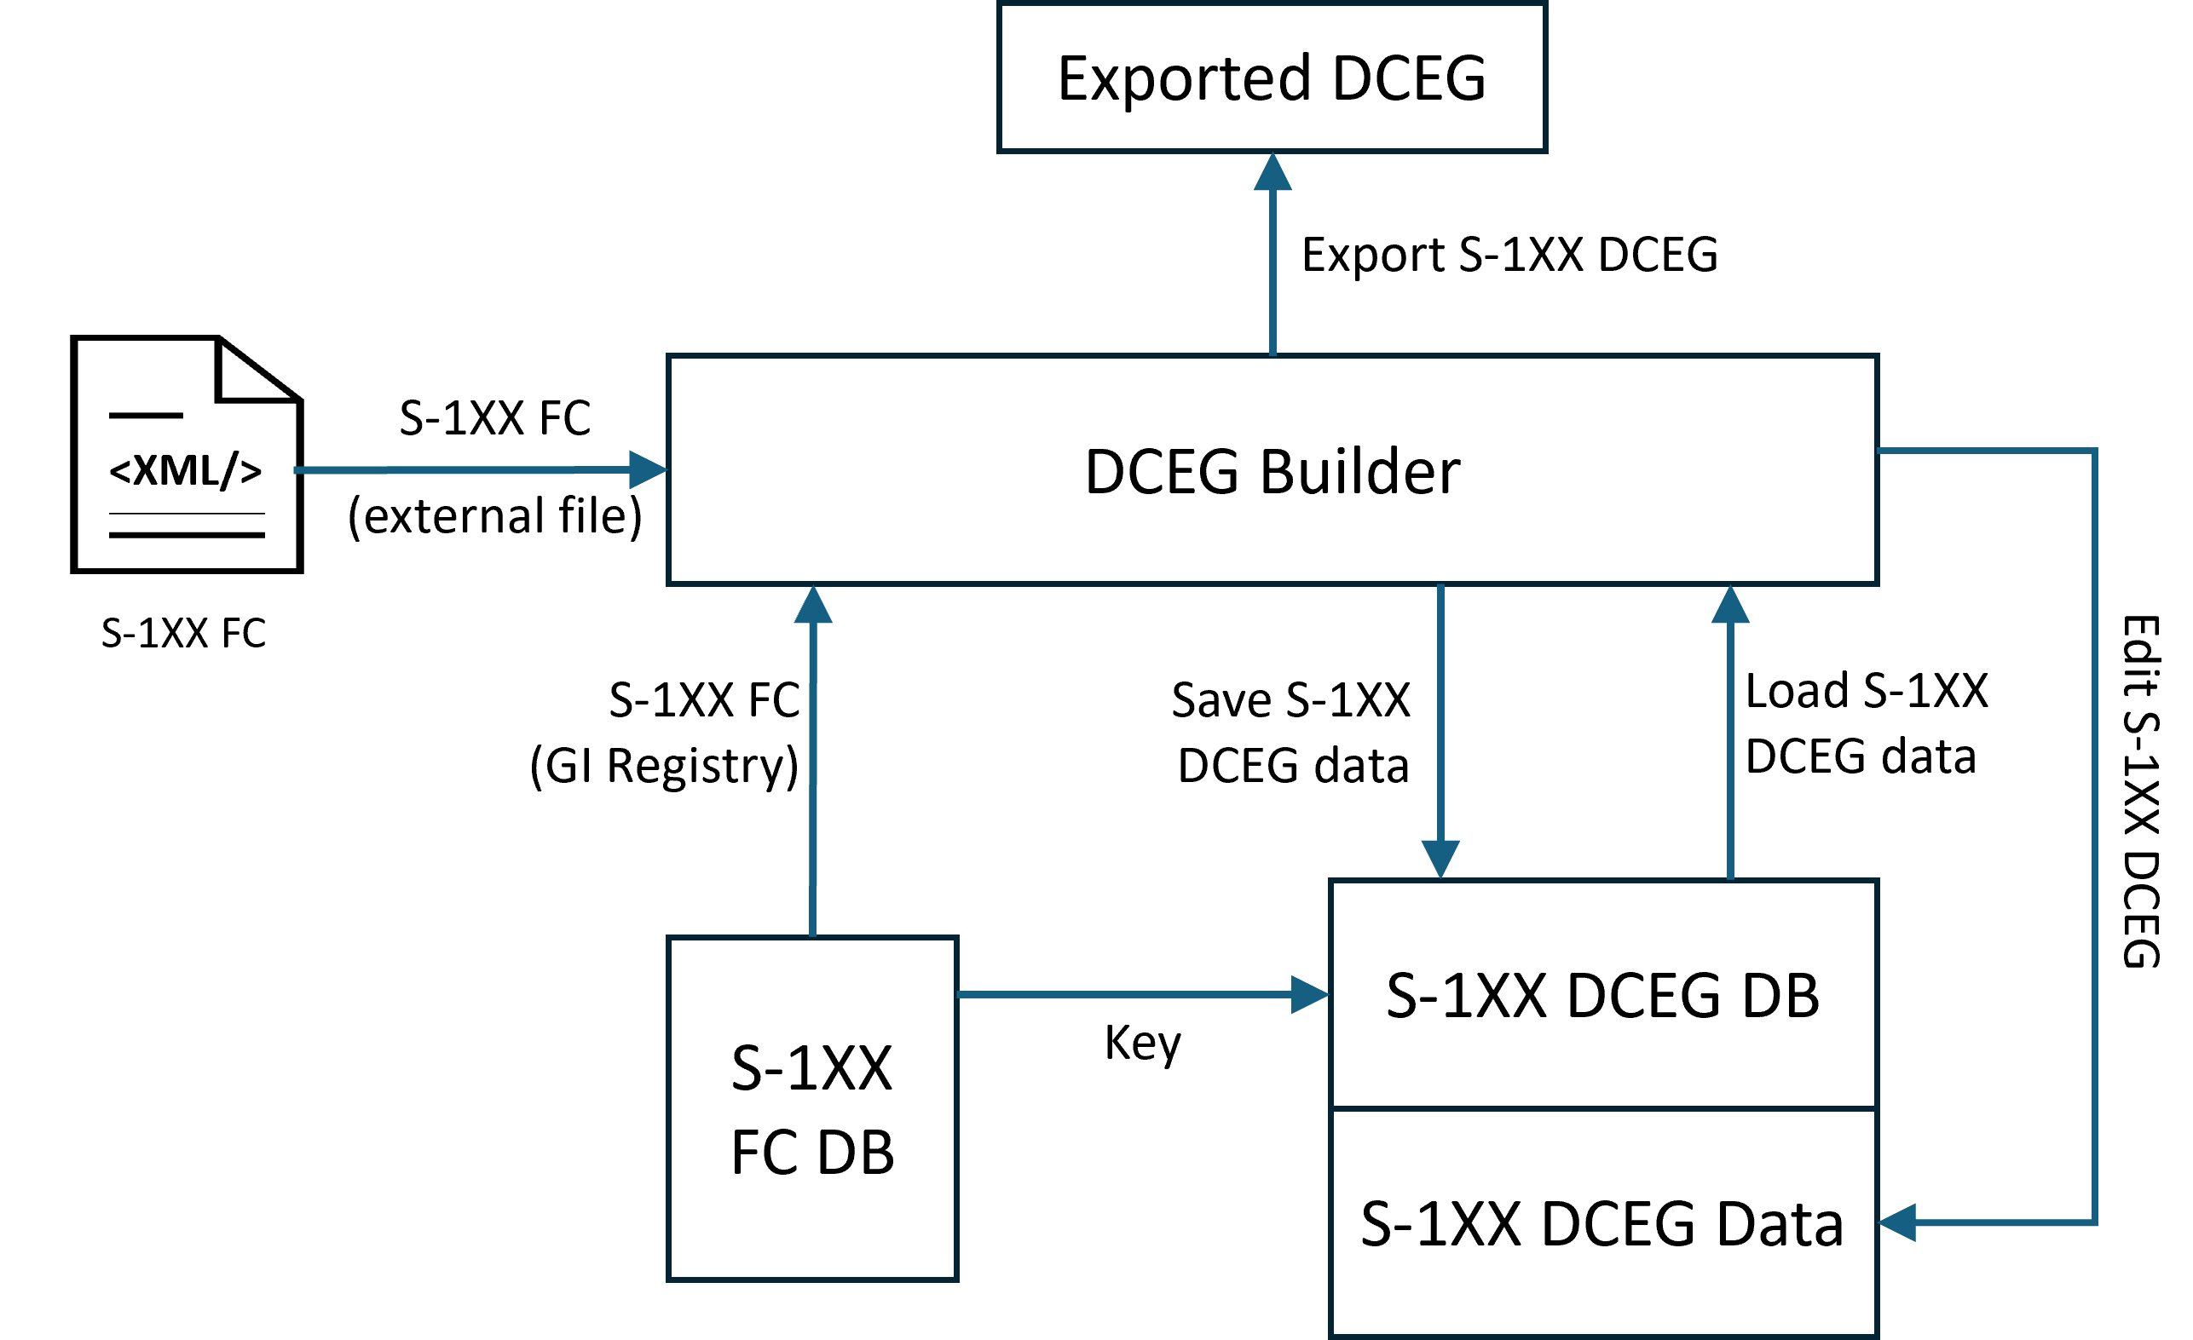

Figure A-7-4 – DCEG Builder architecture

* 1. Portrayal Catalogue Builder

Portrayal Catalogues are machine-readable instructions for how to portray data compliant with a specific data model for a specific version of a Product Specification. They can either be constructed manually or by a Portrayal Catalogue Builder (PCB). In either case, they must comply with the structure specified in S-100 Part 9 and the S-100 Portrayal Catalogue Schema. The IHO infrastructure includes a PCB for any Product Specification development team wishing to utilize it in the creation of a Portrayal Catalogue for an S-100-based Product Specification.

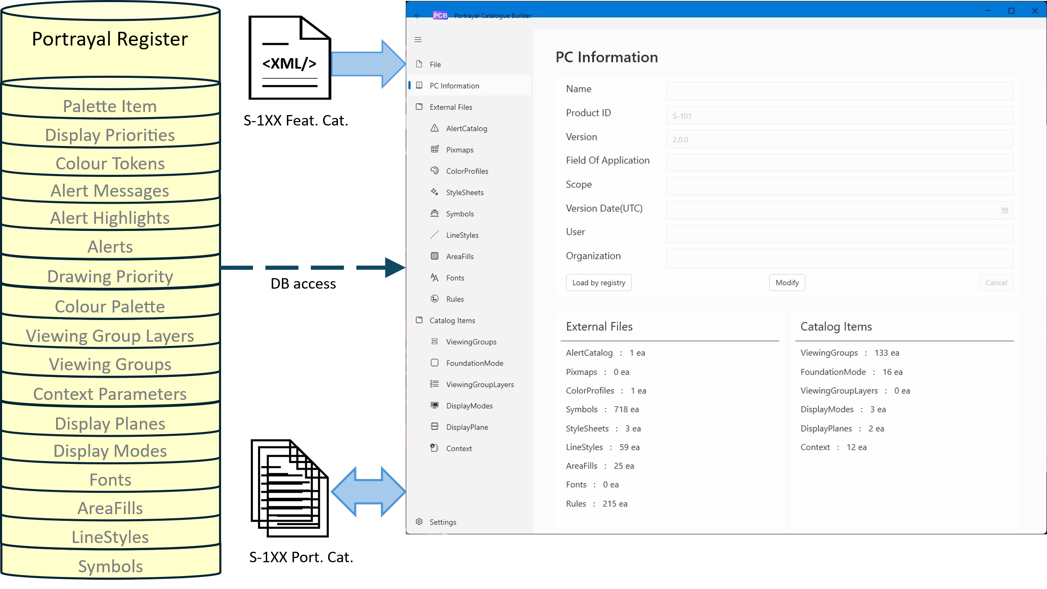

Figure A-7‑5 - Portrayal Catalogue Builder

The software interacts with the Portrayal Register in the IHO GI Registry and the Feature Catalogue and provides an interface for binding elements available in the IHO GI Registry together to form symbols, line styles and area patterns for the desired elements in the Feature Catalogue. Figure A-7-5 above illustrates the PCB concept.

The PCB can create Lua Portrayal Catalogues but editing of Lua rules may need to be done manually especially if custom processing is needed.

The PCB is also started from the main interface of the S-100 toolkit. The PCB includes functionality for viewing most components of a PC by loading it and selecting component type and individual component. Figure A-7-6 shows how this functionality can be used to view a selected area fill over a background specified by colour token.

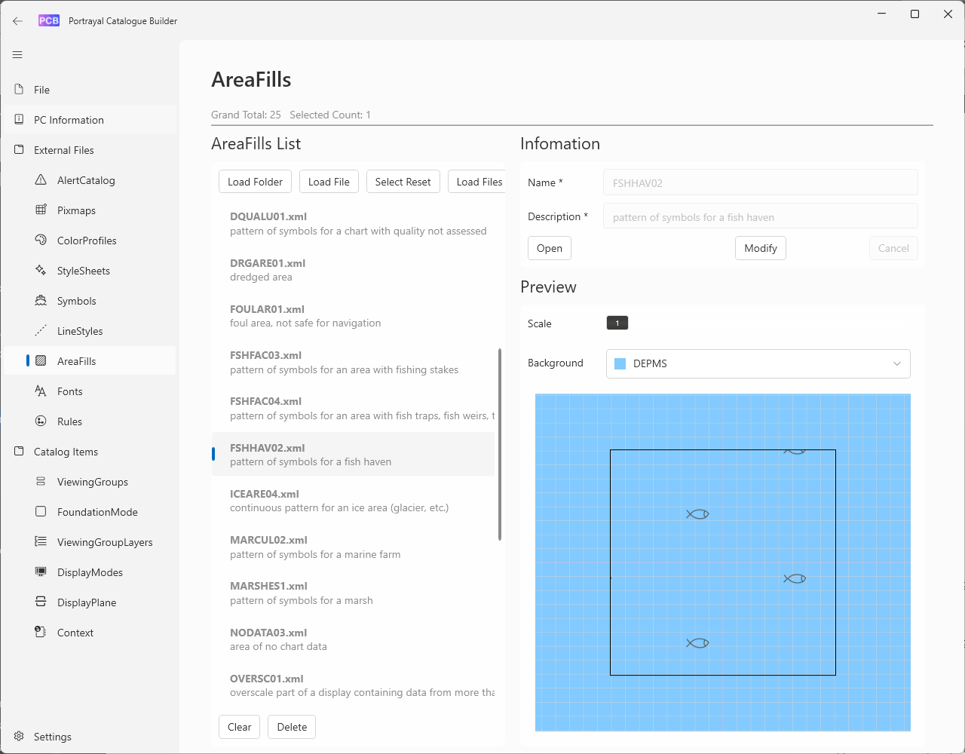

Figure A-7‑6 - Viewing single component of portrayal against user-selected background

* 1. Symbol Editor

The S-100 toolkit includes a **Symbol Editor** (which must be started from the main interface of the toolkit – see clause A-7.7) for developing point symbols conforming to the S-100 SVG profile. This allows specifying SVG paths, stroke widths, loading colour profile files, specifying colours and colour tokens for the symbol fill, while viewing the effects on the symbol under development. Figure A-7-7 depicts the symbol editor in use. Symbols can be viewed on different backgrounds selected by the developer to allow assessment of their visual effects against all possible background areas.

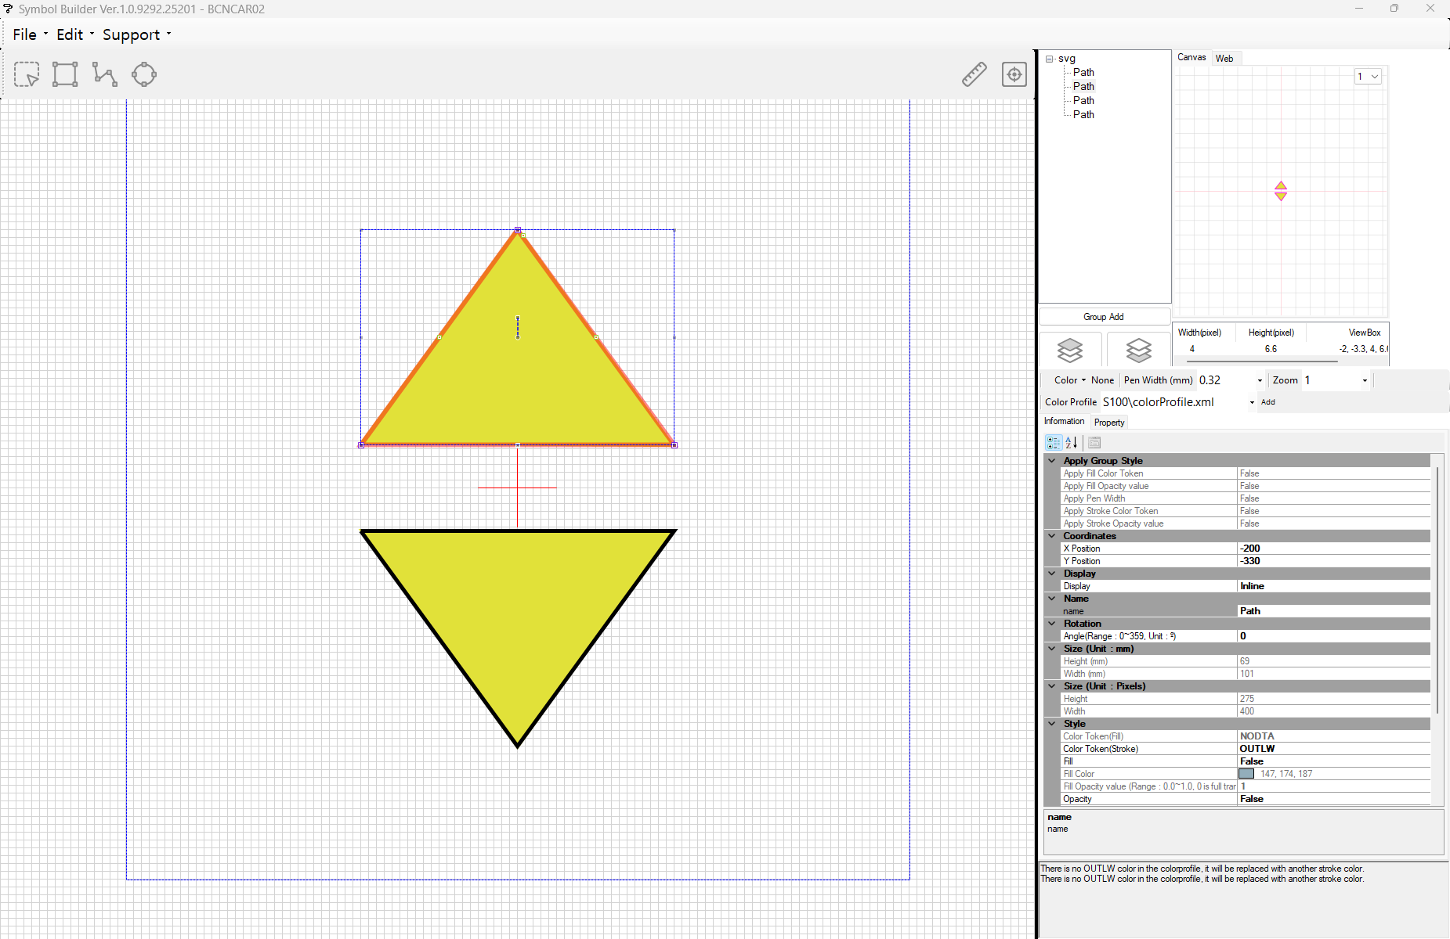

Figure A-7-7 - Symbol editor

* 1. Line Pattern Editor

The toolkit also includes a **Line Pattern Editor** (also started from the main interface of the toolkit) for development of linestyles. The line pattern editor provides for specification of line styles and symbols used in line patterns. As with the symbol editor, colours and pattern parameters can be changed by the user while the displayed pattern adjusts to the changes. The line style can be displayed over different backgrounds selected from a list of colour tokens, to allow assessment of its visual effects over all possible background areas. Figure A-7-8 depicts the line pattern editor in use.

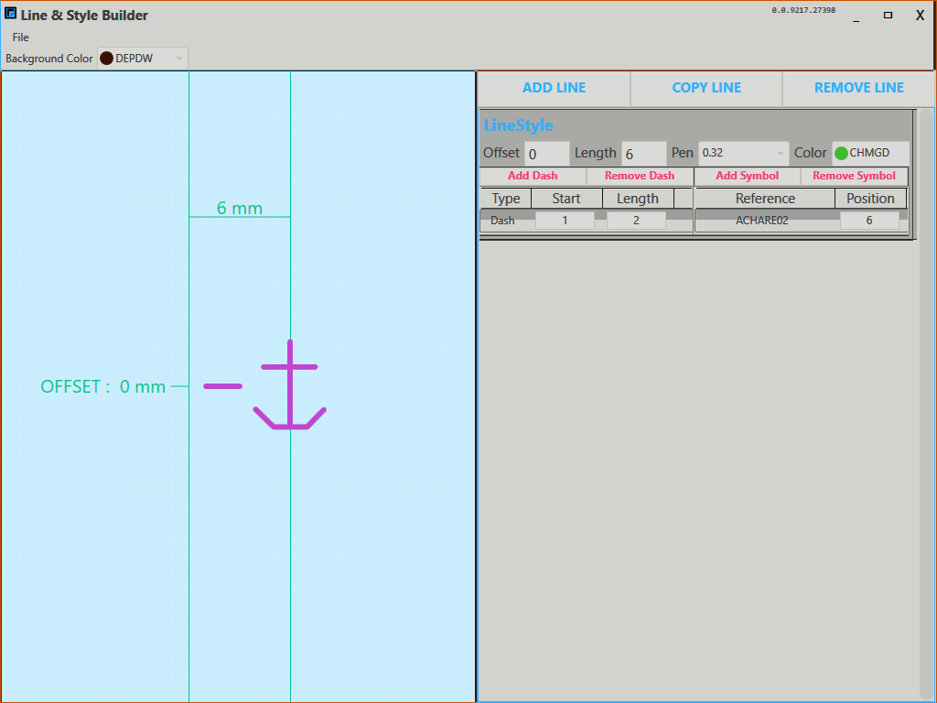

Figure A-7-8 - Line pattern builder

* 1. S-100 Toolkit

A broad-spectrum “S-100 Toolkit” is available for download and local installation from the GI Registry (Help & Guidance / Repository / S-100 Standard Toolkit Launcher). the toolkit provides access to the FCB, PCB, Symbol Editor, Line Pattern Editor and DCEG builder. The figure below depicts the main interface of the toolkit in offline mode,

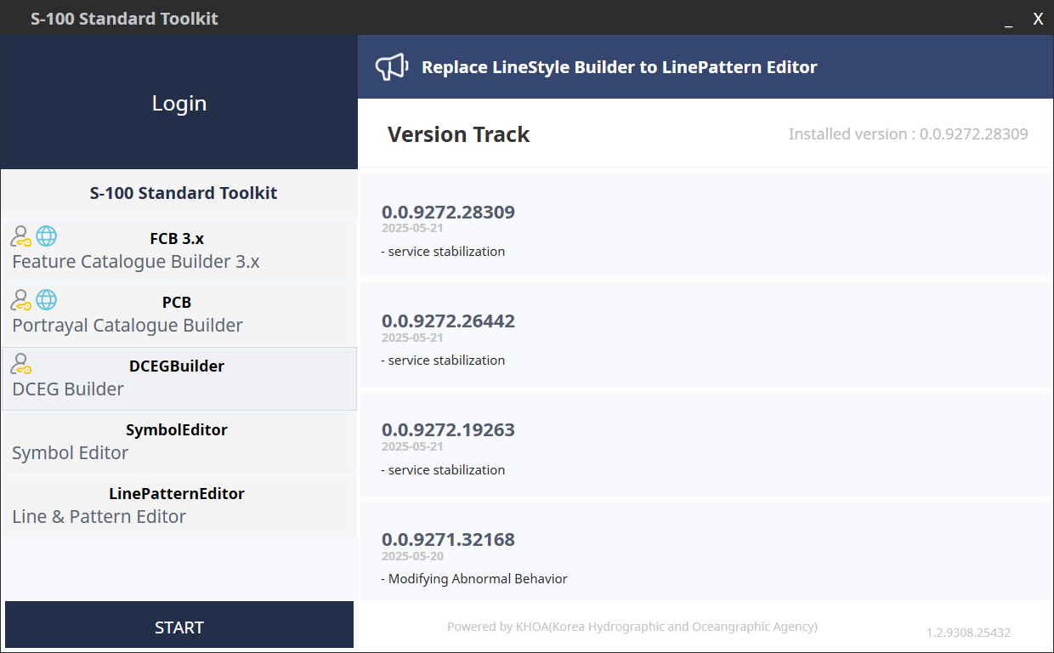

Figure A-7-9 - Main interface to IHO S-100 Toolkit

Each tool must be installed individually after the S-100 Toolkit is installed (log in and click “New”) next to the tool to install. (Updates to individual tools are indicated in the same manner.) To start a tool, select the tool in the left panel and click START.

The S-100 toolkit may be used in online mode (with an active connection to the IHO GI Registry) or offline, without an active connection. Obtaining login credentials is recommended to install tools, install updates, and keep the information synchronized with the GI Registry database.

* 1. Repositories

The IHO organisation account on GitHub can be accessed at https://github.com/iho-ohi. Several public repositories have been created under this account. The public repositories are managed by the IHO Secretariat and various responsible teams, groups, and sub-groups. The attention of Product Specification developers is particularly drawn to the following repositories:

* The “S100Resources” repository which contains various resources related to Product Specifications, including links to testing/development versions of Phase 1 Product Specifications, software tool support (viewers, converters, editors, etc.) for particular data products contributed by various entities, test datasets, and links to test programmes.
* The “S100Infrastructure” repository which is designated for user feedback on IHO S-100 Infrastructure systems, specifically the S-100 Toolkit and the IHO GI Registry.

The other public repositories are more specialized but may be of interest to Product Specification developers developing similar types of data products or components.

Repository names of existing repositories are expected to be stable but changes and reorganisations are possible in the future.

Product Specification developers desiring a repository for an S-100 Product Specification should contact the IHO Secretariat.

* 1. Viewers

Two general-purpose S-100 viewers can currently be obtained from the IHO GI registry (Help & Guidance / Repository / KHOA S-100 Viewer and NIWC S-100 Viewer and Shore ECDIS).

* 1. Digital signatures

The infrastructure relating to digital signatures will be documented in a separate publication by the IHO.

* 1. Basic Portrayal Catalogue

The Basic Portrayal Catalogue (BPC) supports the visualization of data for S-100 product specifications. This is particularly intended to enable visual representation of S-1XX product datasets for which portrayal catalogues have not yet been developed. The BPC has been developed in Lua and XSLT versions, and recently, Lua rule files for gridded data and the ability to label user-desired attributes have been added. The development of this BPC facilitates the review and demonstration of test data, and allows for visual examination of data from S-100 product specifications.

The BPC can also be used as a template for developing a product-specific Portrayal Catalogue.

General availability of the BPC is undetermined as of August 2025 but it is expected to be made available in the “Help & Guidance / Repository” section of the IHO GI Registry or one of the IHO repositories on GitHub.

* 1. Schema servers

XML schemas and associated documentation for S-100 Edition 5.0.0 onwards and GML data products aligned with S-100 5.0.0 onwards have been made available on publicly accessible web servers:

* The server https://schemas.s100dev.net contains schemas and associated documentation, sample datasets, and Schematron files for Product Specifications (and S-100 versions) which have passed through all approval processes and been published by the IHO. The S-100 schemas are also available for download as a zip archive.
* The server https://staging.s100dev.net contains schemas and associated documentation, sample datasets, and Schematron files, and downloadable zip archives of the S-100 schemas for approved Product Specifications and S-100 versions which are relatively mature (that is, have been submitted by the responsible development group for HSSC approval) but are still in the approval process (and therefore still subject to replacement by updated versions).

XML schemas located on the schema servers may be referenced in XML files at the URLs at which they are located. Such URLs are generally of the form

https://<SERVER>/schemas/S100/<N.N.N>/<component>/<YYYYMMDD>/<FILENAME>.xsd

for the S-100 schemas and

https://<SERVER>/schemas/SXXX/<N.N.N>/<YYYYMMDD>/<FILNAME>.xsd

for product schemas.

EXAMPLE:

https://schemas.s100dev.net/schemas/S100/5.2.0/S100Catalog/20240415/S100_ExchangeCatalogue.xsd

is the location of the S-100 5.2.0 (and 5.2.1[3]) exchange catalogue schema and

https://schemas.s100dev.net/schemas/S128/2.0.0/20250512/128_2.0.0.xsd

is the location of the S-128 Edition 2.0.0 GML schema.

Product Specification developers and implementers should verify URLs before distributing them further, for example by usage in sample datasets or in Product Specifications. Locations are listed on “landing pages” for each data product and each version of S-100, which can be viewed using a web browser. The pages can be reached by normal web browser navigation starting from the main pages at https://schemas.s100dev.net/index.html or https://staging.s100dev.net/index.html.

Downloadable zip archives containing all the XML schemas for successive S-100 versions are available through links on the “landing pages” for each S-100 version. Zip archives for Product Specification schemas have not been provided since those schemas are single XSD files.

The README file on the main landing page describes the folder/file layout and update policy for schemas.

* 1. Other resources

Miscellaneous resources including forms related to the GI registry, S-101 converter, form for participating in current (2025) sea trials, are available from the IHO GI Registry (Help & Guidance / Repository) or IHO GitHub repositories under the IHO GitHub account (see clause A-7.8 above). New resources may be added and obsolete resources removed from time to time.

* 1. Product specification development with Metanorma

The IHO are in the process of transitioning document management and development from Microsoft Word format to Metanorma. Metanorma is a framework for preparing technical documents using a variant of AsciiDoc, a text-based markup language that uses defined markup elements to define document structure. The results can be converted to PDF files for publication. Management of IHO Metanorma technical documents will be based on GitHub. In the interim Product Specifications continue to be developed in Microsoft Word format.

More information about IHO templates for technical standards and about authoring and managing IHO standards in Metanorma will be made available by the IHO Secretariat at a later date.

1. Related specifications
   1. Validation

Product-specific validation checks must be prepared prior to release of a Product Specification as an operational version. Each “1XX” Product Specification must have a corresponding list of product-specific validation checks in an S-158:1XX” publication. The structure and template for validation checks is described by IHO Publication S-158. S-158 also includes common foundational material such as a standard classification of check criticality and definitions of spatial operations used by some validation checks.

In addition, there is a published list of S-100 generic validation checks for detecting errors against the specifications contained in S-100 itself, such as self-intersecting polygon boundaries, missing metadata, discrepancies in exchange sets compared to the Exchange Catalogue, etc.

* 1. Structure and usage of MRN identifiers

A publication prescribing the structure and usage of MRN identifiers is being prepared by the IHO.

* 1. Test datasets

Test datasets will need to be prepared prior to operational release of a Product Specification. Each Product Specification is expected to be accompanied by a suite of test datasets as part of an “S-164:1XX” publication.

* 1. ECDIS readiness

IHO Publication S-98 describes requirements and guidance for the implementation of harmonized portrayal and other user interaction functions for S-100 based data products in an ECDIS. It describes how S-100 products are to be used and displayed simultaneously on the navigation screen. As such it contains some requirements data products must satisfy in order to provide a harmonized user experience on ECDIS. It also contains requirements for cross-product compatibility. Data sets intended for ECDIS use must satisfy both types of requirements before they can be loaded in an ECDIS display. The requirements are embodied in another set of validation checks listed in IHO Publication S-158:98. Product Specification developers are advised to review S-98 and S-158:98 to determine how these requirements affect their work. This applies only to data products intended for ECDIS use.

* 1. Digital signatures and data protection

The technical specifications for digital signatures are contained in S-100 Part 15. Supporting infrastructure and procedures will be described in a separate publication being prepared by the IHO.

* 1. Procedures

Registry procedures are described in IHO Publication S-99.

**Part B – Steps, Activities, and Practices**

1. Introduction

The intent of Part B is to explain the various components of a Product Specification for those that are developing S-100 based Product Specifications. It describes the typical phases of development for the typical Product Specification; and a prescribed order for each phase. It provides guidance on how the rules contained in S-100 are used to build the components of a Product Specification, including documentation components; UML models; and machine-readable components such as XML Feature Catalogues and data formats.

1. References

ISO 8211 Specification for a data descriptive file for information interchange structure implementations. ISO/IEC 8211, 1994.

ISO 19101-1 Geographic information — Reference model – Part 1: Fundamentals. ISO 19101-1:2014, 2014.

ISO 19109 Geographic information – Rules for application schema. ISO 19109:2005. (Since replaced by ISO 19109:2015, but S-100 Editions 5.2.0 and 5.2.1 still reference the 2005 edition.)

ISO 19115-1 Geographic information – Metadata – Part 1 – Fundamentals. ISO 19115-1, 2014, as amended by Amendment 1, 2018.

ISO 19115-2 Geographic information – Metadata - Part 2 – Extensions for imagery and gridded data. ISO 19115-2, 2009.

ISO 19115-3 Geographic information – Metadata - XML schema implementation for fundamental concepts. ISO/TS 19115-3, 2016.

ISO 19119 Geographic Information – Services. ISO 19119, 2016.

ISO 19136 Geographic information – Geography Markup Language (GML). ISO 19136, 2007. (Also available as OGC 07-036 Geography Markup Language (GML) Encoding Standard. Open Geospatial Consortium Inc., 2007.)

ISO 19757-3 Information technology – Document Schema Definition Languages (DSDL) – Part 3: Rule-based validation – Schematron. ISO 19757-3, 2016.

IHO Resolution 2/2007 (as amended) – Principles and Procedures for Making Changes to IHO Technical Standards and Specifications.

S-98 IHO S-98 – S-100 ECDIS and Interoperability Specification, Edition 2.0.0, October 2025.

S-99 IHO S-99 – Operational Procedures for the Organization and Management of the S-100 Geospatial Information Registry, Edition 2.0.0, October 2022.

S-100 IHO S-100 – Universal Hydrographic Data Model Edition 5.2.0, June 2024.

S-100_5.2.1 IHO S-100 – Universal Hydrographic Data Model Edition 5.2.1, December 2025.

S-101 IHO S-101 – Electronic Navigational Chart Product Specification, Edition 2.0.0, December 2024.

S-111 IHO S-111 – Surface Current Product Specification, Edition 2.0.0, December 2024.

S-122 IHO S-122 – Marine Protected Areas, Edition 2.0.0. In preparation, 2026.

SVGTiny Scalable Vector Graphics (SVG) Tiny 1.2 Specification. W3C Recommendation 22 December 2008. URL: <http://www.w3.org/TR/2008/REC-SVGTiny12-20081222/>.

NOTE: In this document, “S-100” means both S-100 Edition 5.2.0 and Edition 5.2.1 unless a particular edition is explicitly identified.

1. Terms and abbreviations
   1. Terms

**abstract class**

an object class which cannot be **instantiate**d, or is designated in an information model as not allowed to be instantiated

NOTE: Subclasses of an abstract class may be either abstract or non-abstract.

**aggregation**

special form of association that specifies a whole-part relationship between the aggregate (whole) and a component part (see **composition**) [ISO 19103]

**application**

manipulation and processing of data in support of user requirements [ISO 19101-1:2014]

**application schema**

**conceptual schema** for data required by one or more **applications** [ISO 19101‑1:2014]

**association**

semantic relationship between two or more classifiers that specifies connections among their instances [ISO 19103]

**attribute**

(1) named property of an entity [ISO/IEC 2382-17:1999]

NOTE: Describes a geometrical, topological, thematic, or other characteristic of an entity.

(2) UML: feature within a classifier that describes a range of values that instances of the classifier may hold [ISO/IEC 19501:2005 (Adapted)]

(3) XML: name-value pair contained in an element [ISO 19136]

**base64**

an encoding designed to represent arbitrary sequences of octets in a form that allows the use of both upper- and lowercase letters but that need not be human readable [IETF RFC 4648 (restyled)]

**code**

representation of a label according to a specified scheme [ISO 19118:2011]

**codelist**

value domain including a code for a permissible value [ISO 19136]

**codespace**

rule or authority for a code, name, term or category [ISO 19136]

EXAMPLE: Examples of codespaces include dictionaries, authorities, codelists, etc.

**composition**

form of aggregation association with strong ownership and coincident lifetime as part of the whole [ISO 19103]

**conceptual model**

**model** that defines concepts of a universe of discourse [19101-1:2014]

**conceptual schema**

formal description of a **conceptual model** [ISO 19101-1:2014]

**data client**

an end-user receiving encrypted S-100-based data; the data client will be using a software application (for example ECDIS) to perform many of the operations detailed within the S-100 protection scheme [S-100 Part 15 (adapted)]

EXAMPLE: An ECDIS user.

**data permit**

file containing encrypted product keys required to decrypt the licensed products, normally created specifically for a particular **data client** [S-100 Part 15 (adapted)]

**data server**

an organization producing encrypted data files or issuing **data permits** to **data clients** [S-100 Part 15, (adapted)]

**feature**

abstraction of real world phenomena [ISO 19101-1:2014]

NOTE 1: A feature may occur as a type, class, or an instance. Feature type or feature instance should be used when only one is meant. **Feature class** should be used in the context of a model or Application Schema.

EXAMPLE The phenomenon named 'Eiffel Tower' may be classified with other phenomena into a feature type 'tower'.

**feature association**

**relationship** that links instances of one feature type with instances of the same or a different feature type [ISO 19110]

**feature attribute**

characteristic of a feature [ISO 19101-1:2014]

NOTE A feature attribute type has a name, a data type and a domain associated to it. A feature attribute instance has an attribute value taken from the value domain of the feature attribute type.

EXAMPLE 1: A feature attribute named ‘colour’ may have an attribute value “green” which belongs to the data type “text.”

EXAMPLE 2: A feature attribute named ‘length’ may have an attribute value “82.4” which belongs to the data type “real.”

**feature catalogue**

a catalogue containing definitions and descriptions of the **feature types**, **feature attributes** and **feature associations** occurring in one or more sets of geographic data [ISO 19110]

**feature class**

a class in an **application schema** or **model** that represents a **feature**.

**feature type**

an element in a **feature catalogue** that describes a **feature**, its **attribute**s, and **associations**.

**identifier**

a linguistically independent sequence of characters capable of uniquely and permanently identifying that with which it is associated [adapted from ISO/IEC 11179-3:2003]

**information type**

an identifiable unit of information in a dataset with only thematic attribute properties [S-100 3-5.1.2 (adapted)]

**instantiate**

represent by a concrete instance [Merriam-Webster Online <https://www.merriam-webster.com/dictionary/instantiate>]

**interface**

named set of **operations** that characterize the behaviour of an entity [ISO 19119:2005]

**metadata**

information about a **resource** [ISO 19115-1]; data that defines and describes other data [ISO 11179-3:2013]

**model**

abstraction of some aspects of reality [ISO 19109-2015]

**operation**

specification of a transformation or query that an object may be called to execute [ISO 19119:2005]

NOTE: An operation has a name and a list of parameters.

**register**

set of files containing identifiers assigned to items with descriptions of the associated items [ISO 19135]

NOTE: Descriptions may consist of many types of information, including names, definitions and codes.

**registry**

information system on which a **register** is maintained [ISO 19135]

**relationship**

semantic connection among **model** elements [ISO 19103]

**resource**

identifiable asset or means that fulfils a requirement [ISO 19115-1]

EXAMPLES: Dataset, dataset series, service, document, initiative, software, person or organization.

**scheme administrator**

organization solely responsible for maintaining and coordinating the protection scheme specified by S-100 [S-100 Part 15 (adapted)]

**service**

distinct part of the functionality that is provided by an entity through **interfaces** [ISO 19119:2005]

**spatial object**

object used for representing a spatial characteristic of a feature [ISO 19107:2003]

**stream**

in online data exchange: a continuous sequence of fragmented data to be transported by a communication system [S-100]

**universe of discourse**

view of the real or hypothetical world that includes everything of interest [19101-1:2014]

**vocabulary**

terminological dictionary which contains designations and definitions from one or more specific subject fields [ISO 1087-1:2000]

* 1. Abbreviations

CORBA Common Object Request Broker Architecture

COTS Commercial Off-The-Shelf

CRS Coordinate Reference System

CSS Cascading StyleSheets

DCEG Data Classification and Encoding Guide

DQWG Data Quality Working Group

ECDIS Electronic Chart Display and Information System

ECS Electronic Chart System

ENC Electronic Navigational Chart

FC Feature Catalogue

FCB Feature Catalogue Builder

GFM General Feature Model

GI Geospatial Information

GML Geography Markup Language

HSSC IHO Hydrographic Services and Standards Committee

IALA International Association of Lighthouse Authorities

IEC International Electrotechnical Commission

IETF Internet Engineering Task Force

IHO International Hydrographic Organization

IMO International Maritime Organization

ISO International Organization for Standardization

MRN Maritime Resource Name

OEM Original Equipment Manufacturer

RENC Regional ENC Coordinating Centre

REST Representational State Transfer

SOAP Simple Object Access Protocol

SVG Scalable Vector Graphics

W3C World Wide Web Consortium

XML eXtensible Markup Language

XSD XML Schema Definition

XSL eXtensible Stylesheet Language

XSLT XSL Transforms

1. Overview of steps for development

When developing an S-100 based Product Specification it is recommended that developers consider each of the stages defined in the basic development process. The stages are outlined below and described in greater detail in the following sections.

* 1. Basic development process

The steps described below apply to the development of a Product Specification for a new data product.

The process described in this section should be applied to each specification scope identified for the product. For example, if the product will contain a mixture of vector (feature) and grid coverage data, then the product specification would identify at least two scopes, and the process would be repeated for each scope. If the product contains more than one scope with the same geometry requirement (for example two scopes with vector geometry but different application schemas, or different maintenance regimes), then the process could still be followed twice, once for each scope.

1. **Initiation**. Identify the need for a new data product; define its scope; and decide the boundaries between the new product and existing data Product Specifications. Obtain sample source material. Describe typical application use cases. As part of the initiation stage, determine whether the scope will be feature based (i.e. use vector geometry) or coverage-based, and whether portrayal is needed.
2. **Develop the Domain Model/Application Schema**. Define the classes and attributes that describe the domain and which are relevant to the data product. Define the relationships between the classes and specify applicable constraints. Prepare one or more UML diagrams describing the Domain Model.
   1. Determine which geometry types are required in the product. S-100 includes definitions of 1D and 2D geometry types. If a geometry type is required that is not specified in S-100 Part 7 Spatial Component (or Parts 8 and 10c for coverage products), then apply to the S-100WG for it to be added to the framework.
   2. Determine which attributes (both simple and complex) are required in the product. Seek existing definitions in the GI Registry. If required definitions do not exist then define new attributes.
   3. Determine what feature and information associations are required in the product. Seek existent definitions of associations and roles in the GI Registry. If required definitions do not exist then define new associations and roles.
   4. Determine which listed values are required in the product for enumeration and codelist attributes. Seek existing definitions in the GI Registry. If required definitions do not exist then define new listed values.
3. **Populate the IHO GI Registry from the Domain Model**. Propose amendments to existing classes and attributes and propose new classes and attributes for addition to the Concept and Data Dictionary Registers in the IHO GI Registry using the Registry interface. Follow up on any returned proposals or queries from the Registry Manager or Domain Control Body.
4. **Develop the Feature Catalogue**. Prepare the XML Feature Catalogue from the feature and information classes, attributes and relationships as approved in the IHO GI Registry, utilizing the Feature Catalogue Builder.
5. **Define data transfer modes and packaging**. Determine whether data products are to be delivered as data files contained in transfer (exchange) sets, by web services (and if so, identify or outline a service protocol), e-mail, etc. Determine whether data is to be delivered in real or near real-time. Identify constraints and requirements arising from delivery mechanisms and communication constraints such as message size, bandwidth limitations, availability of communications to customers, licensing and payments, encryption, etc.
6. **Define metadata**. Survey the metadata elements listed in S-100 for their appropriateness to the data product and its allowed packaging and delivery methods. Define appropriate values and restrictions for the metadata elements listed in S-100. Consider whether additional product-specific metadata elements are needed.
7. **Define the data format**. Select an appropriate data format. S-100 provides for 3 standard delivery formats (ISO 8211, GML, and HDF5). Define format-imposed items (for example embedded header metadata). Prepare format-specific artefacts if necessary (for example GML “application schema” XSD files for the GML format).
8. **Develop the Data Classification and Encoding Guide (DCEG)**. The DCEG is intended for cartographers, editors, and data encoders, rather than application developers or OEMs; and should be written from that perspective. A DCEG should contain enough overview and general material about basic concepts such as data types, feature types, information types, associations, etc, to give its intended audience a basic grounding in the concepts they will need to apply; but its main focus should be on what to encode in the data product, and how to encode it.
9. **Define portrayal symbols and rules**. Determine the symbols to be used for portrayal and the rules for generating displays from the data product. This means deciding which features should be displayed; which combinations of attribute values or associated data objects should be assigned distinct symbols; and which pre-existing symbols and colours can be reused and which need to be defined. It also includes defining the new elements in the appropriate formats.
10. **Registration of portrayal elements**. Propose any new portrayal components (for example symbols, colour tokens, line styles, area fills, etc.) to the Portrayal Register in the IHO GI Registry using the Registry interface. Follow up on any returned proposals or queries from the Registry Manager or Domain Control Body.
11. **Develop the Portrayal Catalogue(s).** Prepare a Portrayal Catalogue (or Catalogues) for the features and information types which are intended to be displayed in the intended application domain(s) and usage scenario(s). This consists of encoding the rules in the appropriate portrayal language using the symbols determined in step (8).
12. **Define the spatial reference system**. Identify the recommended coordinate reference system and vertical datum(s).
13. **Define data product packaging and maintenance**. Define the content and structure of delivery packages, updating of data, and any auxiliary content delivered either with or as an adjunct to data.
14. **Define validation checks and quality measures**. Define tests for the spatial, structural, and conceptual integrity of datasets. Define format-specific implementations of validation checks (for example Schematron rules [ISO 19757-3] for the GML format). Define quality measures for the datasets (quality measures will generally be statistics about passed and failed tests).
15. **Determine interoperability** with other data products. Determine which if any product groups in Interoperability Catalogues are supplemented or enhanced by the data product; and how the IHO Interoperability Catalogue will be affected by the new product, including updates to display priorities, interleaving, predefined combinations and other interoperability rules and operations.
16. **Prepare sample data** for test-beds. Create sample datasets and exchange sets conforming to the data format, packaging, and Feature Catalogue defined in the Product Specification.
17. **Testing and feedback**. Carry out tests of data production and use of the sample data in selected applications to validate the correctness, completeness, consistency, and utility of the Product Specification, including related artefacts such as the Feature Catalogue and XML schemas.

Development of Product Specifications is an iterative process of continuous refinement as it moves through the S-100 Readiness Levels. Developers should expect to cycle through the stages above multiple times, in smaller or larger cycles depending on experiences and results of each stage. For example, the first preparation of sample data (Stage 16) might identify gaps in the Domain Model and require revisiting Stage 2 (development of the Domain Model); or the development of portrayal rules (Stages 9 - 11) may identify gaps in the Domain Model (Stage 2). Passage through some intermediate stages in the cycle may be trivial on the second and later passes, as the results may be unaffected by discoveries during later stages in the process – for example, packaging and delivery or choice of spatial reference systems are likely to be unaffected by changes identified during the preparation of sample data.

Figure B-4-1 below depicts the development process, including probable cycles. The circles (except the “Begin” and “Approval...” circles are connector labels used to avoid long crossover lines.

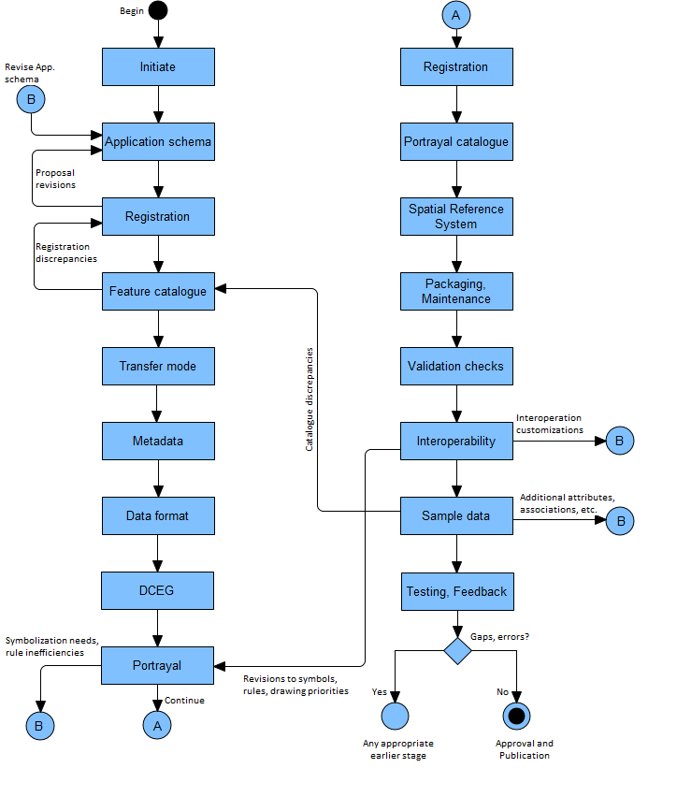

Figure B-4‑1 – Product Specification development process

The process is similar for all types of S-100 data products – vector or coverage – since all types need a feature catalogue and application schema. Products not needing portrayal can skip the stages for development of portrayal, portrayal catalogues. Products not covered by interoperability catalogues (which, as of August 2025 is all products since implementation of interoperability has been postponed) can skip the Interoperability stage.

* 1. Review cycle for S-100-based Product Specifications

IHO Resolution 2/2007 (as amended) outlines the process for development and approval of IHO-based Product Specifications. As part of this lifecycle it is important that Working Groups and Project Teams engage with the IHO Data Quality Working Group (DQWG) to review Product Specifications for adherence to S-100 data quality aspects and completeness. While this review can occur prior to Edition 1.0.0 (Testing and Implementation Edition), the DQWG will review and provide feedback during the Edition 1.0.0 to 1.9.n phase Specification development. Edition 1.0.0 of any IHO S-100-based Product Specification is not designed for regular use in approved arrangements or for provision of operation services by purpose. Edition 2.0.0 of a Product Specification is considered to be mature and can be used for implementation. Figure B‑4‑2 below shows the IHO Review Cycle as included in IHO Resolution 2/2007.

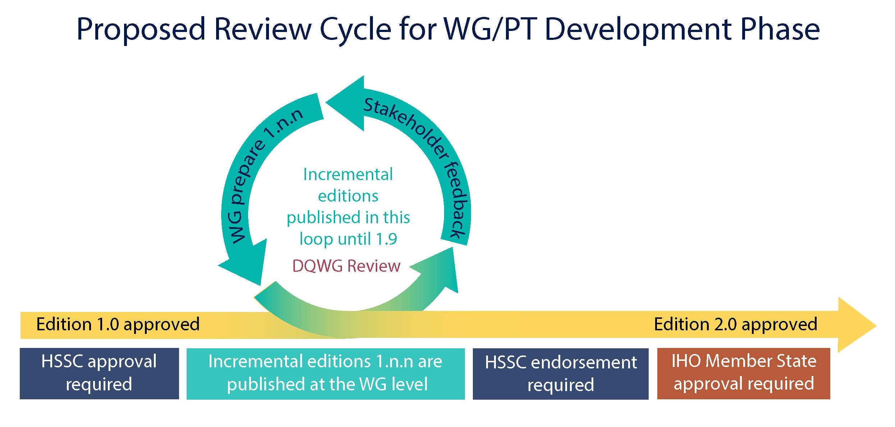

Figure B-4-2 – Review Cycle (IHO Resolution 2/2007 (as amended))

* 1. Process for extending a Specification

If there is a demonstrated need to extend an existing Product Specification, developers should review the steps in the basic process in clause B-4.1 and determine which steps can be omitted.

For example, if features, information types, attributes, or relationships are added, removed, or modified, most of the steps in the basic process will be needed. The spatial reference system and packaging/maintenance may not change in such a revision and the corresponding phases can be skipped.

If the extension consists of defining a new transfer mode, such as adding a streaming delivery mode for data products originally intended for exchange set delivery, it is likely that only the following stages need be executed:

* Transfer mode – to add the streaming mode for transfer, define specifications for servers, etc.
* Metadata – to define which of the metadata elements for the exchange set mode also apply to the streaming mode, whether any new metadata elements are needed, and how metadata is delivered or made available in the new mode.
* Data format – to consider whether the already defined data format is appropriate for streamed transfer and compatible with the intended service delivery and protocols; and specify an appropriate format if necessary.
* Packaging and maintenance – to specify the appropriate data wrapper formats and service protocols; for example WFS, REST, etc. Defining new wrapper formats or protocols is permitted but should be the last resort.
* Sample data – preparation of sample data for testing the streaming mode.
* Testing and feedback – this should include a prototype or simulated streamed data transfer environment.
  1. New overarching procedures (informative)

Updates to processes for maintaining IHO technical standards are being discussed and awaiting finalisation and approval. One of the following approval procedures will be used, selected according to IHO Res. 2/2007 (as amended):

* Procedure 1: WG/PT → Committee → Council (if deemed appropriate) → Member States

Note: WG/PT must conduct an impact study and submit it to the Committee alongside the draft standard package.

* Procedure 2: WG/PT → Committee → Member States

In the new process, IHO technical standards will progress from concept to approved standard by the following stages, summarized in Table B-5-1.

Table B-5-1 – Summary of new overarching process

| **Stage** | **Purpose** | **Activities** | **Documents** |
| --- | --- | --- | --- |
| Proposal Concept (PC) | address new technical standards that are currently unpublished or not being considered by the IHO | IHO body or Member State prepares and submits a concept for a new standard | IHO proposal concept template |
| Proposal Development (PD) | plan for maintaining technical standards, including new standard | IHO responsible body prepares and submits a plan and timeline | IHO development plan template |
| Working Draft (WD) | prepare a draft for endorsement | The responsible body (WG/PT) commences to develop working versions of the standard or specification. | Draft identified as WD-NNN-vX.X.X |
| Endorsement Draft (ED) | Endorsement | The responsible body submits it to the WG/PT/HSSC for endorsement along with an impact study. | Draft identified as ED-NNN-vX.X.X  IHO impact study template |
| Assessment Period | Stakeholder assessment | IHO invites relevant stakeholders to provide technical comments; comments are reviewed by the IHO Secretariat and WG/PT chair; critical issues must be addressed in consultation with the responsible body (WG/PT) | Draft identified as ED-NNN-vX.X.X |
| Approval Draft (AD) | Approval | Member State approval | Draft identified as AD-NNN-vX.X.X |
| Implementation | Implementation | IHO will inform relevant stakeholders of updates to the IHO standards and specifications, including key changes and improvements | Publication identified as S-NNN Edition X.X.X |

While the numbering of documents will change through different stages in the process, and forms for concept initiation (Table B-5-1) and planning can be expected to be revised, the phases described in this document after the Initiation phase are expected to remain the same and will still need to be performed by the responsible working group or project team as part of the Working Draft stage to take a technical standard from completed Proposal Development to the Endorsement Draft phase.

1. Initiation

The initiation phase consists of the following activities. Except for the first (identifying the need) most of the other activities can be done in parallel.

1. Identify a need that a data product will fill – this will normally be the result of external circumstances such as definition of a service portfolio; application-driven demand for new kinds of information; new legal requirements for shipping; IMO decisions; etc.
2. Define the scope of the product – the subject area, the kind of information it is expected to contain; and equally important, what information it will not contain.
3. Determine if existing Product Specifications can be extended. If so, such an extension will probably consume less time and effort than developing a new Product Specification.
4. Determine sub-areas within the product; that is, the scopes within the Product Specification or a new scope for an existing Product Specification.
5. Define constraints – domain, application, platform, etc.
6. Collect samples of source information. These generally include existing databases; and official, unofficial, government and commercial publications – especially those in wide use.
7. Define application use cases.
8. Outline application functionality enabled by the data product.
9. Define delivery modes (transfer set, messages, web services, etc).
10. Obtain approval from the appropriate sponsoring organization.
11. Put together a Project Team.

If the Product Specification development is performed under the umbrella of the IHO then the following step also needs to be included in the initiation stage:

Before deciding to include a new S-100-based Product Specification in the HSSC Work Program, the following considerations should be taken into account:

1. Has the need for the Product Specification proposed been documented?
2. Has a compelling need been demonstrated with detailed examples?
3. Has the Product Specification been considered within the scope of the HSSC?
4. Has the description of the proposed Product Specification sufficiently addressed the cost to the IHO and possible legislative and administrative burdens?
5. Has the development duration been considered?

To simplify the above-mentioned decision-making process, the Product Specification description should provide a set of information beforehand to HSSC for consideration, as shown in Table B-6-1 below.

Table B-6-1 - Product Specification description template

| **Product Specification description** | | |
| --- | --- | --- |
| **Action** | **Description** | **Comments** |
| Product Specification number | The intended number for this Product Specification | Keep this section empty until HSSC have assigned a number |
| Title | The title of the product specification |  |
| Abstract | A brief summary of the Product Specification summarizing:  1. the intended use  2. the primary and secondary user  3. the expected functionality |  |
| Product Specification Scope | The overall scope of the Specification | This should include the expected SOURCE(s) of the data  For example: Coast Pilots or Sailing Directions for data products containing information from nautical publications. |
| Justification | The reason why this Product Specification should be developed |  |
| Specification Interoperability | Any interoperability with other Product Specifications within the S-100 family | Specify the limits of the Product Specification |
| S-98 Applicability | Applicable to S-98 (Yes or No) | S-98 Interoperability Specification in S-100 Navigation Systems |
| Cooperation with other HSSC WGs | Specify which WG will be involved to which extend | NCWG: Portrayal  DQWG. Specific information on Data Quality |
| Budget | Statement of budget need and the figure | Is IHO budget needed? Will the development be financed by an external party and to what extent?  There should be general guidelines for how to calculate this...with reasonable values based on reality and evidence |
| Schedule | Description of the intended time frame | Or at least the steps to accomplish since this is very difficult to determine |

1. Develop data model (Application Schema)
   1. Introduction

The Application Schema as defined in S-100 is usually synonymous with “domain model”. It is a specification of the classes, attributes, and relationships relevant to the data product.

A Product Specification will include only a single Application Schema (which may be broken up into multiple diagrams). However, in theory a Product Specification that describes different scopes may need to distinguish Application Schema for different scopes – for example a product that includes both vector and coverage data might need two Application Schemas.

To minimize complexity, Product Specification developers should try to avoid defining multiple Application Schemas.

Note that this does not prevent a single Application Schema from being depicted using multiple diagrams.

The Application Schema should describe only features, information types, their attributes and relationships that are part of the data product. Any other classes, constraints, or elements that are used to further understand the data product and its role in applications, services or service portfolios should be distinguished from the Application Schema and documented separately in the Product Specification.

Model developers should try to limit the number of model elements while still allowing implementations to make appropriate (conceptually appropriate, logically appropriate, consistent, correct and performance-based) distinctions.

The principles of data normalization learned in relational database design should be kept in mind; but model developers should also note that an S-100-based domain model and Application Schema are feature-attribute-relationship models and not database designs.

* 1. Steps in model development

1. Determine whether the data product is coverage or vector data. Coverage data is characterized by values of characteristics distributed over an area or areas, while vector data is characterized by localized regions (points, and/or areas) that possess boundaries and do not exhibit internal variation in characteristic values (or where such internal variations can be ignored).
2. Identify the concepts in the application domain. This will involve reviewing the source material to identify important features and information in the domain which will be useful to end-users. Source material will include the sample texts identified in the initiation phase and, if available, documentation and data dictionaries of relevant applications, requirements for existing applications, related standards and circulars from IEC, IMO, IALA, etc.
3. Search for existing concepts using key words (classes, attributes and relationships) in the IHO GI Registry which can be re-used.
4. Develop new concepts only for those that do not yet exist in the IHO GI Registry. This will involve examining the source material mentioned earlier in more detail to pin down concepts and their definitions. The process for submitting proposals is described in S-99.
5. Define the classes and attributes that describe the domain and are relevant to the data product. If classes, attributes and codelists/enumerations are already defined in the IHO GI Registry or existing Product Specifications they can be reused. If not, the Project Team will need to develop and define classes and attributes, including listed values for enumeration and codelist types.
6. Consider whether the Product Specification will make use of the *interoperabilityIdentifier* attribute, for links either to or from other data products. The *interoperabilityIdentifier* attribute is described in clause A-6.2.22 and S-100 Part 3, clause 3-10.1. Determine which classes might be linked to or from other products and would therefore need this attribute added.
7. Define the relationships between the classes. Relationships should be defined in order to capture those that exist in the real world and to make links which are useful for application processing. Both reasons will often apply.

EXAMPLE 1: A structure/equipment relationship between classes modelling structure objects and classes modelling equipment mounted on the structure.

EXAMPLE 2: A contact information relationship between classes modelling pilot service areas and contact information for pilot services available in that area.

1. Specify any constraints applicable to the classes, attributes, and relationships. Examples are constraints requiring conditional encoding of attributes, exclusive relationships (that is, when an instance is allowed to participate in only one of multiple possible relationships), etc. Generally, structural restrictions are depicted in UML class diagrams, while value restrictions on individual attributes are not (to reduce clutter). Whether depicted or not, any restrictions should be enforced and documented in the appropriate section or artefact of the Product Specification.
2. Prepare one or more UML class diagrams describing the domain model. Recommended practices for S-100 models are based on ISO TC211 recommended practices as modified by clause B-7.6 of this document.
3. Prepare supporting text explaining the overall structure of the Application Schema; and for each diagram explaining the purpose of each diagram and the relationships between the classes. In addition, explain any additional subtleties of the classes or their relationships that may not be obvious or should be specially noted. This text should not be a listing of classes, attributes, and relationships; but instead should clarify the purpose of the model depicted in the diagram by explaining what domain phenomenon the diagram captures and how the classes and relationships express it. For example, from S-122 Edition 2.0.0:

*Ballast water management areas are modeled as* ***InformationArea*** *features with an attribute describing the nature of the activity pertinent to the feature (ballast water exchange) and an attribute to indicate whether the activity is prohibited or permitted in the area in question. As a sub-type of* ***FeatureType*** *this feature can also encode any of the attributes and relationships attaching to the abstract type* ***FeatureType****, which means, for instance, that it is possible to link regulations, etc., to it by means of an* ***AssociatedRxN*** *association, specify classes of vessels to which it applies using an associated* ***Applicability*** *information type, etc.*

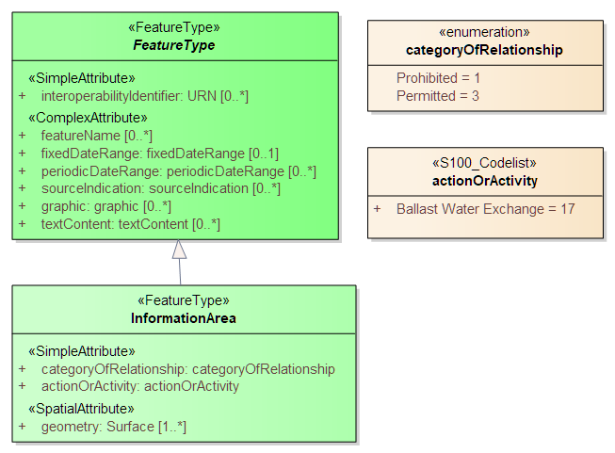

Figure B-6-1 – UML diagram depicting part of the S-122 Application Schema (from S-122 Edition 2.0.0)

* 1. Relationship to the General Feature Model

The General Feature Model is a conceptual model for features, their characteristics and associations; and acts as the basis for the structure of Feature Catalogues. Feature and information types in the Application Schema must be realizations of the meta-classes S100_GF_FeatureType and S100_GF_InformationType from the S-100 General Feature Model (GFM) (S-100 Part 3, Figure 3-1); or subclasses of a class that realizes the appropriate meta-class. Attributes must be realizations of the thematic or spatial attribute meta-classes defined in S-100 Part 3, Figure 3-2; or subclasses of a realization. Product Specifications may define local root classes from which all their feature and information classes are derived, as shown in Figure B‑6‑2 below; or may realize feature and information type classes from S100_GF_FeatureType and S100_InformationType.

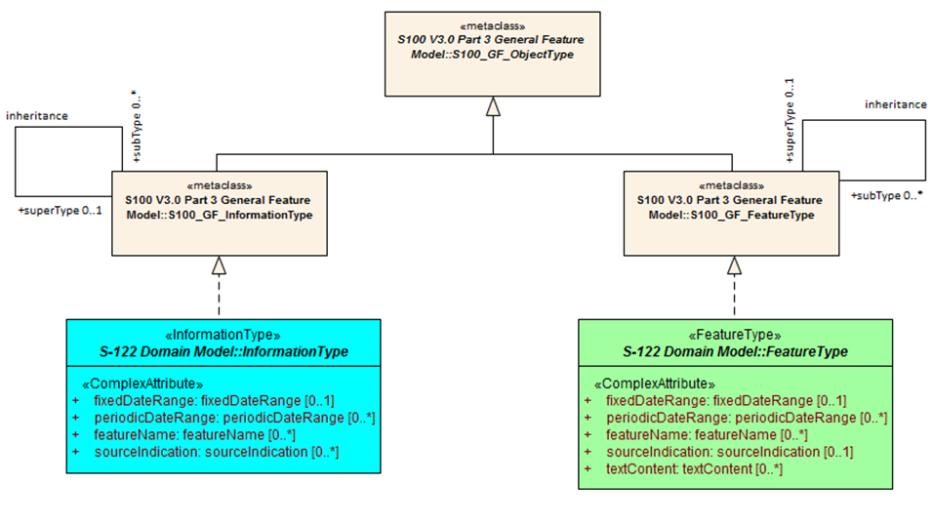

Figure B-6-2 – Example of realization from S-100 GFM

* 1. Rules for Application Schemas

S-100 rules for Application Schemas are based on ISO 19109. The S-100 rules for Application Schemas are defined in S-100 Part 3, clauses 3-6 and 3-7.

* + 1. Application Schemas for vector data

Application Schemas for vector data should follow the guidelines as described below. S-100 Part 3, clause 3-6 describes the rules for Applications Schemas in greater technical detail:

* Features, information types, and complex attributes must be modelled as classes.
* Relationships are modelled by UML associations or association classes (the latter only when the association itself is characterized by attributes – see clause B-7.5.4.2 in this document).
* Attributes are modelled by UML attributes in the appropriate class.
* Associations must be labelled (have association names). Navigable association ends must also be labelled (should have role names).

NOTE: Diagrams may suppress depiction of labels for clarity and to reduce clutter. Labels may be defined by specific rules given in the Product Specification text instead of the UML diagram (for example a Product Specification is allowed to ‘label’ an association end using a statement like “The role of *FeatureX* in all its associations is *theFeatureX*” (see S-100 Part 3, clause 3-5.4.5 on default names for association ends).

* Spatial attributes must be modelled either as attributes with data type one or more (that is, union) of the allowed spatial types in the spatial schema, or an association between the class that represents a feature and one of the spatial objects defined in the spatial schema.
* Enumeration types and their listed values must be modelled by UML enumerations; codelists must be modelled as UML classes with tags specified in S-100 Part 3, clause 3-6.7.
* Standard schemas (for example the spatial schema, Feature Catalogue schema) must not be extended within Application Schemas.
* All classes used within an Application Schema for data transfer shall be instantiable. This implies that the integrated class must not be stereotyped <<interface>>.
* A UML Application Schema must be described within a UML package, which must carry the name of the Application Schema and the version stated in the documentation of the package.
  + 1. Application Schemas for coverage data

The rules for Application Schemas for coverage data are described in S-100 Part 3, clause 3-7; and Part 8.

The rules are similar to the rules for vector data, with the following difference:

* Spatial types for coverage features are modelled by the appropriate point set, grid, or TIN type defined in S-100 Part 8.
* If the Product Specification extends the Part 8 type with additional embedded metadata, a product-specific intermediate coverage class may be added.
  + 1. Re-use of association and role names

This Guidance discourages reuse of role names in different associations – that is if the association named A0 has roles R0 and R1, there should not be an association named A1 that uses either R0 or R1 as a role name. While technically not prohibited in S-100, this kind of reuse is poor modelling practice and causes ambiguity for implementations as to which feature type(s) are expected to be located at the other end of the binding, necessitating that applications look up the association by name to disambiguate linkages. The reasons will become clear when considering that the GML format in Part 10b uses role names as XML tags for feature associations.

EXAMPLE: Allowing <serviceAuthority xlink:href=”#US890321” xlink:title=”VTSControl”/> as well as <serviceAuthority xlink:href=”#US890321” xlink:title=”RadioControl”/> requires applications to look up the associations by name in the FC to determine whether the feature at the other end should be a VTS authority or a radio service.

Association A0 with the same roles R0 and R1 can however be used as-is to associate another pair of feature/information classes; though this latter practice is not recommended (consider creating an abstract generalization class and applying the association to that generalization class).

* + 1. Additional rules

Names of features and information classes must use their camel case codes.

Vector feature classes must use the stereotype <<FeatureType>> and information classes must use the stereotype <<InformationType>>. A stereotype allows designers to extend the UML model by creating new model elements.

Coverage *type* elements (describing the coverage geometry) compliant to S-100 should use the appropriate stereotype from S-100 Part 8; and Application Schemas for coverage data may depict the data attributes by defining a <<FeatureType>> element with the thematic data attributes and associating it with the coverage type element. Examples of coverage type elements and features are shown in Figure B-6-3.

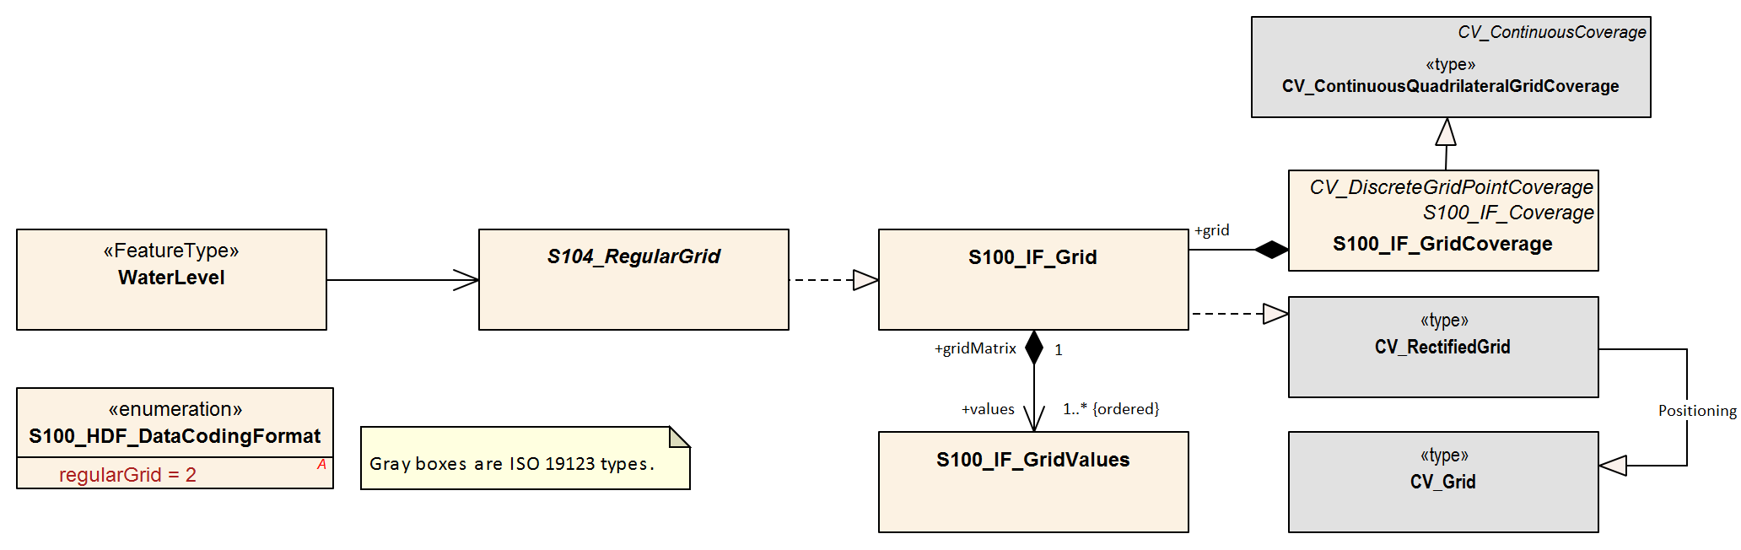

Figure B-6-3 – Example of coverage feature and type elements conforming to S-100 (from S-104 Ed. 2.0.0)

If necessary, Product Specifications may use domain-specific stereotypes in addition to the standard stereotypes.

Abstract classes are indicated by italicizing the class name (Enterprise Architect does this automatically if the “Abstract” checkbox is checked in the UI).

S-100 states that “the use of multiple inheritance shall be minimized, because it tends to increase model complexity”. Multiple inheritance is the situation where a class has more than one immediate superclass. Application Schema developers should note that multiple inheritance contravenes the S-100 GFM, which allows feature and information types to have at most one super-type.

* 1. Other conventions and recommendations
     1. Reuse and harmonization

Before new elements are defined the IHO GI Registry should be checked for existing elements that can be re-used. The following should be also considered:

* Features, information types, and attributes should be re-used whenever possible.
* Structure and associations should be harmonized with S-101 and other existing related or complementary products.
* Defining similar but slightly different items should be avoided unless absolutely essential.
* Extensions such as additional listed values in an enumeration can be proposed to the IHO GI Registry, but conflicts such as different definitions for the same terms must be avoided if at all possible.
* Existing items may be reused with the addition of product specific constraints, such as limiting the set of allowed values for an enumeration or codelist type. Such harmonization includes, for example, re-using complex attributes defined in other Product Specifications with restrictions that exclude some of their sub-attributes.
  + 1. Features and information types

A feature class is “an abstract representation of real-world phenomena” (S-100 Part 3, clause 3-5.1.1). The Application Schema should define a feature class for describing:

1. A concept whose instances have a spatial (geographic) location. Such a class represents a **geographic** feature.
2. A concept whose instances are collections of the above. The collection may consist of instances of one such class or several such classes. Depending on the nature of the collection, the concept will be either an **aggregation** feature or a **composition** feature. In Application Schemas they are treated like geographic features but may or may not have a spatial attribute.
3. Cartographic information (such as feature names, labels, compass roses, legends) that are intended to be positioned at a specified location (or re-positioned from its default position relative to a feature) to avoid obscuring other features. Though not a representation of any real-world phenomenon, such information is also modelled as a feature and treated as a feature in the Feature Catalogue. Such features are called **cartographic** features. The information to be displayed may be encoded in an attribute of the cartographic feature class or identified by reference to another feature class.
4. Meta-information or metadata pertaining to all features (or defined subsets or defined attributes of features) in a particular area. These are called **meta** features.

The S-100 Feature Catalogue model provides a *featureUseType* element for designating feature types as “geographic”, “cartographic”, or “meta”. Aggregation and composition feature types are designated as being of “geographic” *featureUseType*.

Information types are identifiable objects that can be associated with features or other information types, in order to carry information particular to the associated objects. Information types may be considered classes that are typically used to share information among features and other information types. Information types have only thematic attribute properties.

* + 1. Superclasses and subclasses

Defining abstract superclasses is recommended when 3 or more conceptually similar classes exist in the model. The similar classes have some of the same attributes or relationships; and the allowed values of shared attributes are the same. It is not necessary that the classes bind exactly the same sets of attributes or have exactly the same relationships.

Subclasses inherit both associations and attributes, unless explicitly overridden. While overriding is permitted, it introduces additional complexity in data formats and implementations. Instead of overriding, the model should be changed to move the attribute or association down in the hierarchy and assign it only to classes where its use is permitted.

* + - 1. Superclasses versus category attribute

There are different ways of modelling the same item. For example, in order to indicate different buoy types, either the subclass approach or the enumeration approach (categoryOf) can be used. Both approaches are depicted in Figure B-6-4.

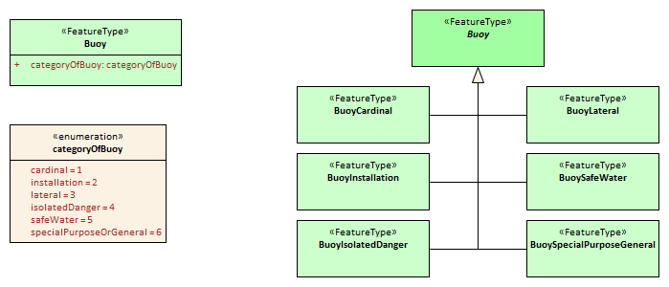

Figure B-6-4 – Illustration of alternative models using category attribute and sibling subclasses

It is up to the Product Specification development team to determine which approach best suits their needs. In order to determine this, consideration should be given to the following issues:

1. Will either approach result in a significant divergence from some external source?
2. Will the “category attribute” approach cause issues for portrayal because the symbols for the different types are presumably different? Or will the subclass approach result in unnecessary portrayal rules because the symbols are the same?
3. Will any of the subclasses have its own specific attributes or relationships? If so, the sub-class approach is preferable.
4. Are the different categories/subclasses in (or likely to be placed in) different viewing groups, or have different drawing order? If so, there is a slight preference for making subclasses. (Only “slight” because the portrayal rules and Interoperability Catalogue can use attribute values in assigning viewing groups to feature instances.
5. If subclasses are used, will that introduce situations where it may be necessary to encode coincident objects with different categories? The answer “Yes” suggests a preference for the categoryOf... approach.
6. Are the subclasses conceptually very different? “Yes” implies the sub-classes approach.
7. Which approach is likely to be compatible with external resources like existing databases and implementations?
8. If there are a large number of subtypes, then the categoryOf... approach may be preferable because it leads to more compact representations in UML diagrams and more compact DCEGs. (“Large” is obviously subjective, but will generally between 5 and 9 based on research into human cognitive psychology and probable implementation methods in user interfaces – there will be variations dependent on concept semantics and similarities.)
9. Overall complexity of the Application Schema and Feature Catalogue. Sibling subclasses of features (or information types) generate more artefacts and documentation than a category attribute. They certainly mean an additional table for each subclass in the DCEG; an additional XML element for each in the Feature Catalogue; and a box in the UML diagram Application Schema for each class. To that extent sibling subclasses are a greater cognitive burden on encoders and developers.
   * 1. Associations and association classes
        1. Navigability, source and target

Association navigability should be indicated if the association is navigable in only one direction; that is, the model designer expects applications to access one object from the other, but not vice versa. Feature/feature and information/information associations are usually navigable in both directions, while feature/information associations must be navigable from the feature end but are not required to be modelled as navigable in the other direction. UML regards navigability information in UML diagrams as hints to implementations rather than hard requirements; and implementations and data formats are free to implement navigability in the most efficient manner.

Unidirectional navigability will normally also determine the source and target of the association.

An association’s source and target should be grammatically and semantically compatible with the name and definition of the association; for example, for the association Person/subscribes/Magazine the source should be Person and the target Magazine.

For feature/feature associations both ends should be named; for feature/information associations the information end should be named and the feature end may be named. This is an S-100 requirement, not a UML requirement.

* + - 1. Association classes

Association classes are a means of adding parameters (characteristics) to associations, rather than to the classes at the end of an association. An attribute of the association class characterizes the relationship between the classes at the ends of the association.

The use case for association classes is basically “whenever a relationship is characterized by one or more attributes”.

EXAMPLE 1: A specified set of vessels is COVERED by a regulation and another set of vessels is EXEMPT from the regulation. The sets of vessels are described by an information type class; the regulation by another information type class; and the relationship between them by an association class which has an attribute characterizing the relationship as inclusion or exclusion (of the specified subset in the specific regulation). This relationship is modelled by the **InclusionType** association class in Figure B-6-5 below.

EXAMPLE 2: Vessels with specified cargo and dimensions must use a specified pilot boarding place; vessels of smaller dimensions are recommended to use the boarding place; and warships are exempt from using the pilot boarding place. The sets of vessels are described by an information type class; the pilot boarding place is a feature class; and the relationship between them by an association class which has an attribute stating whether the specified set of vessels is required/recommended/exempt from use of the pilot boarding place. This relationship is modelled by the **PermissionType** association class in Figure B-6-5 below.

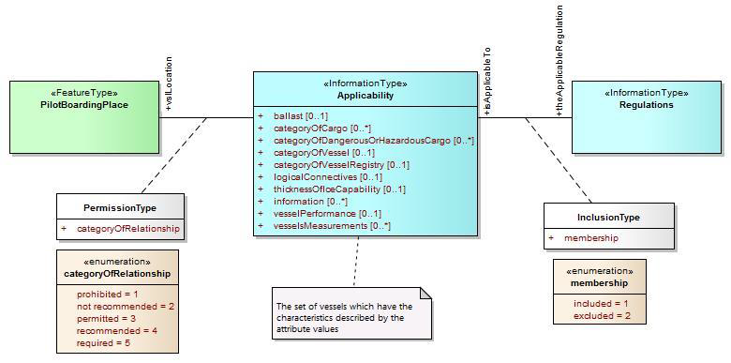

Figure B-6‑5 – Examples of modelling with association classes

* + 1. Attributes in general

Certain attributes may use the same set of listed values as other attributes. For example, an enumeration for compass points may be shared by the attribute **windDirectionCompassPoint**, which is the direction for where wind is coming from; and **directionOfMovement**, which is the attribute describing where a weather system is going toward. At present this can be simply handled in the attribute's definition.

Complex and spatial attributes can be modelled as either named attributes in the UML model class element with a type corresponding to the spatial primitive or the name of the complex attribute; or alternatively, separate model elements linked to feature/information class by an association (ordinary association for spatial type, composition for complex attributes). The two methods are illustrated in Figure B-6-6 below. The second method is not suitable for complex models due to the additional boxes and association lines.

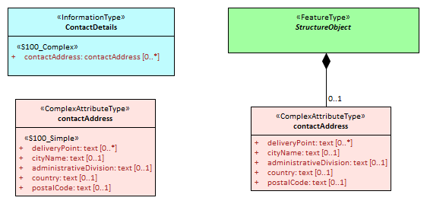

Figure B-6‑6 – Methods of representing complex attribute bindings

* + 1. Codelist and enumeration attributes

Codelists should be used only when an enumeration is either unusable or inefficient (for example, if the full list of values is not known to the Product Specification authors or the list of allowed values is long, volatile, controlled by another authority and/or shared by multiple domains).

Individual members of a codelist or enumeration (“listed values”) are generally meaningful only in a given context (or “container”), which is a specific (named) enumeration. The context corresponds to an attribute concept.

The sub-clauses below discuss modelling considerations. For format considerations, see clause B-13.4.

* + - 1. Choosing to use a codelist or enumeration type

When deciding between using a codelist and enumeration, consider the completeness, stability, source, reuse, and application dependencies of the list of values.

* If the set of allowed values is fixed and reasonably short (fewer than 20 values), an enumeration must be used.
* If the list is fixed but long, an enumeration is preferred but a “dictionary model” codelist may be used.
* If only the likely values of an enumeration are known, or the list may be extended by data producers or the user community, a codelist must be used. Whether the “dictionary” or “open” form is preferable depends on who might add values – if it is maintained by an organization, the dictionary form is preferable, if user communities or data producers may add values, the “open” form is preferable.
* If the allowed values change frequently and the list should be updated without major revisions of the product specification, a codelist may be used. The “dictionary” form may be preferable under these circumstances.
* If application logic or portrayal rules depend on values, an enumeration is preferred but a codelist may be used if the logic/rules can be written to cover all possible values (for example, using wildcards or defaults), or otherwise allow graceful recovery from unanticipated values.
* Collections which have internal structure (e.g., types and subtypes of vessels) should be modelled as “dictionary” codelists, pending discussion of the matter by ISO TC211.
  + - 1. Hierarchies of codelists

A codelist may also be used as a super-type for more specific codelists. The vocabulary of the super-type is the union of the vocabularies of its sub-types[4]. If additional values are permitted the super-type must be an “open enumeration” or “open dictionary” codelist. Practically, this allows vocabularies developed by different domain expert groups or organizations to be merged.

* + - 1. Codelists maintained by external organizations

If there is an existing well-established codelist maintained by a responsible source, it can be referenced in an application schema. The codelist should meet the following requirements[5].

* It must be managed by a responsible source – an official national or international standards body, long-established user community, group, or consortium;
* The codelist and its values must be identified by persistent HTTP URIs;
* The list should be well-maintained, meaning all its values must remain available forever, even if they have been deprecated, retired or superseded;
* The list should be in a dictionary language accepted for use in S-1XX product specifications.

The IHO may be requested to arrange for the translation, reproduction, and maintenance of codelists meeting only some of the above requirements. Note that this may necessitate a discussion between the IHO and the source.

* + 1. Labels and definitions for listed values

Labels should be short but informative, keeping in mind that both end-users and encoders may leverage them. Implementers of end-user display and production tools are likely to use listed value labels as ‘tooltips’ or explanatory text, or as the ‘display text’ of the attribute numeric code value for end-users. End-users are more likely to see labels than full definitions due to other demands on their attention and screen display constraints.

* + 1. Data types

S-100 defines a set of primitive and derived data types in a Table included in Part 2a, clause 2a-4-10. Attribute values of thematic attributes should be one of the types listed in this Table. If restrictions on the values are needed, Product Specifications may define constraints, if possible encoded using one or more of the elements in S100_CD_Constraints (length, range, pattern, and precision). Constraints which cannot be encoded must be documented as a ‘Remark’ or note.

The data types defined in S-100 can in principle be extended by Application Schemas but if this is done the Product Specification must define the extended data type in terms of the predefined data types in S-100 and use the predefined data type in the Feature Catalogue. Data formats may use their equivalent built-in types which are defined in the underlying format standard (for example HDF5 and XML built-in types) in order to leverage standard data validation software, provided the equivalence is documented either in the Product Specification or the underlying format standard.

* + 1. Codes for listed values

Numeric codes *must* be positive integers; and *should* be in the range 1-254 if possible (to allow data formats and implementations to use compact representations – however codes up to 65535 are allowed). Codes used for retired listed values can only be used if the proposal is a revision (supersession) of the retired listed value.

The IHO GI Registry also allows specification of alias and camel case codes for listed values. The camel case field should be completed with a camel case code derived from the label, beginning with a lowercase letter. The guidelines for camel case codes are specified in S-99 Annex A.

* 1. Recommended practices
     1. Reviews of model elements and structure

Models should be reviewed at regular intervals while under development, with reviews involving domain experts as well as information modelling experts.

* + 1. Diagram layout

Common ‘best practices’ for layout of UML diagrams should be followed. In particular, diagrams should not contain too many elements; should minimize line crossings; and use vertical layouts for hierarchies (or left-right horizontal layouts if a vertical layout does not work). Lines representing associations should minimize the use of curved segments.

* + 1. Colour coding of model elements

Colour coding should be used to distinguish diagram elements for features; information types; enumerations and codelists; complex attributes; association classes; and constraints and notes. Abstract types should be indicated by darker shades.

Figure B-6-1 and Figure B-6-5 illustrate the use of colour coding to depict different kinds of UML elements. Compare the shades of the non-abstract feature and information classes in these figures to the abstract feature and information classes in Figure B-6-2.

S-100 departs from ISO TC211 recommendations for the use of black-and-white-only UML diagrams in order to distinguish between feature and information types (the concept of information type is unique to S-100).

* + 1. Documentation tables

These may be formatted like the UML schema documentation tables in S-100 or generated by the UML software. Whichever method is used, the documentation must document the classes, attributes, enumeration and codelist types; and associations in the Application Schema, including names, definitions, multiplicities, data types and roles.

* + 1. Recommended software tools

The S100 Working group recommends using Enterprise Architect™ to develop the UML Application Schema(s). Other UML tools or special templates in off-the-shelf editors may also be used but are likely to have minor differences in UML notations which will need to be adjusted or explained in the Product Specification.

XML data including Feature Catalogues and metadata is easier to view in open-source or COTS XML software rather than ordinary text editors.

* + 1. Identification of models

The identification of each Application Schema must include a name and a version. If there is only one Application Schema in the Product Specification, this identification is implicit in the name and version of the Product Specification. Product Specifications with more than one Application Schema must identify each, potentially by associating it with a scope.

1. Data Classification and Encoding Guide

The DCEG includes the collection criteria for mapping real world objects to the conceptual objects of the dataset.

Any organization performing data capture for the data product defined by the Product Specification must provide references to any more detailed encoding guide used in addition to that indicated in the Product Specification for the capturing process.

Product Specification developers are encouraged to provide encoding instructions in DCEGs especially for editions after the initial 1.0.0 edition. Encoding instructions are text and/or pictorial/diagrammatic information describing how particular cases should be encoded and describing any applicable constraints on features, information types, associations and values. Such additional constraints cannot always be expressed in the feature catalogue model, for example as conditionally mandatory attributes or requirements that at least one of the sub-attributes of a complex attribute be populated. In addition, encoding instructions should address real-world situations and explain how they can be translated into the feature-attribute-association paradigm of application schemas and feature catalogues, as well as addressing potential special circumstances, pitfalls and interactions with other information in the dataset or other products.

1. IHO GI Registry

Procedures for registration are explained in S-99. It is recommended that at least one member of the Project Team or Working Group register as a Submitting Organization. Submitting Organizations propose changes and additions to the contents of Registers. Submitting Organizations will normally represent a recognized body or stakeholder group (such as from government, industry, academia and relevant user groups). Registered Submitting Organizations may submit proposals for consideration under any Domain in a Register. Stakeholders and any other interested parties who do not wish to enrol should submit proposals through an existing Submitting Organization.

To harmonize with other Product Specifications, developers should propose extensions to existing Registry items where possible. For example, propose generalization or specialization of an existing element; or additional values in an enumeration or codelist type. Restrictions of existing types can become new sub-types rather than changes to an already defined type; or it may suffice to define a constraint in the Product Specification.

1. Feature Catalogue

The Feature Catalogue is an XML document which conforms to the S-100 XML Feature Catalogue Schema. Note, for Imagery and Gridded Data, a coverage is a feature type; and a Product Specification Feature Catalogue should define the attributes, coverage feature (with spatial primitive type ‘coverage’).

While feature catalogues can be constructed using the Feature Catalogue Builder in the IHO S-100 Toolkit, Product Specification developers must review and update the result for completeness and conformance to the Application Schema. Updates outside the FCB are best done with XML editor software. The following aspects in particular may need attention.

* The header section, for use of the correct namespace and feature catalogue schema location. The XML FC must use the appropriate version of the FC schema for the S-100 version used in the Product Specification. (Note that the namespace and location in the S-100 generic schemas are not updated unless the schema changes.)
* Permitted values in enumeration and codelist attributes: Review the list of permitted values in both the attribute type definition and bindings to ensure that all and only the values specified in the application schema are present.
* Ensure units of measure and constraints are added to numeric attributes to which they apply. At present the FCB does not obtain this information from the registry. Furthermore, many constraints are product-specific, for example text pattern constraints on the names of support files.
* Pending proposals which are still in the approval process may not be applied.
* Registry entries which have been superseded are replaced by the latest versions by the FCB.

While the feature catalogue is under development, the Schematron rules for feature catalogues which are provided on the schema server may be used for additional checking. Using the Schematron rule with XML tools may require adding a processing instruction at the top of the XML FC pointing to the rules file, for example:

<?xml-model href="https://schemas.s100dev.net/schemas/S100/5.2.0/S100FC/20240515/S100_FC.sch"?>

to reference the 5.2.0 Schematron rules file for feature catalogues. This processing instruction can be removed after the FC is finalised.

For review purposes during Product Specification development, a human-readable document generated from the XML FC may be useful. Such a document can be generated from the FCB or by external means.

1. Data transfer modes and packaging

Define mode of delivery – exchange set, message, or service. A Product Specification may also specify more than one delivery mode.

This needs to be done before metadata is specified because some metadata elements as well as the treatment of metadata (for example separate versus embedded) depend on delivery mechanisms, constraints, and protocols.

Details of packaging and transfer content can be finalized in a later stage (see clause B-18).

1. Metadata

The minimum metadata requirements are set forth in Part 4a of S-100. Product Specification developers should consider whether the metadata elements listed in S-100 are relevant to the data product and which of them are appropriate for its allowed packaging and delivery methods. For relevant elements, define appropriate values and restrictions if necessary for the metadata elements listed in S-100 Part 17

* 1. Metadata for exchange set products

This section describes metadata for products that are delivered in exchange sets.

* + 1. Generic metadata model

S-100 provides for S-100 discovery metadata for exchange sets to be encoded in the Exchange Catalogue. Figure B-11-1 below depicts an example of relevant cases. The latest approved S-100 discovery metadata model is located within the latest edition of S-100 Part 17.

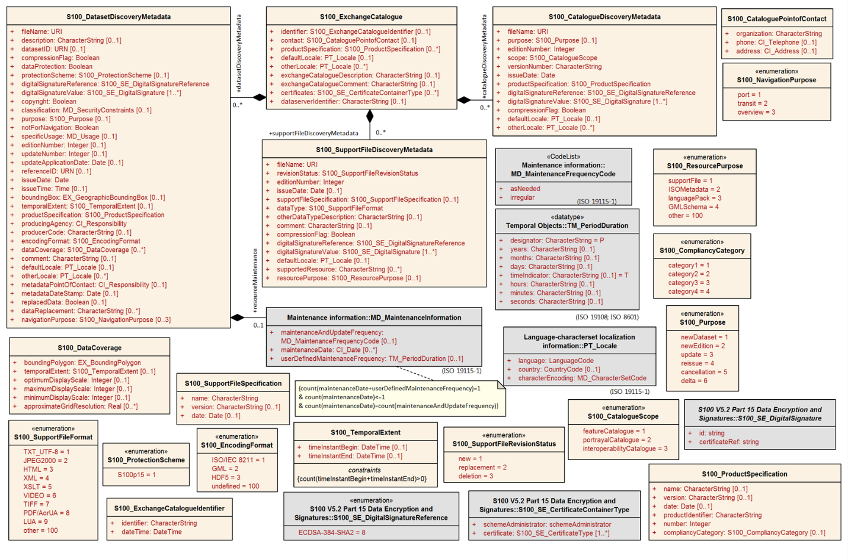

Figure B-11‑1 – Exchange Catalogue and discovery metadata classes

If additional metadata elements are required they should be documented in the Product Specification Metadata section and extensions to the generic metadata schemas developed using the standard ISO extension mechanism.

Extension of S-100 metadata defined in Part 17 is prohibited for data products intended for ECDIS use and covered by S‑98 (S‑100 Part 4a, Appendix 4a-D). Any CATALOG.XML file which is valid according to the rules of the Product Specification must also be valid when checked using the S-100 generic schemas. Note that this does not prohibit restriction of S-100 metadata.

For other data products, extension is not prohibited by S-100 Appendix 4a-D but is discouraged by these guidelines. Prior to the creation of extended metadata, a careful review of the existing metadata within ISO 19115-1 [and the S-100 generic metadata model] must be performed to confirm that suitable metadata does not already exist. If suitable metadata exist within ISO 19115-1 [or the generic S-100 metadata model], then it must be used. (S-100 Part 4a, Appendix 4a-D.)

IHO metadata XML schemas for Exchange Catalogues and discovery metadata have been developed and are available at the IHO schema server (https://schemas.s100dev.net)..

An Exchange Catalogue Builder to be provided by IHO is under development. Exchange Catalogues can also be prepared using off-the-shelf commercial and open-source XML editing and authoring tools. Generic tools for ISO metadata can be used for ISO metadata files for each dataset (the ISO metadata files are separate from, and referenced by, the Exchange Catalogue XML files). The schema server has links to online documentation showing the elements and structure of Exchange Catalogues as well as a sample generic Exchange Catalogue.

* + 1. Use of the IHO S-100 generic metadata model and schemas in Exchange Catalogues

Product Specifications use the generic model in S-100 Part 17 and the IHO generic schema for exchange catalogues with product-specific restrictions as defined in the Product Specification. Custom UML diagrams similar to S-100 Figure 17-7 may be included in Product Specifications at the discretion of the responsible project team or working group.

S-100 Part 17 specifies which of the S-100 metadata classes and attributes are mandatory and which are optional.

Product Specifications may define product-specific subsets of metadata by restricting the S-100 model. Restrictions on S-100 classes and attributes must be expressed as constraints applied to the S-100 model and generic schemas. Restrictions may include making an optional attribute mandatory, using a subset of attribute values permitted by S-100, or prohibiting an optional class or attribute. Further restrictions of the Exchange Catalogue elements would typically be:

* Omitting a class (for example S100_SupportFileDiscoveryMetadata).
* Omitting optional attributes of a class (for example attribute updateNumber in class S100_DatasetDiscoveryMetadata).
* Changing the multiplicity (for example mandating multiplicity 1 instead of 0).
* Constraining values in an enumerated attribute (for example only using category3 and category4 values in S100_CompliancyCategory).
* Conditional mandatory described in Remarks (for example issueTime being mandatory when the interval between datasets is shorter than 1 day, such as 6 hourly forecast).
* Mandated text for CharacterString attributes (for example S100_ProductSpecification attribute name mandated to be “Surface Currents” for S-111).

If a Product Specification further restricts the Exchange Catalogue elements, an XSD file reflecting the Product Specification specific Exchange Catalogue should be provided as a Product Specific component, as per the guidance in S-100 Edition 5.2.1 Part 17. The naming convention for the XSD as specified in S‑100 Edition 5.2.1 Part 17 is:

nnn-x-y-z.xsd

where:

* nnn reflects the number of a Product Specification (e.g. 101).
* x reflects the Edition number.
* y reflects the Revision number.
* z reflects the Clarification number.

In order to implement a product-specific metadata model, the S-100 XML schemas that encode generic S-100 metadata can be supplemented with executable constraint checks to apply product-specific restrictions, in Schematron[6] or another language. Such executable constraints can be separated from the generic schemas, customized for each Product Specification, and evolve without affecting the generic schemas. While Schematron is a popular means of implementing such constraint checks, it is not the only means – XSLT transforms, for example, are an alternative implementation method.

Product-specific customization can be implemented by adding supplementary files to the S-100 generic implementation.

Table B-12-1 below describes how Product Specifications can describe their metadata models. The actions are elaborations of the allowed extensions listed in S-100 Part 4a, Appendix 4a-D. The UML diagram would be based on S-100 Figure 17-7.

Product Specifications must define their metadata models by reusing the S-100 generic metadata model and defining product-specific constraints.

Table B-12-1 – Specifying metadata in Exchange Catalogues for individual Product Specifications

| **Action** | **UML diagram** | **Documentation table** | **XML implementation** |
| --- | --- | --- | --- |
| Omit an optional class or attribute | Suppress its display using diagramming tool functionality. | Omit the corresponding table or row. | Rule to check that the XML element is not present. |
| Make an optional class or attribute mandatory | Alternative methods:  1) No change. The multiplicity will still be 0.. but a diagram note may be added stating that it is mandatory in this product.  2) Redraw the diagram with the multiplicity lower bound changed to 1. | Multiplicity column should have the mandatory multiplicity and the Remark column a remark stating it is mandatory in this product. | Rule to check that the XML element is present. |
| Restrict multiplicity (general) | As for the previous row, with appropriate modifications to multiplicity upper and lower bounds.  This is the general case of making an optional attribute mandatory. | | |
| Limit enumeration values to a subset | Suppress display of excluded values using diagramming tool functionality. | Omit the corresponding row. | Rule to check that the value is not used. |
| Restrict the value of a text, numeric, CharacterString attribute | No change required. | Specify the value in the Remark column. | Rule to check that the value is as specified. |
| Add a new metadata class or attribute  Not permitted for EDCIS data products (S-100 App. 4a-D) | Specialize the appropriate S-100 metadata class and add the new class or attribute. | Add a new documentation table, or extend the table describing the original class. Inherited attributes should be distinguished from direct attributes. | Additional XSD that imports the generic metadata XML schema and extends its types. |
| Add a new metadata package in the Exchange Catalogue.  (Note: Whether the new package must be in the Exchange Catalogue or the ISO metadata depends on product-specific considerations like its expected use in applications)  Not permitted for EDCIS data products (S-100 App. 4a-D) | Add the class or classes for the new package and aggregate to a specialization of the Exchange Catalogue container class (S100_ExchangeCatalogue). | New tables for the new classes and extended catalogue container class. | As specified in ISO 19115-3 and S-100 clause 4a-5.7.5). If required in the Exchange Catalogue, additional XSD that imports the generic metadata XSD and extends its types. |
| Add a new metadata package only in ISO metadata  Not permitted for EDCIS data products (S-100 App. 4a-D) | Diagram(s) extending S-100 Figure 17-7 and specifying new classes and attributes. | New tables for the new classes. | Describe the extensions in the ISO 19115-3 metadata extension format and extend the ISO metadata XSDs with new types. |
| Add values to an enumeration  (Consider proposing its addition to S-100 generic metadata via an S-100 maintenance proposal instead of a product-specific extension)  Not permitted for EDCIS data products (S-100 App. 4a-D) | Specialize the relevant S-100 metadata class and override the affected attribute. | Describe the override and new data type in the appropriate tables. | XML schema override in a derived XSD. Ignore any warnings generated by generic constraint-checking rules. Define new constraint-checking rules if necessary. |
| Create new metadata codelist elements (expand a codelist)  Not permitted for EDCIS data products (S-100 App. 4a-D) | Expand codelist in diagram(s). (Some codelists like languages may be too long for a UML diagram.) | Add codelist values to codelist table (if any), or document the new values using another method. | Add new value to appropriate codelist and GML dictionary files. |
| Create a new metadata codelist to replace the domain of an existing metadata element that has “free text” listed as its domain value (Note: Simply restricting the character strings as described in an earlier row is a simpler solution)  Not permitted for EDCIS data products (S-100 App. 4a-D) | Specialize the relevant S-100 metadata class and override the affected attribute. Add a codelist UML element documenting the codelist. | Document the specialization and new codelist in appropriate tables. | XML schema override in a derived XSD. Ignore any warnings generated by generic constraint-checking rules. Define new constraint-checking rules if necessary.  Add new codelist to appropriate codelist and GML dictionary files. |
| No value for a mandatory attribute  Not permitted for EDCIS data products (S-100 App. 4a-D), except that string type attributes may be 0-length strings. | None. | Specify that the mandatory attribute must be nilled or assigned one of the allowed values as a fixed default. | Rule to check the value. |

If extending or restricting metadata, Product Specifications should not clone and rename classes, attributes, and enumerations defined in the generic model. This requirement helps keep product-specific and generic S-100 metadata harmonized as both S-100 and the Product Specifications evolve over successive versions. Cloning and renaming classes and attributes will result in branching metadata models and schemas. The divergence of metadata branches will increase as both S-100 and Product Specifications evolve over successive versions. One consequence will be a need for implementations to have independent product-specific metadata processing modules. This situation would be undesirable for products that are processed by the same application (such as generic viewers, ECDIS, or ECS).

A typical Product Specification Exchange Catalogue UML diagram is reproduced in Figure B-11-2 below. Compare to Figure B-11-1, noting the omission of attributes not used in S-104 and restrictions of support file format and data format enumerations.

A sample generic Exchange Catalogue file is available on the IHO schema server.

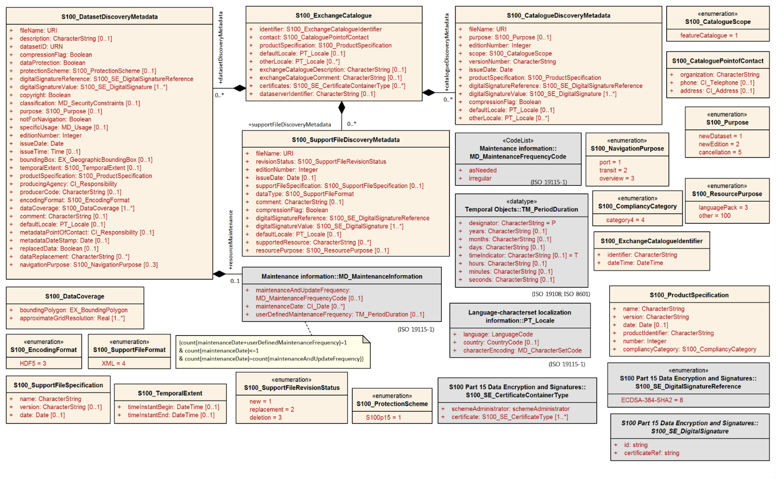

Figure B-11-2 – Example Exchange Catalogue metadata classes for S-104 Edition 2.0.0 (Water Level Information for Surface Navigation)

* + 1. Extensions in ISO metadata files

S-100 Part 4a, clause 4a-5.7.5 specifies how extensions must be documented. This specification is derived from the ISO Specification.

Product Specification authors are reminded that ISO metadata files are not intended to be used on ECDIS, but may be optionally included to support wider interoperability with other user communities or to fulfil ISO metadata requirements where needed (S-100 clause 17-4.3.2).

* + 1. Data protection, authentication and encryption

The purpose of data protection in S-100 is threefold:

1. Piracy protection: To prevent unauthorized use of data by encrypting the product information.
2. Selective access: To restrict access to only the products for which a customer has acquired a license.
3. Authentication: To provide assurance that the products were actually created and distributed by the producers and distributors who are identified as such in the product package or datasets.

Piracy protection and selective access are achieved by encrypting the products and providing data permits to decrypt them. Data permits have an expiration date to enable access to the products for a licensed period. Authentication is provided by means of digital signatures applied to the product files. Selective access to individual products is supported by providing users with a licensed set of data permits. The license is created using a unique hardware identifier of the target system and is unique to each Data Client. Consequently, licenses cannot be exchanged between individual Data Clients.

Authentication is achieved by means of digital signatures, which are now required in Exchange Catalogues for each dataset, support file, feature and portrayal catalogue. (Portrayal catalogues are signed after a zip archive containing the whole portrayal catalogue is created.)

* + - 1. Application of protection measures

Product Specifications should specify whether datasets must, must not, or may be encrypted using the S-100 recommended security scheme, which utilizes the *dataProtection* attribute of **S100_DatasetDiscoveryMetadata**. If this Boolean attribute is set to TRUE the co-attribute *protectionScheme* must also be assigned a value from the enumeration of security schemes (**S100_ProtectionScheme**). S-100 at present defines only one recommended security scheme, which is described in Part 15.

* + - 1. Digital signatures

S-100 Parts 15 and 17 mandate digital signatures for datasets, support files, and catalogues in exchange sets. Signing datasets is independent of whether the recommended security scheme is applied to the dataset.

The digital signature method is encoded in attribute *digitalSignatureReference*. There is also an attribute *digitalSignature* for encoding the digital signature itself. These attributes are present in dataset discovery metadata, catalogue metadata and support file discovery metadata (classes **S100_DatasetDiscoveryMetadata**, **S100_ExchangeCatalogue**, and **S100_SupportFileDiscoveryMetadata**). The structure of the digital signature is specified in S-100 Part 15. S-100 Part 17 is quite permissive as to the format, allowing either well-formed XML (one or more XML elements from an unspecified schema) or a character string (for example base64 encoded signature) – this means that the validity of the signature as a signature must be checked by means other than XML schema validation.

* + - 1. Compression and archive format

Compression of data products as used in S-100 Parts 17 and 15 includes specification of the archive format as well as the actual file compression method. In S-100 there is only one archive format (ZIP) and only one allowed compression method (DEFLATE). Compression requires packing into an archive. Product Specification authors must specify whether an exchange set must, must not, or may be compressed by specifying appropriate constraints on the *compressionFlag* metadata attribute in Exchange Catalogues. Further information about archive format and compression method is provided in S-100 Part 15. S-100 provides for Exchange Catalogues to have only one instance each of the *compressionFlag* attribute, which therefore applies to all files in the exchange set (that is, after compression, there will be only one ZIP archive which contains all data files, support files, and catalogues in the exchange set, with the DEFLATE compression method applied to all[7]).

Product Specification authors should note that an exchange set may contain other exchange sets. Each included exchange set can be treated as an individual item for compression purposes (that is, packed into a ZIP archive or not), but they will all be packed into the archive of the overall container exchange set, either as a folder hierarchy or single-file ZIP archives, depending on whether they are individually compressed.

The encryption and digital signature features of ZIP are not used.

* + 1. Metadata for imagery and gridded data

Exchange set metadata for Product Specifications dealing with imagery and gridded information is the same as for vector datasets (clauses B-12.1.1 – B-12.1.4), extended with an additional metadata attribute for grid resolution.

The Exchange Catalogue for coverage products should be developed in the same way as for vector products – by restricting the S-100 Exchange Catalogue model to prohibit unneeded elements and attributes, add product-specific constraints and specify product-specific values for relevant attributes.

* + 1. Embedded metadata

Certain metadata may be embedded in dataset headers (ISO 8211 and GML formats – S-100 Parts 10a and 10b) or defined attributes and groups (HDF5 format – Part 10c). While specifying embedded metadata is up to individual Product Specifications, this guideline recommends that only metadata considered essential to identifying and reading the dataset should be embedded. Examples are dataset name, persistent global identifier and MRN (if any); as well as bounding box, number of objects of each type and CRS identification. Gridded data products may encode spatial representation information such as grid spacing and grid bounding box as metadata for individual features. Gridded data products may also encode structural metadata such as a code indicating the type of grid (regular, irregular, etc).

* + 1. Discovery metadata case-by-case instructions

While the metadata section covers all the cases and values pertaining to metadata for new editions, updates, reissues, and cancellations of datasets and support files, it can be difficult for application and tool developers to figure out what metadata to use when and what values metadata fields must have under different circumstances. Product Specification authors are encouraged to describe each such scenario (new edition, update, etc.) in separate sub-clauses, describing:

* The circumstances in which a dataset must be issued as a new edition, updated, reissued, or cancelled.
* What metadata must be provided within the Exchange Catalogue in each scenario, including which metadata classes and attributes are mandatory, which are inapplicable, and what values are appropriate for included metadata attributes.

Such clauses may be easier for application developers and data producers to find when placed under a “Production Processes” section, however their placement in the Product Specification documents is at the discretion of Product Specification developers.

* 1. Metadata for services

This section describes metadata for products that are delivered as services.

* + 1. Generic metadata for services

Generic metadata for services is a work in progress. S-100 Part 4a defines a metadata model for services which conforms to the ISO 19115-1/2 model. S-100 Part 14 defines service metadata differently (**S100_ServiceMetaData** – clause 14-8.1.1). It is left to Product Specifications to determine if servers need to supply service identification metadata in the sense of the underlying ISO standards (reproduced in S-100 Figure 4a-A-2).

Product Specifications needing to define service metadata (identifying and describing the service itself) should use or extend the **SV_ServiceIdentification** class in S-100 Figure 4a-2. Any extensions or restrictions should conform to the ISO rules as described in S-100 Part 4a, Appendix 4a-E.

* + 1. Use of the IHO S-100 metadata model and schemas

S-100 Part 14, clause 14-9.1.3 specifies a *GetMetaData()* operation with *CharacterString* return parameter *exchangeSet* defined as “The exchange set describing the datasets”. It is not clear at this time whether this is the metadata defined in S-100 Part 14, clause 14-8 or the Exchange Catalogue of S-100 Part 17. This can be considered **payload metadata** (metadata describing the transferred information) to distinguish it from metadata that describes the service itself.

If Product Specifications need to define a subset and/or extension of the S-100 Exchange Catalogue to describe payload metadata, they should use the same methods specified in S-100 Part 4a/4b and clause B-12.1 of this Guidance. Note that these sections require conformance to the ISO rules described in S-100 Part 4a, Appendix 4a-D.

* + 1. Data protection, authentication and encryption

Many of the data protection, authentication and encryption provisions of S-100 Part 15 should also apply to services, but details and implementation constraints will differ. For example, a data product may create its transfer package using a format other than ZIP; and the connection protocol may need to be secure (for example HTTPS rather than HTTP). Product Specification teams which need to use security schemes in service transfer modes are encouraged to use or adapt S-100 Part 15 and report on their experiences.

* + 1. Embedded metadata

The considerations are similar as for embedded metadata described in clause B-12.1.6. Additional considerations may arise from the transfer mode; for example, giving greater importance to minimizing data volume. Product Specification teams are encouraged to use or adapt the embedded metadata principles in clause B-12.1.6 and the methods and constraints of the data format which is used (ISO 8211, GML, HDF5, or other format) and report on their experiences.

1. Define data encoding format
   1. Selection of encoding format

The encoding format should be selected based on the type of product and other requirements, including production and processing. The characteristics of the three standard data formats included in S-100 are summarized in Table B-13-1 below for convenience.

Table B-13-1 – Characteristics of S-100 standard encoding formats

|  | **ISO 8211** | **GML** | **HDF5** |
| --- | --- | --- | --- |
| Type of product to which suited | Nautical charts and feature-heavy vector data | Nautical publications and information-heavy vector data; discrete weather information; small datasets such as marine safety information; data delivered via messages and web services | Coverage-based data |
| Generic data format | Yes | Yes | Yes |
| Data production complexity | Requires custom tools | Can be produced with a range of tools from text editors to custom apps and database SQL queries | Custom apps that use off-the-shelf libraries |
| Processing complexity | High | Low | High |
| Supporting off-the-shelf software | Yes | Off-the-shelf viewers and server software; can be viewed with ordinary text editors | Off-the-shelf viewer |
| Data volumes | Lower | Higher | Lower |
| Type of data | Vector | Vector; coverage schemas are defined in the GML specification but not used in S-100 | Gridded |
| Supporting artifacts needed in Product Specifications | Feature Catalogue | XML schemas for data validation; datasets can be processed by apps without XML schemas; self-documented format (tags indicate objects and attributes); Feature Catalogue optional | Embedded object and attribute tags; Feature Catalogue optional |

While other formats than the three standard encodings are possible, the use of a non-standard format has the following implications:

* Loss of genericity, requiring special purpose development by implementers or conversion to a standard format with impacts on performance.
* Potential loss of compatibility with interoperability.

The question of appropriate formats for transactional, web-service, or message-based information has not been formally addressed in depth at this time, but Product Specifications needing such delivery modes should endeavour to use one of the standard formats in order to minimize implementation complexities.

* 1. Data format definition artefacts for GML

Selection of the GML format will require definition of XSD files encapsulating the S-100 Application Schema and conforming to the GML specification (ISO 19136 and S-100 Part 10b). There must be a 1:1 mapping from the Application Schema to XML schema constructs in the GML XSD files that implement the model as GML Application Schemas.

* Feature and information classes in the UML domain model map to XML complex types and XML elements. The class (camel case) name is the same as the element name (XML tag excluding any namespace).
* Simple attributes in the UML domain model map to XML elements contained in the feature and information complex types mentioned above. The names (XML tags, excluding any namespace) are the same as the (camel case) names of the UML attributes.
* Complex attributes in the UML domain model map to XML elements contained in the feature and information complex types mentioned in the first bullet. The names (XML tags, excluding any namespace) are the same as the (camel case) names of the UML attributes. The types of these XML elements are XML complex types with the same (camel case) name, either with or without “Type” suffixed.
* Enumerations map to XML enumerations of the same (camel case) name.
* Codelists map to XML union types of the same (camel case) name; one member of the union type is an anonymous enumeration of the listed values and another member is a string restricted to the pattern “other: ...” as specified in S-100 Part 3, clause 3-6.7.
* Associations are encoded as elements contained in the feature and information complex types, named according to the role indicated in the UML domain model and with a GML attribute that contains the gml:id of the referenced object.
* The *title* XML attribute is now required for associations from feature or information types, for implementation reasons. The value of this attribute must be the alpha code (“camel case”) of the association. This requirement will be enforced by S-158:100 validation checks. (S-100 clause 10b-11.4 provides more information about the attributes for association bindings in GML datasets.)

EXAMPLE: <navTrack xlink:href=”#US890321” xlink:title=”RangeSystem”/>

* The *arcrole* XML attribute is now required on the *informationAssociation* element of a spatial type. Note that this does not mandate *informationAssociation* elements for all instances of spatial types, only that if the element is present it must have an *arcrole* attribute.

EXAMPLE: In a dataset with an *<S100:Point>* element defining a point spatial object whose quality is indicated by a *SpatialQuality* object with *id=SQ.01*:

<S100:informationAssociation xlink:href="#SQ.01" xlink:arcrole="data:defines"/>

where *defines* is the role name defined in the information association from spatial types to the *SpatialQuality* information type.

* Abstract types in feature catalogues map to abstract types in the schema. Abstract types are used only in inheritance relationships. Datasets must not encode feature or information instances corresponding to abstract types. Product Specification developers must therefore ensure that schema types corresponding to abstract types in feature catalogues are designated as abstract XML types in GML schemas.
  + Non-abstract types derived from abstract types inherit the attributes and bindings (associations) of the abstract types. Datasets can encode such inherited attributes and associations in instances of the non-abstract type.
* The order of elements in GML Schema types (feature, information, complex attributes) shall be identical with the ordering in the corresponding Feature Catalogue type. When the Feature Catalogue contains inheritance, a similar structure may be implemented in the GML schema. All inherited properties (attribute and association bindings) shall appear before those belonging to the derived type, and the order of properties within classes shall be preserved.

Schema developers should note that conformance to the GML specification requires conformance to the rules set forth in the GML specification (ISO 19136 / OGC 07-036), not merely XML-validation against the GML schemas.

S-100 Part 10b describes the S-100 GML profile. The XSD files for the S-100 GML profile are available on the IHO schema server (https://schemas.s100dev.net). Previously defined GML schemas for other Product Specifications will provide useful guidance and are available on the schema server (or, for Product Specifications still in the approval process, on the staging server https://staging.s100dev.net). Product Specification developers should check the corresponding Product Specification first for the S-100 edition on which the Product Specification (and hence the schema) is based.

Some data products also provide sample GML datasets, either in GitHub repositories or on the deployment or staging schema server mentioned above.

Guidance for generic processing for GML datasets is included in S-100.

* 1. Finalisation of GML schemas

After the GML schema is generated from the feature catalogue, it must be checked for conformance to Part 10b rules. This should be done even if the schema is generated by the S-100 toolkit FCB builder. Aspects to be checked and updated include:

* The header section, for use of the correct namespace and schema location. See S-100 10b-11.1.1.
* Structure of enumeration and codelist attributes. For Product Specifications using the S-100 Part 10b format and aligned to S-100 5.0.0 and later editions, enumeration attributes must be structured as XML types with the XML attribute code providing the numeric code of the listed value. An example is shown in the figure below.

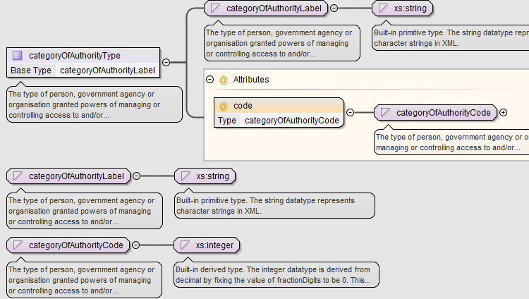

Figure B-12-1 - Structure of enumeration attribute in GML format

Codelist attributes must be structured similarly but allow for appropriate “extra” values depending on the type of codelist. Typical structure for an open enumeration type codelist is depicted in the figure below.

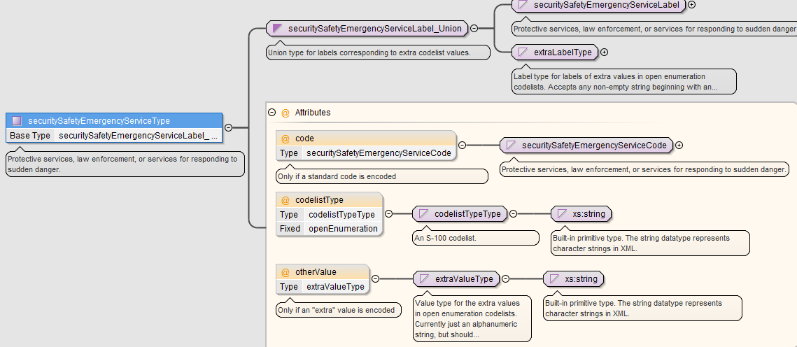

Figure B-12-2 - Typical structure for open enumeration codelist in Part 10b format

* Addition of unit of measure and constraints for certain numeric attributes. At present the FCB does not obtain this information from the registry; note furthermore that many constraints are product-specific, for example any constraint on the names of support files must allow for the length and pattern (e.g., “131...”) required by the Product Specification.
* Pending proposals which are still in the approval process.
* Registry entries which have been superseded but are not yet retired.

Common practice is to use XML software tools for such checking and update. The feature catalogue schema for the latest edition of S-100 is available on the IHO schema server (currently this is for Editions 5.2.0/5.2.1).

Besides the feature catalogue schema, the IHO schema server provides online documentation depicting the XML structure of feature catalogues, a sample generic feature catalogue, and a Schematron file for checking FC content in ways additional to XSD schema validation; for example, the Schematron file checks whether numeric attributes have units of measure and constraints defined. Changes to the FC are left to the discretion of the Product Specification developer, since some warnings emitted by the Schematron rules can safely be ignored such as warnings about missing units of measure for attributes which do not use them (for example, scales and numeric identifiers).

The finalised Feature Catalogue must conform to the S-100 feature catalogue schema.

Schemas on the schema server may be consulted for more details and examples.

* 1. Data formats of codelist typed attributes

The codelist model in S-100 is designed to be flexible by decoupling application schema from data format to some extent. Data formats may use “codelist extractions” created by extracting codes or values from a codelist dictionary and treat them as ordinary enumerations. The effect is to allow data formats to use either an external dictionary or ordinary enumerations. For example, an XML data format might convert an ISO3166CountryCodes codelist maintained by IHO into an XML Schema type:

<xs:simpleType name=”ISO3166CountryCodesType”>

<xs:restriction base=”xs:string”>

<xs:enumeration value=”EN”/>

<xs:enumeration value=”FR”/>

... other country codes ...

As far as implementations using that schema are concerned, it is indistinguishable from an ordinary enumeration. The decision as to which alternative(s) to use in any particular product specification should depend on the circumstances of the data product and its use environment. The decision should be made by the product specification authors when developing the data format. Obviously allowing different data formats to use different representations introduces additional maintenance requirements relating to some data formats, these would be limited to the formats which use “closed” representations (i.e., convert the codelist to an ordinary enumeration).

* + 1. GML and other XML data formats

Enumeration with pattern: The data format in XML schemas must conform to ISO 19136 E.2.4.9, i.e., a union of an enumeration and a text pattern of the form specified in S-100 Part 3:

other: [a-zA-Z0-9]+( [a-zA-Z0-9]+)*

Examples of use (assuming a codelist which explicitly lists “Norwegian” with numeric code 3 but not Nynorsk and Bokmål):

<language codelistType="openEnumeration" code=”3”>Norwegian</language>

<!-- Norwegian is an enumerated value -->

<language codelistType="openEnumeration" otherValue=”other: nno”>Nynorsk<language>

<!-- Norwegian Nynorsk is not an enumerated value -->

External Dictionary: Dictionaries must use the ISO 19115-3 codelist type (which is also used for S-100 metadata codelists as well as ISO codelists used in S-100). The S-100 codelists file is available from the schema server (https://schemas.s100dev.net/schemas/S100/5.2.0/resources/Codelists/cat/codelists.xml).

Example

<cat:codeEntry>

<cat:CT_CodelistValue id="S100_MD_LanguageCode_eng">

<cat:identifier>

<gco:ScopedName codeSpace="http://www.iho.int/S100/lan/1.0">eng</gco:ScopedName>

</cat:identifier>

<cat:name>

<gco:ScopedName codeSpace="http://www.iho.int/S100/lan/1.0">eng</gco:ScopedName>

</cat:name>

<cat:definition>

<gco:CharacterString>English</gco:CharacterString>

</cat:definition>

<description gco:nilReason="inapplicable"/>

</cat:CT_CodelistValue>

</cat:codeEntry>

Note that the value of *codeSpace* is a nominal URL identifier and not an actual Internet resource.

In a dataset:

<language codelistType="closedDictionary" codeList="https://schemas.s100dev.net/schemas/S100/5.2.0/resources/Codelists/cat/codelists.xml#S100_MD_LanguageCode" codeListValue="eng">English</language>

* + 1. ISO 8211 encodings

Enumeration with pattern: To accommodate producer-defined values (“other: xyz”) this can be encoded either as a “text” type (character string) or as a complex attribute with an integer sub-attribute (for the listed allowed values) and a text sub-attribute (the “other:...” values).

External Dictionary: This can be encoded in two ways:

1. A URI data type with a value constructed by combining the URI for the vocabulary (dictionary) and the item code. For example:

http://registry.iho.int/codelists/locode/2013/1/USNYC for New York City (in the July 2013 edition of UN/LOCODEs list).

1. A complex attribute with two sub-attributes: Vocabulary location (URI) and item code (text). To use the same example: sub-attributes are vocabulary= http://registry.iho.int/codelists/locode/2013/1/ and itemCode=USNYC.

The first method is recommended as it reduces data complexity.

* + 1. Dictionary formats

Use of ISO 19115-1 codelist format is required, since this is already used for codelists in metadata.

* + 1. Dictionary distribution and discovery

In order to remove dependence on Internet connectivity for interpreting codelist values, codelist dictionaries may be distributed as support files in special exchange sets (like current practice for Feature and Portrayal Catalogues). These should be treated as “system” support files rather than ordinary support files. Discovery metadata for support files is described in Part 17.

* + - 1. Location resolution with local dictionary files

If mappings from namespaces to dictionary files are needed for a data product, the use of a catalogue file is suggested in which case the product specification may specify the catalogue file name and format. The catalogue file itself can be treated as another support file, having a fixed filename and location in the exchange set which are stated in the product specification.

EXAMPLE: A product specification uses XML catalogues for resolving codelist namespaces to local dictionary files. It specifies that the catalogue file shall conform to the OASIS standard for XML catalogues (“XML Catalogs V. 1.1”),

URL: https://www.oasis-open.org/standards#xmlcatalogsv1.1). The product specification standardizes the name of the catalogue file as CODELSTCAT.XML.

A rewrite rule in the OASIS XML Catalog can be used to redirect retrieval from the Internet server to a local file:

EXAMPLE:

<rewriteURI uriStartString="https://schemas.s100dev.net" rewritePrefix="file:///E:/schemas/S100"/>

informs software that is capable of using OASIS XML Catalogs to redirect retrieval of the dictionary from the server schemas.s100dev.net to folders under /schemas/S100 on the local system’s E: drive. The rest of the dictionary URL after the string “schemas.s100dev.net” will be appended to the replacement string header.

1. Portrayal elements and rules

Portrayal Catalogues are necessary only for data products that are intended to be displayed graphically (as opposed to text or other processing).

Often there will be only one intended application domain – generally ECDIS – and a limited number of closely related usage scenarios (that is, route monitoring/planning and voyage planning) utilizing one Portrayal Catalogue. Some data products may not be intended for display, in which case no Portrayal Catalogue is needed. Other data products may be intended for more than one application domain, in which case the possible need for different Portrayal Catalogues should be considered. Different usage scenarios may also benefit from different Portrayal Catalogues.

S-100 defines an XSLT-based portrayal mechanism in Part 9 and a LUA scripting language as an alternative portrayal mechanism in Part 9a.

The portrayal section of a Product Specification should include:

* Pictorial representations of symbols and colours, accompanied by symbol specifications (the latter preferably in the form of machine-processable files as well as formal specifications in the text of the portrayal section).
* Specifications and recommendations for the use of symbols by implementers; for example, calculating orientation from attribute values and the use of thinning to reduce crowding of displays at small display scales, display of text accompanying symbols, masking of boundaries, etc.
* Products that need to be included in ECDIS must have day, night, and dusk palettes defined.
* Any product-specific additional information, principles, or requirements, such as de-cluttering methods, recommendations and formulas for symbol scaling according to the value of a designated attribute, requirements for product-specific user interface functionality, etc.

1. Registration of portrayal elements

Portrayal elements must be registered in the Portrayal Register of the IHO GI Registry. Elements that need to be registered are listed below. A portrayal element needs to be registered only if it is new to the Register – elements that are already in the Register need not be registered again.

* New symbols, fonts, line styles, area fills, and pixmaps.
* New display modes.
* New viewing group layers.
* Viewing groups.
* New display planes.
* New colour tokens.
* New colour profiles used by portrayal of this product. If there are multiple palettes (for example day/night/dusk), the colour profile file(s) must define all palettes.
* New CSS files encoding the colour tokens and RGB values used by all symbols in the portrayal of this product.
* New context parameters.
* New display priorities.

1. Portrayal Catalogue

An IHO Portrayal Catalogue Builder is available to Product Specification developers in the Help and Guidance/Repository section of the IHO GI Registry.

1. Reference systems

The preferred coordinate reference system is EPSG 4326 which is based on the WGS 84 horizontal datum.

Horizontal datum will normally be referenced by giving its code in the EPSG Register.

A set of vertical datums is listed in S-100 Part 10c (S100_VerticalAndSoundingDatum). Product Specification developers are encouraged to adopt the S-101 ENC datum as a common vertical reference datum if possible. If a need for an additional datum is identified, it should be proposed as a revision to S-100. Where products are in scope for interoperability in ECDIS (as defined in S-98), they should use the same datum as the underlying ENC. Incompatible datums may lead to reduced functionality or rejection of datasets.

S-100 includes ‘local datum’ as an allowed value for vertical datum attributes, but this is of limited utility even within a data product. (S-101 cites an example of use of local datum in a non-tidal basin, where depths may refer to a sounding datum different from that in open waters. If this area is navigable at the optimum display scale of the ENC data, the value of this datum must be encoded using attribute vertical datum = 24 (local datum), in a meta feature co-incident with the area covered by the dock.) Data conversion to/from unspecified local datums would be problematic.

1. Data product delivery
   1. Delivery content and structure

Product Specifications must define the content and structure of delivery packages: Exchange sets, messages, or web services.

* + 1. Exchange sets

Exchange set structure must conform to the requirements in S-100 Part 17 clause 17-4.2 including both the folder structure and the names mandated in S-100 clause 17-4.2. The conceptual structure of exchange sets and the relationship of exchange set content to metadata in the Exchange Catalogue is depicted in Figure B-17-1 below. The physical structure is depicted in Figure B-17-2 following.

Where the language in S-100 clause 17-4.2 is permissive rather than normative (i.e., with respect to grouping individual data files and support files) the Product Specification should add appropriate restrictions so as to minimize application complexity, for example by specifying whether placement of individual files in subfolders is permitted.

Product Specifications should adapt the figures and rules in S-100 clauses 17-4.2 and 17-4.3 to their own data product and include the product-specific structure in their Product Specifications; for example, use the appropriate product code at the beginning of file names, omit the parts relating to support files if the data product does not use support files, etc.

A Portrayal Catalogue must be packaged as a zip archive file which is placed in the CATALOGUES folder of an exchange set. Each such zip archive should contain exactly one Portrayal Catalogue. The archive must reproduce the hierarchical structure of a Portrayal Catalogue (S-100 clause 9-13.2) without intermediate structure (that is, unpacking it into folder <X> should make <X> the root folder described in S-100 9-13.2).

EXAMPLE: The Portrayal Catalogue for a hypothetical product S-999 Edition 2.3.0 is packaged as a zip file named 999_2_3_0_PC.zip. Unpacking it into a folder named 999_2_3_0_PC results in file portrayal_catalogue.xml and folders Rules, Fonts, etc. being placed directly in the 999_2_3_0_PC folder.

A Feature Catalogue must be packaged as an uncompressed XML file.

Feature and Portrayal Catalogues are now packaged by the IHO Secretariat as individual special exchange sets distributed from the Product Specifications register in the IHO Geospatial Information Registry. These exchange sets contain no datasets, only a feature or portrayal catalogue. The structure of these exchange sets is compatible with the requirements in S-100 Part 17 except for names. Product Specifications should indicate the (prospective) availability of these special exchange sets. Given the availability of these special exchange sets, it is not necessary to include feature catalogues and portrayal catalogues in “normal” exchange sets containing datasets.

The Product Specification **may** describe how the exchange set as a whole is packaged (for example ordinary folders, zip file, etc).



Figure B-17-1 – Prototype exchange set structure (S-100 Figure 17-2)

Product Specification authors **must** determine what naming conventions, if any, must apply to individual components of the exchange set - dataset files, exchange sets and support files. The S-100 conventions for naming are described in S-100 clause 17-4.3 and Product Specifications should apply the necessary product-specific restrictions in addition (for example, specifying the product code).

Naming conventions are generally not needed for message-based or service modes of data delivery, but a unique identifier will generally be needed for each message or service transaction.

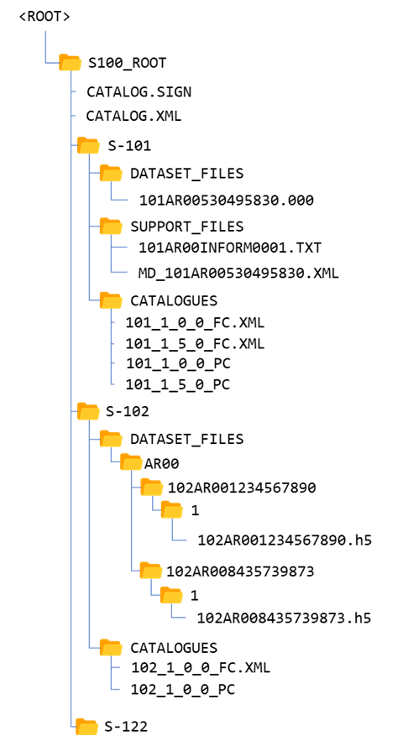

Figure B-17‑2 - Exchange set folder structure (S-100 Figure 17-3)

* + 1. Services

S-100 Part 14 describes three types of communication:

* Session oriented communication (S-100 Part 14, clause 14-4) - point-to-point connections between client and server described by an interaction model that describes the life span of a session (initiation, maintenance and termination of the session).
* Session-less interactive communication (S-100 Part 14, clause 14-5) - an encapsulation of all relevant information within a request, based on which the server formulates an appropriate response.
* Message streams (S-100 Part 14, clause 14-6) - a unidirectional flow of messages containing well-defined sets of data.

For message and web service modes of delivery, specify the container format and packaging; and specify the transfer protocol (for example REST (Representational state transfer), SOAP (Simple Object Access Protocol)) and packaging (for example WSDL (Web Services Delivery Language), WFS (Web Feature Service)). S-100 Part 14 currently permits three service technologies: SOAP, REST and CORBA.

[Developing specifications for online services will be included in a later version of this document, pending more experience with S-100 Part 14.]

* 1. Dataset updates and cancellations
     1. General considerations for updates

Define the conditions and mechanisms for data updates, specifically:

* Update cycles – how frequently data must be updated; whether updates are issued on a regular cycle, as-needed, or a combination of both;
* How long each dataset is valid and how validity periods will be indicated;
* Mechanisms for cancellation, replacement and reissue of datasets;
* Metadata for updates;
* Types of updates – whether the data product requires incremental, whole-dataset replacement, irregular or cumulative updates; and
* Criteria for determining when datasets must be replaced by new datasets, superseded, reissued, updated and cancelled.

In defining a strategy for updates, cancellations, and removal of old data, authors of Product Specifications for forecasts and similar time series datasets should consider the frequency of data release, effects on edition and update numbering, the nature of temporal overlaps between successive datasets, and consequences on distributor and end users, e.g., end users subscribing to a particular series of forecasts for a limited period, which may mean that they never receive a “base” dataset.

* + 1. Format-specific update considerations

ISO 8211: S-100 Part 10a describes update mechanisms for ISO 8211 datasets. Each Product Specification must define the structure of update datasets.

GML: Replacement of whole objects is the recommended method, but there are XML specifications that allow update of individual attributes. (Details will be included in a later version of this document, pending further discussions.)

HDF5: While a Feature (coverage) can be updated in its entirety or in part (the update can be a sub-grid), common practice in Product Specifications to date has been to provide for updating datasets by issuing a new edition and cancelling the old dataset if it has not expired.

* + 1. Cancellations

S-100 provides two methods of cancelling datasets, described in S-100 clause 17-4.4.1:

* File-based cancellation, where a dataset is cancelled by issuing an update dataset file for which the Edition number must be set to the Edition number of the product being cancelled in the S100_DatasetDiscoveryMetadata record in the Exchange Catalogue. Other metadata fields are set to values appropriate for an update.
* File-less cancellation, where the Edition number must be set to the Edition number of the product being cancelled in the S100_DatasetDiscoveryMetadata record in the Exchange Catalogue and all other mandatory metadata fields also set to the same values as the original, with the exception of the *issueDate* and *issueTime* (the latter only if required by the Product Specification), which must be set to the issue date and time of the fileless cancellation itself. No update dataset is issued.

Only base datasets can be cancelled using these methods. Cancelled datasets must be removed from the system.

* + 1. Time-series datasets
       1. Temporal validity and replacement

If datasets have a definite temporal validity (such as forecasts, which span a definite future interval), the interval during which the datasets are valid must be indicated using the *temporalExtent* attribute of S100_DatasetDiscoveryMetadata in the exchange catalogue. The HDF-5 format also provides for encoding temporal extent in carrier metadata. Data products with definite temporal validity for datasets must make the S-100 metadata attributes indicating temporal extent mandatory in discovery metadata in CATALOG.XML. They may also define equivalent carrier metadata attributes to embed the same information within the dataset.

Datasets with irregular or indefinite time validity will have *temporalExtent* populated only with the start of validity (if valid immediately upon issue, *temporalExtent* need not be populated at all).

If the time at which the successor will be issued is known ahead of time (as for regular forecasts) the Product Specification should require *resourceMaintenance* metadata attribute in *S100_DatasetDiscoveryMetadata* to be populated with the interval between datasets. They may also define equivalent carrier metadata attributes to embed the same information within the dataset.

If the time of issue of the successor is not known ahead of time *resourceMaintenance* should be populated with an appropriate value (“irregular” or “asNeeded”) from the ISO *MD_MaintenanceFrequencyCode* list of values as restricted by S-100 (17-4.5).

* + - 1. Time-expired datasets

Product Specifications should not require time-expired datasets to be cancelled or updated. Instead a time-expired dataset should be followed by a successor dataset whose validity extends beyond the expiry of the predecessor dataset. To avoid spurious validation failures, such predecessor and successor datasets should have distinguishable dataset file names and identifiers, which generally implies incorporating the date/time of commencement of validity into the file name in some manner.

* + - 1. Loading, unloading and removal

Loading/unloading of datasets forming a time series is up to the system to manage. Generally the most recent unexpired dataset will be loaded (allowing for simulated time), however this again would be for the system to manage and up to the relevant performance standards to specify how it should be managed. As mentioned in Part A, the S-98 loading/unloading strategy will control for ECDIS, but Product Specifications may explain how the S-98 strategy works for the data product.

Deletion of time-expired datasets from the system (as opposed to loading/unloading) is also up to the system to manage. Deletion of data from the system will generally be controlled by regulatory requirements and/or performance standards, and is therefore likely to be out of the scope of the Product Specifications.

* 1. Supporting information

Describe how any auxiliary content is delivered either with or as an adjunct to data. S-100 provides for ‘support files’ to be included in exchange sets. Support files can be graphic or text information files referenced by dataset objects, or other files such as dictionaries and catalogues (including Feature or Portrayal Catalogues). Define allowed file formats and naming conventions for support files.

Note that since Feature and Portrayal Catalogues are shared by all datasets conforming to a specific version of a Product Specification, it will generally be more efficient to deliver Feature and Portrayal Catalogues once rather than with every exchange set. Possible methods of such special deliveries have not been standardized yet and are left to Product Specification developers, but may include special exchange sets distributed through the usual channels or a centralized means such as publication on a web server. If a central distribution mechanism is adopted consideration must be given to the possible needs of end users who have only infrequent or no access to the distribution hub (for example low-bandwidth or no Internet access).

1. Validation checks

At least two types of validation checks are needed:

* Dataset validation checks for individual datasets. These checks operate on individual objects in datasets and on individual datasets as a whole. They should check the integrity of individual objects in the dataset (spatial, feature and information types); associations between objects in the dataset; any embedded metadata or header information in the dataset; and support files referenced in the dataset.
* Package validation checks for verifying the structure and content of packages (for example exchange sets) and accompanying metadata.

Products intended for ECDIS use must also pass a third set of checks: cross-product validation checks to ensure their mutual compatibility and usability on ECDIS.

General principles for validation, along with a template for check structure and format, are available in IHO Publication S-158 (Validation Checks – Introduction and Structure).

IHO Publication S-158:100 (Universal Hydrographic Data Model Validation Checks) contains a set of generic validation checks. Product Specification developers will need to determine which of the S-100 level checks apply to their data product. The checks in S-158:100 are organized by S-100 Part and this can be used as a first-pass filter. For example, vector data products will not need validation checks derived from S-100 Part 10c, which describes the HDF-5 format for coverage spatial types. The data format used for the product is another obvious first-pass filter.

* 1. Validation checks for datasets

Validation checks for datasets should cover:

1. Completeness; including population of attributes and presence of required information, complex attributes without sub-attributes, etc.
2. Logical consistency; for example, missing association targets.
3. Spatial consistency; for example, topological sanity checks for non-crossing external boundaries, excessive vertex density in lines, etc.
4. Positional accuracy; for example, closeness of reported coordinate values to accepted or known absolute or relative coordinate values.
5. Temporal accuracy; for example, closeness of reported time measurements to accepted or known values accepted as or known to be true, correctness of the order of events, or validity of data with respect to time.
6. Thematic accuracy; such as attribute values that are consistent with any other related attributes and within allowed ranges or sets.
7. Format consistency; conformance to the data format described in the Product Specification, which for most products will be one of the data formats described in S-100 with additional restrictions imposed in the Product Specification.
8. References to support files.
9. Other requirements specific to the product; for example, encryption, signatures, etc.

Some of these issues are addressed in the common set of validation checks. A recommended common set of validation checks is described in S-158:100. Product Specification developers should supplement the common set with such additional checks as are appropriate for the particular product, in a product-specific S-158:1XX publication. Further information about validation checks in general can be obtained from S-158 (Validation Checks - Introduction and Structure) and S-158:100 may be consulted for examples.

* 1. Validation checks for packages

Validation checks for packages should cover:

1. Package completeness – whether all required components are included, including datasets, support files, metadata and appropriate catalogues (for example exchange set catalogues, Feature Catalogues and Portrayal Catalogues). Note that the Product Specification must indicate which catalogues are appropriate to the delivery method; for example, message-based delivery methods may not include catalogues in the delivery packages.
2. Package container format and structure – whether the package is in the approved container format (for example ISO 8211, TIFF, etc.) and whether appropriate encryption and signatures have been applied at the container level. Examples of package validation checks are:

* Assuming the Product Specification specified delivery as zip files, is the container a zip file of the appropriate type?
* If the package is arranged in a directory (folder) structure, are the structure and names of directories (folders) as required in the Product Specification?

Package validation checks for exchange sets are included in S-158:100 and Product Specification developers should add any product-specific checks in their own validation publication S-158:1XX.

* 1. Common validation checks

Common validation checks applying to all S-100 products have been defined in S-158:100. The principles for supplementing them with product-specific validation checks are described in S-158.

* 1. Validation checks for base versus update datasets

If the Product Specification defines an update dataset format, the validation checks developed for new (base) datasets should be reviewed for their applicability to update dataset formats. It may be necessary to restrict the scope of certain validation checks to base or update datasets in the product-specific validation publication S-158:1XX.

1. Preparing for interoperability (informative)

Implementation of interoperability by means of interoperability catalogue (S-100 Part 16) has been suspended for the immediate future and this section is designated informative pending further action on interoperability.

Product Specification developers should carry out the activities described below if the data product is a candidate for inclusion in an Interoperability Catalogue. Further details on these activities will be provided in future editions of S-100 and IHO Publication S-98.

* Determine which, if any, product groups in Interoperability Catalogues are supplemented or enhanced by the data product.
* Determine whether, and how, the IHO Interoperability Catalogue will be affected by the new product; including updates to display priorities, interleaving, predefined combinations and other interoperability rules and operations.
* Revise Portrayal Catalogues as needed.
* Compare the Application Schema to related Product Specifications and advise the developers of the Interoperability Catalogue on their similarity to features in other Product Specifications. This comparison should include feature concept similarity, attribute bindings, attribute value domains, potential discrepancies in feature geometries, etc.
* Examine the Specification scope and factors affecting the quality of information which may also be present in other products; for example, whether information is for context or background in one product but a significant part of the other. The results of this analysis should be communicated to Interoperability Catalogue developers.
* Consider interactions due to cartographic objects; for example, text placement issues in interoperability mode. Product Specification teams should consult with OEMs on how to mitigate such issues.
* Advise Interoperability Catalogue developers on whether features are supplementary information for features in another product. Such features may be combined as part of interoperability.
* Attempt to harmonize effects of optimum and minimum display scales used by datasets in order to avoid situations where one data product is within display scale but a complementary product is not.

1. Sample data / test datasets

Test data should be created in sufficient quantity to validate the main characteristics of the Application Schema. Specifically, the first test dataset should contain:

* At least one instance of each kind of feature and information type.
* A representative set of feature and information associations, preferably at least one instance of each named association. (It is not necessary to create an instance for each and every pair of object classes which may be linked by an association.)
* At least one instance of each meta feature and data quality feature.

At least one update dataset should also be prepared, to validate the update dataset format and packaging.

Additional test datasets should test typical data volume, representative data capture problems and error cases.

If delivery is intended to be in the form of exchange sets, the test datasets should be packaged as complete exchange sets, including an Exchange Catalogue. Sample packages for other forms of delivery (transactions, messages, web services, etc.) should be emulated as realistically as is practical at this stage; that is, setting up a web server, service broker, etc. for web services should be done if doing so is practical but is not an essential requirement (it can and should be done as part of the testing stage).

1. Testing and feedback

A formal test plan should be prepared, including test cases.

Newer IHO procedures include a testing and feedback phase after a draft Product Specification package has been submitted for endorsement by HSSC (clause B-5.4).

1. Work processes
   1. Registration and requesting an S- number

Apply for a Product Specification number – this should ordinarily be assigned when the development project is approved during the initiation stage.

Registration of Product Specification artefacts in the IHO GI registry should be done in accordance with the procedures established in IHO publication S-99.

* 1. Project Teams

Project Teams should involve domain specialists, information modelling specialists and representatives of OEM/developer communities.

* 1. Iterative refinement as a development process

Development should plan for iterative refinement, with the following being reviewed at the indicated stages of development:

* Initial Application Schema. Reviews of subsequent revisions can be rolled into the reviews of the main Product Specification document;
* First drafts of the main document of the Product Specification and DCEG. Subsequent revisions should be reviewed as ready;
* Feature Catalogue, data format and sample datasets should be checked after each major revision to the Application Schema and Feature Catalogue;
* Portrayal Catalogue – first draft and significant revisions;
* Other artefacts or components, such as validation tests – when substantially completed; and after revisions due to changes to the Application Schema, Feature Catalogue, or data format;
* The Product Specification as a whole – after the complete package is ready.

Reviews of different components can be combined to fit the development schedule or Working Group meeting schedules. The Application Schema, main Product Specification and DCEG should be expected to undergo multiple reviews during different stages of development.

Reviews during the development stage should be requested from:

* Project Team – initial reviews;
* Technical group(s) sponsoring the Specification, as well as related technical Working Groups – after some stability has been achieved;
* Developers, implementers, and OEMs – formal reviews after initial reviews and stabilization in the Project Team and sponsoring technical Working Group. Note that individual implementer/OEM/developers should ideally be involved from the earliest stages of development if available.

Reviews should be conducted for completeness, correctness, ability to capture and express the domain, performance/efficiency; as well as conformance reviews for verifying compliance to S-100 and underlying Standards.

In addition, the IHO Data Quality Working Group should review the Product Specification for completeness.

Stakeholder reviews should be requested as the Specification matures, and should involve:

* Producers;
* Developers and OEMs.

Subsequent stages should involve users and user testing; and preparation of an impact study.

Test development and testing should commence upon the Feature Catalogue and data format achieving reasonable stability, presumably after one or two cycles of review.

Final assessment will be at the HSSC level for IHO; or equivalent for other organizations.

Pre-publication review will be conducted by the IHO or other publishing organization prior to publication, to check production issues.

* 1. Maintenance of Product Specifications

Clarifications, corrections, and revisions should be designated in accordance with the same criteria used for S-100 as described in S-100 Part 12, Clause 12-2 (Maintenance Procedures).

Product Specifications should undergo periodic review. A two-year review period is suggested for new Specifications, which may be increased to five years after the Specification reaches maturity.

* 1. Review by Data Quality Working Group

The DQWG are able to review Product Specification packages for internal consistency as well as compare models with the S-101 ENC model and evaluate the data quality section. Developers are recommended to send mature pre-approval Product Specification packages to the DQWG Chair requesting such review. Decisions about whether or not to apply changes recommended by the DQWG or address issues identified in cross-product comparisons are made by the Product Specification development team.

* 1. Verification process for feature and portrayal catalogues

Validation of feature and portrayal catalogues against schemas is not necessarily sufficient to detect all inconsistencies and incompatibilities with other product specifications, nor against a number of other issues that might exist. Further, the inclusion of a fully featured programming language in the portrayal catalogue structure, Lua, poses a serious cyber security risk requiring management and mitigation measures.

Formal processes for this are yet to be formalized by the respective working groups and IHO Secretariat. In the interim, the following procedure for external validation of feature and portrayal catalogues is proposed;

1. The Project Team drafts product specification, feature, and portrayal catalogues
2. Internal review of catalogues by project team to ensure they match the objectives of the product specification and match the Application Schema.
3. External (to the PT) independent validation of the feature and portrayal catalogues takes place. This involves
   1. Validation against current S-100 schemas
   2. Validation using specific validation tests defined at the S-100 level (to be defined).
4. Once passed, catalogues are digitally signed by the IHO acting as a data producer and labelled with a status (in the signature certificate) of “DRAFT”. Certificates are valid for the review period only.
5. Draft catalogues are passed to broader groups consisting of:
   1. Nominated technical experts at the S-100 level
   2. OEMs registered with the data protection scheme
   3. RENCs and distributors registered as AGGREGATORs under the security scheme

Test data must be included with catalogues distributed including:

i) Valid, representative data for the product specification

ii) “Chart 1” style portrayal, for portrayal catalogues

iii) Exhaustive test data for non-trivial Lua scripts.

Once agreed, catalogues are considered live, they are signed again by the IHO, verified as identical to the verified versions, given certificates with a long lifespan (e.g. 10 yrs), and marked with a status (in the signature certificate) of “LIVE”. These are the only catalogues which may be installed on ECDIS and signed by the scheme administrator acting as a data producer (as identified in the role in the certificates).

The above is a proposed process which has not yet (August 2025) been formalized by the IHO Secretariat and responsible working groups. Changes to the process are therefore still possible.

Interoperability catalogue implementation has been suspended for the time being and therefore interoperability catalogues are not mentioned in the process.

1. Other guidance
   1. Guidance on Unique Identifiers

A major benefit of the S-100 framework is that products can be produced which can be displayed together on one screen such as in an ECDIS or VTS monitoring system. That necessarily requires a regime which enables an S-100 based system to operate with different products simultaneously. The challenging aspect of operating with different products simultaneously, is to find a solution that allows exactly one instance of a data within the system and which might be simultaneously included in various products. In an S-100 environment, the data originators provide the data and this data could be used in various products without direct influence of a hydrographic office. As long as the data is based on the same framework and if the multiple instances use the same identifier, the data exchange and data processing of this supply chain can be relatively simple.

It is important to preserve original identifiers in data products to assist in identifying data objects which describe the same real-world entity between different datasets, especially datasets from different specifications. For example: Identify instances of the same restricted area between ENC (S-101) and Marine Protected Area (S-122) datasets in an ECDIS. Another principle for preserving instance identifiers is to assist in identifying associated instances between datasets, especially datasets from different specifications. For example: S-124 Navigational Warning marking a light as out of order. This one navigational warning could be used to mark the issue in S-201, S-125 and S-101. Note that this requires the identifiers to be preserved so that the system can link the related feature instances.

Persistent unique Identifiers would reduce the workload and likely issues with translation tables which have to be developed and maintained if various stakeholders use different Identifiers for the same feature; for example, a light has an IALA Identifier (created by a coastal authority) and a HO Identifier. The use of unique Identifiers will likely become more important as interoperability between various products within an S-100 based environment evolves. Thinking interoperability to the last consequence, the clear and standardized definition of the Unique Identifier’s structure becomes essential within that structure, and it is recommended that the Maritime Resource Name (MRN) concept, see Part 3 clause 3-10, be utilized as far as possible to have a common system of identifiers within the S-100 regime.

S-100 Product Specifications may implement an attribute called interoperabilityIdentifier. This attribute is intended to provide a persistent and unique identifier, to be expressed as an MRN, between features in datasets of different Product Specifications. In an S-100 ECDIS context, for instance, this would allow feature interrogation to include related features from different Product Specifications. Implementation of interoperabilityIdentifier is optional, see S-100 Part 3, clause 3-10.1.

There are implications to establishing a regime of preserving persistent unique identifiers. These include;

* Implications for data maintenance: Processes have to be established to preserve the persistent unique identifiers for features where the identifier is needed, and to do so through maintenance cycles. This means that the identifier remains static throughout the feature lifecycle, even when there are changes to the attributes of the feature. For example, the status of a conspicuous building may change over time, but the building is the same and the identifier should therefore remain static.
* Production processes must be established to preserve the persistent unique identifiers of sources into product instances. If a source object is used to create an amalgamated feature (for example, built up area is made up of all the buildings in the area, but need not show them individually), then the new feature should get a new identifier, and it may not be necessary to preserve the source object identifiers into the product.
* It may be prudent to establish product specific rules for when and how persistent unique identifiers change with object change. For example, a platform is removed; does the remaining obstruction retain the identifier, or is it given a new identifier?
* Persistent unique identifiers may not give any indication of version/date of a feature instance. Guidelines should be established by stakeholders of products and object types for how to determine the most up to date instance if there are discrepancies between data objects which describe the same real-world entity between different datasets.

Persistent unique identifiers are likely to only be unique from the source originator. It is theoretically possible that two source originators generate different feature instances from the same real-world item. It is therefore important that stakeholders communicate, especially among stakeholders that intend to provide data to the same end user systems. Communication should be aimed at understanding domains and working out interoperability issues.

* 1. Dealing with overlapping data

Product Specifications should address the question of whether overlaps between adjacent datasets are permitted and under what circumstances. Principles for prohibiting and permitting overlaps between datasets must be defined in the Product Specification. Considerations include:

* Whether data are scale-dependent or scale-independent, and whether datasets have optimum, maximum and minimum display scale information associated.
* Whether overlapping datasets are from the same producer or different producers.
* Overlaps in data coverage areas vs. features extending outside data coverage areas.
* Whether a “small” overlap is tolerable – for example a 5-metre overlap in S-101 ENC datasets, or single grid cells along national boundaries cutting across the grid.
* Whether the nature of the data is such that features cannot naturally be truncated at dataset boundaries, whether there is an advantage to the end user in depicting such overlap. For example, radio broadcasts areas naturally extend across national boundaries and end users may want to know where broadcasts from their destinations can be received, even if it is across a national boundary.
* Whether data outside producer jurisdictions is needed because of the kind of information, for example weather and ice information.
* The kind of information – for example, gridded bathymetry, water level, and current information should not extend beyond grid extents to avoid ambiguity in interpretation and possible data conflicts.

Generally speaking overlaps along producer boundaries can be permitted to a limited extent. Overlaps between datasets at datum boundaries may be inevitable (especially gridded data where the grid area covers areas where different vertical datums are used) but should be as limited as possible.

* 1. Datums

While vector products can deal with having multiple vertical datums within a dataset extent by adding different data coverages, multiple vertical datums is a more complex issue for gridded data because the datum boundary rarely coincides with grid cell boundaries. This problem is currently being addressed by cloning the grid feature into two or more grid features with the same extents and grid cell parameters but different vertical datums, and populating grid cells intersecting the datum boundary in features for all the datum areas the cell intersects.

* 1. Product Specification name and identifier in datasets

The content of product specification identification DSID.PRSP in the ISO 8211 format shall be specified as: INT.IHO.S-NNN.X.X where NNN represents the product specification number (101 or 401) and X.X represents the EDITION.REVISION number. Each “X” component may consist of one or more digits, with leading zeros omitted.

The content of productIdentifier in Dataset identification header for GML formats shall be specified using the same convention as above.

The content of the HDF5 attribute productSpecification in the root group in HDF5 formats shall be specified using the same convention as above.

* 1. Support for validation

Product Specification developers may wish to consider providing artefacts to support dataset and exchange catalogue validation. Exemplary artefacts include code libraries or Schematron rules for validating Exchange Catalogues and GML datasets. While schema-validation for XML takes care of much of the problem of ensuring conformance to data format, there are often constraints which cannot be validated by means of XML schema validation. If provided, focusing on product-specific requirements and constraints is suggested to limit effort needed, under the assumption that generic S-100 validation can be developed in common by multiple Product Specification teams in combination.

* 1. Support for relating modelled types to real world entities

Product Specification developers and their controlling working groups may wish to consider support for developing databases and query tools for establishing correspondences between real-world entities and modelled feature classes.

China MSA report[8] having carried out a project to enable surveyors and cartographers to understand as intuitively as possible how S-101 features correspond to the real world

* For the features whose corresponding real world entities are visible, for example coastline, aids to navigation and so on, the correspondences are shown in the form of pictures.
* For the features whose corresponding real world entities are invisible, for example fairway, anchorage area and so on, the correspondence are shown in the form of paper chart symbol, ECDIS symbol, or Schematic drawing.

Further information about this or similar such projects is awaited as of the preparation of this document. If and when widely available, Product Specification may wish to consider mentioning it in DCEGs as a supporting tool.

Page intentionally left blank

**Part C – Data Quality**

1. Introduction

Part C is intended to ensure that data quality aspects are addressed in an appropriate and harmonized way for all S-100 based Product Specifications.

This Data Quality Guideline can be used by HSSC Working Groups developing S-100 based Product Specifications. It provides 10 recommendations for appropriate data quality measures as deemed necessary to be used within S-100 based Product Specifications.

When drafting a Product Specification, the Data Quality Guideline will serve as a guidance document to verify if the appropriate Data Quality Elements have been included in the Product Specification. A Data Quality Element is a quantitative component documenting the quality of a dataset. The applicability of a Data Quality Element to a dataset depends on both the dataset’s content and its Product Specification, the result being that all available Data Quality Elements may not be applicable to all datasets.

The place of data quality measures in dataset and exchange set metadata and the encoding of data quality in metadata is described in various ISO standards (ISO 19115-1/2/3, ISO 19157) and in S-100 Parts 4a–4c.

1. References

IG-D2.8.II.1 D2.8.II.1 INSPIRE Data Specification on Elevation – Technical Guidelines, v3.3.0. INSPIRE document identifier D2.8.II.1_v3.3.0, 2024-01-31.

ISO 8211 Specification for a data descriptive file for information interchange structure implementations. ISO/IEC 8211, 1994.

ISO 19101-1 Geographic information — Reference model – Part 1: Fundamentals. ISO 19101-1:2014, 2014.

ISO 19101:2002 Geographic information — Reference model – Part 1: Fundamentals, ISO 19101:2002, 2002.

ISO 19115-1 Geographic information – Metadata – Part 1 – Fundamentals. ISO 19115-1, 2014, as amended by Amendment 1, 2018 and Amendment 2, 2020.

ISO 19115-2 Geographic information – Metadata - Part 2 – Extensions for imagery and gridded data. ISO 19115-2, 2009 and Amendment 1, 2022.

ISO 19115-3 Geographic information – Metadata - XML schema implementation for fundamental concepts. ISO/TS 19115-3, 2023.

ISO 19157 Geographic information – Data Quality. ISO 19157, 2013, as amended by Amendment 1, 2018.

S-44 IHO S-44 – Standards for Hydrographic Surveys. Edition 6.2.0, October 2024.

S-100 IHO S-100 – Universal Hydrographic Data Model, Edition 5.2.0, June 2024.

S-100_5.2.1 IHO S-100 – Universal Hydrographic Data Model, Edition 5.2.1, December 2025.

S-101 IHO S-101 – Electronic Navigational Chart Product Specification, Edition 2.0.0, December 2024.

S-102 IHO S-102 – Bathymetric Surface Product Specification, Edition 3.0.0, December 2024.

S-121 IHO S-121 – Maritime Limits and Boundaries, Edition 1.0.0, October 2019.

NOTE: In this document, “S-100” means both S-100 Edition 5.2.0 and Edition 5.2.1 unless a particular edition is explicitly identified.

1. Terms and abbreviations
   1. Terms

**data product specification**

a detailed description of a dataset or dataset series together with additional information that will enable it to be created, supplied to, and used by another party. A data product specification provides a description of hydrographic concepts and a specification for mapping the universe of discourse to a dataset. It may be used for production, sales, end-use or other purposes

**data quality element**

quantitative component documenting the quality of a dataset [ISO 19101:2002; S-100 5.2.0/5.2.1 Annex A]

NOTE: The applicability of a data quality element to a dataset depends on both the dataset’s content and its product specification, the result being that all data quality elements may not be applicable to all datasets

**data quality evaluation procedure**

the whole of operations used in applying and reporting quality evaluation methods and their results

**data quality measure**

an evaluation of a data quality sub-element

**data quality overview element**

the non-quantitative component documenting the quality of a dataset. Information about the purpose, usage, and lineage of a dataset is non-quantitative quality information

**data quality result**

a value or set of values resulting from applying a data quality measure or the outcome of evaluating the obtained value or set of values against a specified conformance quality level

**data quality scope**

the extent or characteristic(s) of the data for which quality information is reported

NOTE: The scope for a dataset can comprise a dataset series to which the dataset belongs, the dataset itself, or a smaller grouping of data located physically within the dataset sharing common characteristics. Common characteristics can be an identified feature type, feature attribute, or feature relationship; data collection criteria; original source; or a specified geographic or temporal extent.

**data quality sub-element**

a component of a data quality element describing a certain aspect of that data quality element

**Metadata ISO19115**

quality report in the format specified in the relevant ISO standards (ISO 19115-1/2/3 and ISO 19157)

**metaquality**

information about the reliability of data quality results [ISO 19157]

**result scope**

scope of the (data quality) result [ISO 19157, adapted]

NOTE: Result scope is a subset of the data quality scope.

**standalone quality report**

free text document providing fully detailed information about data quality evaluations, results and measures used [ISO 19157:2013]

* 1. Abbreviations

DQWG IHO Data Quality Working Group

ECDIS Electronic Chart Display and Information System

ECS Electronic Chart System

ENC Electronic Navigational Chart

GI Geospatial Information (generally followed by “registry” or “register,” meaning either the IHO Geospatial Information Registry or a specific register in it).

GML Geography Markup Language

GSD Ground Sampling Distance

HDF-5 Hierarchical Data Format Version 5

IEC International Electrotechnical Commission

IHO International Hydrographic Organization

IMO International Maritime Organization

ISO International Organization for Standardization

PS Product Specification

RMSE Root Mean Square Error

SD Standard Deviation

XML eXtensible Markup Language

1. Overview of data quality measures

The relations between data quality terms are presented in Figure C-4-1 below. The terms have been defined in clause C-3.1.

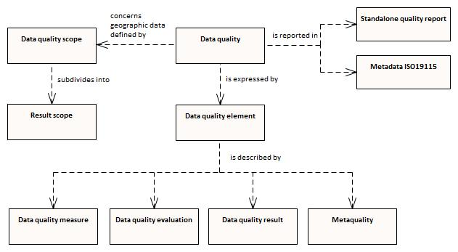

Figure C-4‑1 – Conceptual model of quality for geographic data*[9]*

The components of Data Quality Measure can be divided into the following elements[10]:

1. Completeness
2. Logical Consistency
3. Positional Accuracy
4. Thematic Accuracy
5. Temporal Quality
6. Aggregation
7. Usability

Data Quality Evaluation can be divided into the following elements:

1. Data Quality Full Inspection
2. Data Quality Sample Based Inspection
3. Data Quality Indirect Evaluation
4. Data Quality Aggregation Derivation

Data Quality Result can be divided into the following elements:

1. Data Quality Conformance Result
2. Data Quality Quantitative Result
3. Data Quality Descriptive Result
   1. Data quality measures

The description of data quality measures in this section is quoted from ISO 19157.

**Completeness** is defined as the presence and absence of features, their attributes and relationships. It consists of two Data Quality Elements:

* Commission – excess data present in a dataset;
* Omission – data absent from a dataset.

**Logical Consistency** is defined as the degree of adherence to logical rules of data structure, attribution and relationships (data structure can be conceptual, logical or physical). If these logical rules are documented elsewhere (for example in a Product Specification) then the source should be referenced (for example in the data quality evaluation). It consists of four Data Quality Elements:

* Conceptual consistency – adherence to rules of the conceptual schema;
* Domain consistency – adherence of values to the value domains;
* Format consistency – degree to which data is stored in accordance with the physical structure of the dataset;
* Topological consistency – correctness of the explicitly encoded topological characteristics of a dataset.

**Positional Accuracy** is defined as the accuracy of the position of features within a spatial reference system. It consists of three Data Quality Elements:

* Absolute or external accuracy – closeness of reported coordinate values to values accepted as or being true;
* Relative or internal accuracy – closeness of the relative positions of features in a dataset to their respective relative positions accepted as or being true;
* Gridded data positional accuracy – closeness of gridded data spatial position values to values accepted as or being true.

**Thematic Accuracy** is defined as the accuracy of quantitative attributes and the correctness of non-quantitative attributes and of the classifications of features and their relationships. It consists of three Data Quality Elements:

* Classification correctness – comparison of the classes assigned to features or their attributes to a Universe of Discourse (for example ground truth or reference data);
* Non-quantitative attribute correctness – measure of whether a non-quantitative attribute is correct or incorrect;
* Quantitative attribute accuracy – closeness of the value of a quantitative attribute to a value accepted as or known to be true.

**Temporal Quality** is defined as the quality of the temporal attributes and temporal relationships of features. It consists of three Data Quality Elements:

* Accuracy of a time measurement – closeness of reported time measurements to values accepted as or known to be true;
* Temporal consistency – correctness of the order of events;
* Temporal validity – validity of data with respect to time.

**Usability** is based on user requirements. All quality elements may be used to evaluate usability. Usability evaluation may be based on specific user requirements that cannot be described using the quality elements described above. In this case, the usability element must be used to describe specific quality information about a dataset’s suitability for a particular application or conformance to a set of requirements.

1. Recommendations for Product Specification developers

S-97 Part C applies the Data Quality concept from ISO 19157 to the development of S-100 based Product Specifications. It provides ten recommendations which assist in finding and applying applicable Data Quality Measures as described in S-100.

* 1. Completeness > Commission / Omission

DQ_CompletenessCommission: Defined in S-100 Appendix 4c-C, Hydrographic Quality Metadata Attribute Definitions.

DQ_CompletenessOmission: Defined in S-100 Appendix 4c-C, Hydrographic Quality Metadata Attribute Definitions.

**Recommendation 1**: Data Quality Measure Completeness (Commission/Omission) to be included in the Product Specification.

* 1. Logical Consistency > Conceptual Consistency

The Conceptual Schema Language is described in S-100 Part 1 – Conceptual Schema Language. It provides the description of:

* classes;
* attributes;
* basic data types;
* primitive types;
* complex types;
* predefined derived types;
* enumerated types;
* codelist types;
* relationships and associations;
* composition and aggregation;
* stereotypes and optional, conditional, and mandatory attributes and associations;
* naming and name spaces;
* notes; and
* packages.

**Recommendation 2**: Data Quality Measure Conceptual Consistency to follow the guidelines from S-100 Part 1 and to be included in the Product Specification.

* 1. Logical Consistency > Domain Consistency

This is described in S-100 Part 5 – Feature Catalogue. This Part provides a standard framework for organizing and reporting the classification of real world phenomena in a set of geographic data. It defines the methodology for classification of the feature types and specifies how they are organized in a Feature Catalogue and presented to the users of a set of geographic data. This methodology is applicable to creating catalogues of feature types in previously uncatalogued domains and to revising existing Feature Catalogues to comply with standard practice. It applies to the cataloguing of feature types that are represented in digital form. Its principles can be extended to the cataloguing of other forms of geographic data.

**Recommendation 3**: Data Quality Measure Domain Consistency to follow the guidelines from S-100 Part 5 and to be included in the Product Specification.

* 1. Logical Consistency > Format Consistency

This is described in S-100 Part 10 – Encoding formats. S-100 does not mandate particular encoding formats so it is left to developers of Product Specifications to decide on suitable encoding standards and to document their chosen format. The issue of encoding information is complicated by the range of encoding standards that are available, which include but are not limited to: ISO/IEC8211, GML, XML, GeoTiff, HDF-5, JPEG2000.

**Recommendation 4**: Data Quality Measure Format Consistency to follow the guidelines from S-100 Part 10 and to be included in the Product Specification.

* 1. Logical Consistency > Topological Consistency

This is described in S-100 Part 7 – Spatial Schema. It supports 0, 1, 2, and 2.5 dimensional spatial schemas and two levels of complexity – geometric primitives and geometric complexes.

The conditions for topological consistency are provided in S-100 Part 7 – Spatial Schema, clause 7-4.3 and Appendix 7-A. The Figures in clause 7-4.3 and Appendix 7-A should be referred to for more details.

**Recommendation 5**: Data Quality Measure Topological Consistency to follow the guidelines from S-100 Part 7 and to be included in the Product Specification.

* 1. Positional Accuracy

Positional Accuracyis described by S-100 Part 4c – Metadata - Data Quality.

This is further subdivided into Absolute or External Accuracy (including Vertical Position Accuracy and Horizontal Positional Accuracy), Relative or internal accuracy and Gridded Data Position Accuracy.

One should take notice of the different ways in which spatial data referencing is applied. Point set data includes a coordinate direct position for each point in the point set (points/curves). Gridded data references the grid as a whole. The two spatial properties of gridded data describe how the spatial extent was tessellated into small units and spatial referencing to the earth. The ISO 19123 Standard indicates that a grid may be defined in terms of a coordinate reference system. This requires additional information about the location of the grid’s origin within the coordinate reference system; the orientation of the grid axes; and a measure of the spacing between the grid lines. A grid defined in this way is called a rectified grid. If the coordinate reference system is related to the Earth by a datum, the grid is a georectified grid. The essential point is that the transformation of grid coordinates to coordinates of the external coordinate reference system is an affine transformation.

For Positional Accuracy, currently in the hydrographic community the 95% confidence level (Gaussian distribution) is commonly used. The Root Mean Square Error (RMSE) is commonly used in the scientific community. RMSE is the square root of the average of the set of squared differences between dataset coordinate values and coordinate values from an independent source of higher accuracy for identical points.

Other calculation methods are also possible, depending on the specific Product Specification. Comparisons of S-44, S-101, S-102, and S-121 were done. They use various methods of calculating and/or expressing the same concept (uncertainty). Some of the methods in use are:

* S-44: 95% (2*SD)
* S-121: Standard Circular Error (=0.7071*SQRT(SD(X)+SD(Y))), converted to a category attribute.
* S-101: All horizontal positional (2D), vertical (1D), horizontal distance (1D) and orientation (1D) uncertainty attributes concern the 95% confidence level of the variation associated with all sources of measurement, processing and visualization error. Uncertainty is encoded as: (1) uncertainty fixed (The maximum absolute value of the one-dimensional error (for vertical) or two-dimensional error (for horizontal). The error is assumed to be positive and negative.) and (2) uncertainty variable factor (The factor to be applied to a quantity to calculate its uncertainty. The fraction that equates to the factor (or percentage) contributing to the variable uncertainty component is indicated, that is a factor of 5% is encoded as 0.05.)

The situation above is like using nautical miles, imperial miles, and kilometres separately between different Product Specifications – which may work well in isolation, but when combining the different Product Specifications and use computer algorithms to create a “smart” system based on these quality parameters, great care must be taken in developing systems to ensure confusion is not introduced.

The IHO DQWG is considering different approaches to addressing this situation, and may leave the separate Product Specifications with their own parameters but inform developers and other users of the Specifications how to convert from one accuracy standard to another.

**Recommendation 6**: Data Quality Measure Positional Accuracy to follow the guidelines from S-100 Part 4c and to be included in the Product Specification. The calculation of the Positional Accuracy is to be further harmonized where possible with other S-100 based Product Specifications.

* 1. Thematic Accuracy

Thematic Accuracyis described in ISO 19157.

This is further subdivided into: Quantitative Attribute Accuracy; Non-quantitative Attribute Accuracy; and Thematic Classification Correctness.

The data content of a geographic application is defined in accordance with a view of real world features and in the context of the requirements of a particular application. The content is structured in terms of objects. This document considers two types of object:

1. Features – features are defined together with their properties.
2. Information Types – information types are used to share information among features and other information types. Information types have only thematic attribute properties.

For Thematic Classification Correctness, the assignment of an item to a certain class can either be correct or incorrect.

For Quantitative Attribute Accuracy, the accuracy of quantitative attributes can be measured in terms of uncertainty intervals.

For Non-quantitative Attribute Accuracy, the attribute values of non-quantitative attributes can be correct or incorrect.

**Recommendation 7**: Data Quality Measure Thematic Accuracy to follow the guidelines from S-100 Part 4c and to be included in the Product Specification.

* 1. Temporal Quality

Temporal Quality is described by Part 4c – Metadata - Data Quality.

Temporal Consistency and Temporal Validity are recommended to be included as this provides the user with the guarantee that any information in the temporal-spatial domain is registered correctly. For data elements with a very precise temporal attribute (for example remote sensing), the temporal accuracy may also be provided.

**Recommendation 8**: Data Quality Measure Temporal Quality to follow the guidelines from S-100 Part 4c and to be included in the Product Specification. Temporal Consistency and Temporal Validity should be included.

* 1. Aggregation

Data Quality specified at upper level (for example series) is applicable at lower level (for example dataset), see Table C-5-1 (quoted from ISO 19157) below. If the Data Quality differs between the upper and lower level, then supplemental information should be provided at the lower level.

Table C-5-1 – Hierarchical levels

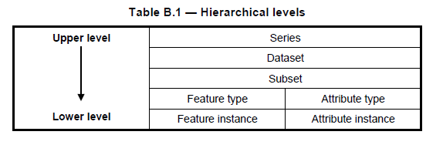

In the case of aggregation of different quality results, the standalone quality report should provide full information on the original results (with evaluation procedures and measures applied); the aggregated result; and the aggregation method, whereas the metadata may describe only the aggregated result with a reference to the original results described in the standalone quality report.

The aggregated Data Quality result provides a result if the dataset has passed conformance to the Data Product Specification.

**Recommendation 9**: Data Quality Measure Aggregation results should be included to indicate if the dataset/dataset series have passed the Product Specifications.

* 1. Usability

Usability is based on user requirements. All quality elements may be used to evaluate usability. Usability evaluation may be based on specific user requirements that cannot be described using the quality elements described above. In this case, the usability element shall be used to describe specific quality information about a dataset’s suitability for a particular application or conformance to a set of requirements.

* 1. Introduction to data quality

All Product Specifications should have a paragraph describing Data Quality. To ensure harmonization across different Product Specifications, DQWG recommends that all Product Specifications share a common text explaining the concept of Data Quality -> Introduction to Data Quality. The recommended text for the introduction is contained in clause C-7.1.

**Recommendation 10**: Paragraph “Introduction to data quality” from clause C-7.1 to be used as a template by all S-100 based Product Specifications.

1. Data quality measures

This list is derived from ISO 19157.

There are twenty-six different data quality measures defined that can be used for validation of S-100 based Product Specifications. These are shown in Table C-6-1 below. There is a recommendation following the table for the target result of Positional Accuracy for depth contour lines and gridded bathymetry.

The full list of ISO 19157 measures applicable to S-100-based Product Specifications is available in S-100 Appendix 4c-C – Hydrographic Quality Metadata Attribute Definitions.

Table C-6-1 – Recommended data quality measures

| **No.** | **Data Quality Measure** | **Definition** | **DQ measure / description** | **Evaluation scope** | **Applicable to spatial representation types** |
| --- | --- | --- | --- | --- | --- |
| 1 | Completeness / Commission | Excess data present in a dataset, as described by the scope. | numberOfExcessItems / This data quality measure indicates the number of items in the dataset, that should not have been present in the dataset. | dataset/dataset series | All S-100 based PS |
| 2 | Completeness / Commission | Excess data present in a dataset, as described by the scope. | numberOfDuplicateFeatureInstances / This data quality measure indicates the total number of exact duplications of feature instances within the data. | dataset/dataset series | All S-100 based PS |
| 3 | Completeness / Omission | Data absent from the dataset, as described by the scope. | numberOfMissingItems / This data quality measure is an indicator that shows that a specific item is missing in the data. | dataset/dataset series/spatial object type | All S-100 based PS |
| 4 | Logical Consistency / Conceptual Consistency | Adherence to the rules of a conceptual schema. | numberOfNonCompliantItems / This data quality measure is a count of all items in the dataset that are noncompliant to the rules of the Conceptual Schema. | spatial object / spatial object type | All S-100 based PS |
| 5 | Logical Consistency / Conceptual Consistency | Adherence to the rules of a conceptual schema | numberOfInvalidSurfaceOverlaps / This data quality measure is a count of the total number of erroneous overlaps within the data. Which surfaces may overlap and which must not is application dependent. Not all overlapping surfaces are necessarily erroneous. | spatial object / spatial object type | PS with geometric surfaces. |
| 6 | Logical Consistency / Domain Consistency | Adherence of the values to the value domains. | numberOfNonconformantItems / This data quality measure is a count of all items in the dataset that are not in conformance with their value domain. | spatial object / spatial object type | All S-100 based PS |
| 7 | Logical Consistency / Format Consistency | Degree to which data is stored in accordance with the physical structure of the data set, as described by the scope | physicalStructureConflictsNumber / This data quality measure is a count of all items in the dataset that are stored in conflict with the physical structure of the dataset. | dataset/dataset series | All S-100 based PS |
| 8 | Logical Consistency / Topological Consistency | Correctness of the explicitly encoded topological characteristics of the dataset, as described by the scope. | rateOfFaultyPointCurveConnections / This data quality measure indicates the number of faulty link-node connections in relation to the number of supposed link-node connections. This data quality measure gives the erroneous point-curve connections in relation to the total number of point-curve connections. | spatial object / spatial object type | PS with curves. |
| 9 | Logical Consistency / Topological Consistency | Correctness of the explicitly encoded topological characteristics of the dataset, as described by the scope. | numberOfMissingConnectionsUndershoots / This data quality measure is a count of items in the dataset within the parameter tolerance that are mismatched due to undershoots. | spatial object / spatial object type | PS with curves. |
| 10 | Logical Consistency / Topological Consistency | Correctness of the explicitly encoded topological characteristics of the dataset, as described by the scope. | numberOfMissingConnectionsOvershoots / This data quality measure is a count of items in the dataset within the parameter tolerance that are mismatched due to overshoots. | spatial object / spatial object type | PS with curves. |
| 11 | Logical Consistency / Topological Consistency | Correctness of the explicitly encoded topological characteristics of the dataset, as described by the scope. | numberOfInvalidSlivers / This data quality measure is a count of all items in the dataset that are invalid sliver surfaces. A sliver is an unintended area that occurs when adjacent surfaces are not digitized properly. The borders of the adjacent surfaces may unintentionally gap or overlap to cause a topological error. | dataset / dataset series | PS with geometric surfaces. |
| 12 | Logical Consistency / Topological Consistency | Correctness of the explicitly encoded topological characteristics of the dataset, as described by the scope. | numberOfInvalidSelfIntersects / This data quality measure is a count of all items in the dataset that illegally intersect with themselves. | spatial object / spatial object type | PS with curves / geometric surfaces. |
| 13 | Logical Consistency / Topological Consistency | Correctness of the explicitly encoded topological characteristics of the dataset, as described by the scope. | numberOfInvalidSelfOverlap / This data quality measure is a count of all items in the dataset that illegally self-overlap. | spatial object / spatial object type | PS with curves / geometric surfaces. |
| 14 | Positional Accuracy / Vertical Position Accuracy | Closeness of reported coordinative values to values accepted as or being true. | LinearMapAccuracy3Sigma / Half length of the interval defined by an upper and lower limit in which the true value lies with probability 95%. | spatial object / spatial object type | PS with objects that have a vertical coordinative values associated. |
| 15 | Positional Accuracy / Horizontal Position Accuracy | Closeness of reported coordinative values to values accepted as or being true. | circularError95/Radius describing a circle in which the true point location lies with the probability of 95%. | spatial object / spatial object type | PS with objects that have a horizontal coordinative values associated. |
| 16 | Positional Accuracy / Relative or Internal Accuracy | Closeness of the relative positions of features in a dataset to their respective relative positions accepted as or being true. | relativeVerticalError / An evaluation of the random errors of one relief feature to another in the same data set or on the same map / chart. It is a function of the random errors in the two elevations with respect to a common vertical datum. [Adapted from ISO 19157] | spatial object / spatial object type | PS with objects that have a coordinative value associated. |
| 17 | Positional Accuracy / Relative or Internal Accuracy | Closeness of the relative positions of features in a dataset to their respective relative positions accepted as or being true. | relativeHorizontalError / An evaluation of the random errors in the horizontal position of one feature to another in the same data set or on the same map/chart. [Adapted from ISO 19157] | spatial object / spatial object type | PS with objects that have a coordinative value associated. |
| 18 | Positional Accuracy / Gridded Data Position Accuracy | Closeness of reported coordinative values to values accepted as or being true. | RMSErrorPlanimetry / Radius of a circle around the given point, in which the true value lies with probability P. | spatial object / spatial object type | PS with objects that have a gridded coordinative values associated. |
| 19 | Temporal Quality / Temporal Consistency | Correctness of ordered events or sequences, if reported. | chronologicalOrder / This data quality measure that indicate that an event is incorrectly ordered against the other events. [Adapted from ISO 19157] | dataset/dataset series/spatial object type | PS with objects that have a time value associated. |
| 20 | Temporal Quality / Temporal Validity | Validity of data with respect to time | numberOfNonConformantItems / This data quality measure is a count of all items in the dataset that are not in conformance with their value domain. [Adapted from ISO 19157] | dataset/dataset series/spatial object type | PS with objects that have a time value associated. |
| 21 | Temporal Quality / DQ_AccuracyOfATimeMeasurement | Correctness of the temporal references of an item (reporting of error in time measurement) | attributeValueUncertainty3Sigma / This data quality measure indicates the attribute value of uncertainty where half the length of the interval defined by an upper and lower limit in which the true value for the quantitative attribute lies with a probability of 95%. [Adapted from ISO 19157] | dataset/dataset series/spatial object type | PS with objects that have a time value associated. |
| 22 | Thematic Accuracy / ThematicClassificationCorrectness | Comparison of the classes assigned to features or their attributes to a universe of discourse. | miscalculationRate / This data quality measure indicates the number of incorrectly classified features in relation to the number of features that are supposed to be there. [Adapted from ISO 19157]  This is a RATE which is a ratio, and is expressed as a REAL number representing the rational fraction corresponding to the numerator and denominator of the ratio.  For example, if there are 1 items that are classified incorrectly and there are 100 of the items in the dataset then the ratio is 1/100 and the reported rate = 0.01. | dataset/dataset series/spatial object type | All S-100 based PS. |
| 23 | Thematic Accuracy / Non-Quantitative Attribute Accuracy | Correctness of non-quantitative attribute. | numberOfIncorrectAttributeValues / This data quality measure is count of the total number of erroneous attribute values within the relevant part of the dataset. It is a count of all attribute values where the value is incorrect. [Adapted from ISO 19157] | dataset/dataset series/spatial object type | PS with objects that have a non-quantitative attribute value. |
| 24 | Thematic Accuracy / Quantitative Attribute Accuracy | Accuracy of a quantitative attribute. | attributeValueUncertainty3Sigma / This data quality measure indicates the attribute value of uncertainty where half the length of the interval defined by an upper and lower limit in which the true value for the quantitative attribute lies with a probability of 95%. [Adapted from ISO 19157] | dataset/dataset series/spatial object type | PS with objects that have a quantitative attribute value. |
| 25 | Aggregation Measures / AggregationMeasures | In a data Product Specification, several requirements are set up for a product to conform to the Specification. | DataProductSpecificationPassed / This data quality measure is a boolean indicating that all requirements in the referred data Product Specification are fulfilled. | dataset/dataset series/spatial object type | PS that a require a complete pass of all elements of a dataset/dataset series/spatial object types |
| 26 | Aggregation Measures / AggregationMeasures | In a data Product Specification, several requirements are set up for a product to conform to the specification. | DataProductSpecificationFailRate / This data quality measure is a number indicating the number of data Product Specification requirements that are not fulfilled by the current product/dataset in relation to the total number of data Product Specification requirements. | dataset/dataset series/spatial object type | PS that a require a complete pass of all elements of a dataset/dataset series/spatial object types |

NOTE 1: Recommendations for Positional Accuracy / Absolute or External Accuracy[11]:

Maximum RMSE (horizontal) = E / 10000

Maximum RMSE (vertical) = Vint / 6

Recommendation for Positional Accuracy / Gridded Data Position Accuracy:

Maximum RMSE (horizontal) = GSD / 6

Maximum RMSE (vertical) = GSD / 3

Where:

E = Denominator of intended scale of mapping

Vint = normal contour line interval

GSD = Ground Sampling Distance

NOTE 2: Data quality elements that are not applicable for the Product Specification may be removed from the table of quality measures in the Product Specification.

1. Recommended template for the data quality section of Product Specifications

Clauses C-7.1 through C-7.8 following specify the structure and recommended content for the Data Quality section of Product Specifications.

Content in red font and/or angle brackets (< ... >) in clauses C-7.1 through C-7.8 indicates something which should be replaced by the Product Specification developer and/or instructions for the Product Specification developer.

“S-149” in the examples is a hypothetical Product Specification and does not currently correspond to an actual product.

**[Option1:],** **[Or Option2:],** etc. - The text associated with only one of the Options offered is to be included; the other Option is to be deleted.

“The checks are listed in <X>” - <X> may be an annex to the Product Specification and/or a separate document or list of documents.

* 1. Introduction to data quality

Data quality allows users and user systems to assess fitness for use of the provided data. Data quality measures and the associated evaluation are reported as metadata of a data product. This metadata improves interoperability with other data products and provides usage by user groups that the data product was not originally intended for. The secondary users can make assessments of the data product usefulness in their application based on the reported data quality measures.

For S-1XX the following Data Quality Elements have been included:

* Conformance to this Product Specification;
* Intended purpose of the data product;
* Completeness of the data product in terms of coverage;
* Logical consistency;
* Positional uncertainty and accuracy;
* Thematic accuracy;
* Temporal quality;
* Aggregation measures;
* Validation checks or conformance checks including:
  + General tests for dataset integrity;
  + Specific tests for a specific data model.

*<The Product Specification should include the text above, omitting inapplicable elements. The language in the introductory paragraph about reporting, metadata, and assessments of data quality by user groups and secondary groups should be modified as appropriate.>*

* 1. Completeness

The presence and absence of features is described by the data quality elements Completeness (including commission and omission). Completeness should only be used on the feature type level, describing whether the features in the universe of discourse are found in the data set or not.

* + 1. Commission

Commission is applicable for S-1XX **[or]** the data quality scope <XXX> of S-1XX.

S-1XX products must be tested with commission checks prior to release by the Data Producer. The Data Producer must review the check results and address any issues to ensure sufficient quality of the data products. The checks are listed in <X>. **[Option a1:]** Data should only be published if it passes the test. **[Or Option a2:]** It is allowable to publish the data with a quality statement which indicates non-conformance.

**[Option b1:]** The Product Specification must describe how commission is to be populated, for example, stating the mechanism to reference the quality evaluation procedure, and allowable values for the quality results.

**[Or Option b2:]** In terms of commission, S-1XX products must at least populate numberOfExcessItems that indicates the number of items that should not have been present in the dataset, and numberOfDuplicateFeatureInstances that indicates the total number of exact duplications of feature instances within the data.

EXAMPLE: An example Commission clause for a hypothetical product “S-149” follows.

**X.Y.1 Commission**

Commission is applicable for S-149.

S-149 products must be tested with commission checks prior to release by the Data Producer. The Data Producer must review the check results and address any issues to ensure sufficient quality of the data products. The checks listed in IHO Publications S-158:100 – S-100 Validation Checks and S-158:149 – S-149 Validation Checks include data validation check(s) intended to identify excess and/or duplicate items.

Data should only be published if it passes the test.

S-149 quality testing must populate numberOfExcessItems with the number of items that should not have been present in the dataset and numberOfDuplicateFeatureInstances with the total number of exact duplications of feature instances within the data.

* + 1. Omission

Omission is applicable for S-1XX **[or]** the data quality scope <XXX> of S-1XX.

S-1XX products must be tested with omission checks prior to release by the Data Producer. The Data Producer must review the check results and address any issues to ensure sufficient quality of the data products. The checks are listed in <X>. **[Option a1:]** Data should only be published if it passes the test. **[Or Option a2:]** It is allowable to publish the data with a quality statement which indicates non-conformance.

**[Option b1:]** The Product Specification must describe how omission is to be populated; for example, stating the mechanism to reference the quality evaluation procedure, and allowable values for the quality results.

**[Or Option b2:]** In terms of omission, S-1XX products must at least populate numberOfMissingItems that indicates the total number of missing items.

* 1. Logical consistency
     1. Conceptual consistency

Conceptual Consistency is applicable for S-1XX **[or]** the data quality scope <XXX> of S-1XX and follows the guidelines from S-100 Part 1.

S-1XX products must be tested with conceptual consistency checks prior to release by the Data Producer. The Data Producer must review the check results and address any issues to ensure sufficient quality of the data products. The checks are listed in <X>. **[Option a1:]** Data should only be published if it passes the test. **[Or Option a2:]** It is allowable to publish the data with a quality statement which indicates non-conformance.

**[Option b1:]** The Product Specification shall describe how conceptual consistency is to be populated; for example, stating the mechanism to reference the quality evaluation procedure, and allowable values for the quality results.

**[Or Option b2:]** In terms of conceptual consistency, S-1XX products shall at least populate numberOfNonCompliantItems that is a count of all items in the dataset that are noncompliant to the rules of the Conceptual Schema. **[Option c1:]** As a Product Specification with geometric surfaces, S-1XX shall also at least populate numberOfInvalidSurfaceOverlaps that indicates the total number of erroneous overlaps within the data. **[Option c2:]** Product Specifications without geometric surfaces should not populate numberOfInvalidSurfaceOverlaps.

* + 1. Domain consistency

Domain consistency is applicable for S-1XX **[or]** the data quality scope <XXX> of S-1XX and follows the guidelines from S-100 Part 5.

S-1XX products must be tested with domain consistency checks prior to release by the Data Producer. The Data Producer must review the check results and address any issues to ensure sufficient quality of the data products. The checks are listed in <X>. **[Option a1:]** Data should only be published if it passes the test. **[Or Option a2:]** It is allowable to publish the data with a quality statement which indicates non-conformance.

**[Option b1:]** The Product Specification must describe how domain consistency is to be populated; for example, stating the mechanism to reference the quality evaluation procedure, and allowable values for the quality results.

**[Or Option b2:]** In terms of domain consistency, S-1XX products must at least populate numberOfNonconformantItems that is a count of all items in the dataset that are not in conformance with their value domain.

* + 1. Format Consistency

Format Consistency is applicable for S-1XX **[or]** the data quality scope <XXX> of S-1XX and follows the guidelines from S-100 Parts 10a/10b/10c.

S-1XX products must be tested with format consistency checks prior to release by the Data Producer. The Data Producer must review the check results and address any issues to ensure sufficient quality of the data products. The checks are listed in <X>. **[Option a1:]** Data should only be published if it passes the test. **[Or Option a2:]** It is allowable to publish the data with a quality statement which indicates non-conformance.

**[Option b1:]** The Product Specification must describe how format consistency is to be populated; for example, stating the mechanism to reference the quality evaluation procedure, and allowable values for the quality results.

**[Or Option b2:]** In terms of Format Consistency, S-1XX products must at least populate physicalStructureConflictsNumber that is a count of all items in the dataset that are stored in conflict with the physical structure of the dataset.

* + 1. Topological consistency

**[Option1:]**

Topological consistency is not applicable for S-1XX which is a grid Product Specification without curves and geometric surfaces.

**[Or Option2:]**

Topological consistency is applicable for S-1XX **[or]** the data quality scope <XXX> of S-1XX and follows the guidelines from S-100 Part 7.

S-1XX products must be tested with topological consistency checks prior to release by the Data Producer. The Data Producer must review the check results and address any issues to ensure sufficient quality of the data products. The checks are listed in <X>. **[Option 2a.1:]** Data should only be published if it passes the test. **[Or Option 2a.2:]** It is allowable to publish the data with a quality statement which indicates non-conformance.

**[Option 2b.1:]** The Product Specification must describe how topological consistency is to be populated; for example, stating the mechanism to reference the quality evaluation procedure, and allowable values for the quality results.

**[Or Option 2b.2:]** In terms of topological consistency, **[Option 2c.1:]** As a Product Specification with curves, S-1XX products must at least populate:

* rateOfFaultyPointCurveConnections that indicates the number of faulty link-node connections in relation to the number of supposed link-node connections;
* numberOfMissingConnectionsUndershoots that is a count of items in the dataset within the parameter tolerance that are mismatched due to undershoots;
* numberOfMissingConnectionsOvershoots that is a count of items in the dataset within the parameter tolerance that are mismatched due to overshoots;
* numberOfInvalidSelfIntersects that is a count of all items in the dataset that illegally intersect with themselves; and
* numberOfInvalidSelfOverlap that indicates all items in the dataset that illegally self-overlap.

**[Option 2c.2:]** As a Product Specification with geometric surfaces, S-1XX products must at least populate:

* numberOfInvalidSlivers that is a count of all items in the dataset that are invalid sliver surfaces;
* numberOfInvalidSelfIntersects that is a count of all items in the dataset that illegally intersect with themselves; and
* numberOfInvalidSelfOverlap that indicates all items in the dataset that illegally self-overlap.

**[Option 2c.3:]** As a Product Specification with curves and geometric surfaces, S-1XX products must at least populate:

* rateOfFaultyPointCurveConnections that indicates the number of faulty link-node connections in relation to the number of supposed link-node connections;
* numberOfMissingConnectionsUndershoots that is a count of items in the dataset within the parameter tolerance that are mismatched due to undershoots;
* numberOfMissingConnectionsOvershoots that is a count of items in the dataset within the parameter tolerance that are mismatched due to overshoots;
* numberOfInvalidSlivers that is a count of all items in the dataset that are invalid sliver surfaces;
* numberOfInvalidSelfIntersects that is a count of all items in the dataset that illegally intersect with themselves; and
* numberOfInvalidSelfOverlap that indicates all items in the dataset that illegally self-overlap.
  1. Positional uncertainty and accuracy
     1. Absolute or external accuracy
        1. Vertical position accuracy

**[Option1:]**

Vertical Position Accuracy is not applicable for S-1XX which is a Product Specification without objects that have a vertical coordinative value associated.

**[Or Option2:]**

Vertical position accuracy is applicable for S-1XX **[or]** the data quality scope <XXX> of S-1XX and follows the guidelines from S-100 Part 4c.

S-1XX products must be tested with vertical position accuracy checks prior to release by the Data Producer. The Data Producer must review the check results and address any issues to ensure sufficient quality of the data products. The checks are listed in <X>. **[Option 2a.1:]** Data should only be published if it passes the test. **[Or Option 2a.2:]** It is allowable to publish the data with a quality statement which indicates non-conformance.

**[Option 2b.1:]** The Product Specification must describe how vertical position accuracy is to be populated; for example, stating the mechanism to reference the quality evaluation procedure, and allowable values for the quality results.

**[Or Option 2b.2:]** In terms of vertical position accuracy, S-1XX products must at least populate linearMapAccuracy3Sigma that indicates the attribute value of uncertainty where half the length of the interval defined by an upper and lower limit in which the true value lies with a probability of 90%.

* + - 1. Horizontal position accuracy

**[Option1:]**

Horizontal position accuracy is not applicable for S-1XX which is a Product Specification without objects that have a horizontal coordinative value associated.

**[Or Option2:]**

Horizontal position accuracy is applicable for S-1XX **[or]** the data quality scope <XXX> of S-1XX and follows the guidelines from S-100 Part 4c.

S-1XX products must be tested with horizontal position accuracy checks prior to release by the Data Producer. The Data Producer must review the check results and address any issues to ensure sufficient quality of the data products. The checks are listed in <X>. **[Option 2a.1:]** Data should only be published if it passes the test. **[Or Option 2a.2:]** it is allowable to publish the data with a quality statement which indicates non-conformance.

**[Option 2b.1:]** The Product Specification must describe how horizontal position accuracy is to be populated; for example, stating the mechanism to reference the quality evaluation procedure, and allowable values for the quality results.

**[Or Option 2b.2:]** In terms of horizontal position accuracy, S-1XX products must at least populate circularError95 that indicates the radius describing a circle in which the true point location lies with the probability of 95%.

Recommendations on thresholds for Positional Accuracy / Absolute or External Accuracy are as follows:

Maximum RMSE (horizontal) = E / 10000

Maximum RMSE (vertical) = Vint / 6

Where:

E = Denominator of intended scale of mapping

Vint = Normal contour line interval

* + 1. Relative or internal accuracy

**[Option1:]**

Relative or internal accuracy is not applicable for S-1XX which is a Product Specification without objects that have a relative or internal coordinative value associated.

**[Option2:]**

Relative or internal accuracy is applicable for S-1XX **[or]** the data quality scope <XXX> of S-1XX and follows the guidelines from S-100 Part 4c.

S-1XX products must be tested with relative or internal accuracy checks prior to release by the Data Producer. The Data Producer must review the check results and address any issues to ensure sufficient quality of the data products. The checks are listed in <X>. **[Option 2a. 1:]** Data should only be published if it passes a particular test. **[Or Option 2a.2:]** It is allowable to publish the data with a quality statement which indicates non-conformance.

**[Option 2b.1:]** The Product Specification must describe how relative or internal accuracy is to be populated; for example, stating the mechanism to reference the quality evaluation procedure, and allowable values for the quality results.

**[Or Option 2b.2:]** In terms of relative or internal accuracy, S-1XX products must populate one or both of relativeVerticalError that indicates an evaluation of the random errors of one relief feature to another in the same data set or on the same map/chart; and/or relativeHorizontalError that indicates an evaluation of the random errors in the horizontal position of one feature to another in the same data set or on the same map/chart.

* + 1. Gridded data positional accuracy

**[Option1:]**

Gridded data positional accuracy is not applicable for S-1XX which is a Product Specification without objects that have a gridded coordinative value associated.

**[Or Option2:]**

Gridded data positional accuracy is applicable for S-1XX **[or]** the data quality scope <XXX> of S-1XX and follows the guidelines from S-100 Part 4c.

S-1XX products must be tested with gridded data positional accuracy checks prior to release by the Data Producer. The Data Producer must review the check results and address any issues to ensure sufficient quality of the data products. The checks are listed in Annex <X>. **[Option 2a.1:]** Data should only be published if it passes the test. **[Or Option 2a.2:]** it is allowable to publish the data with a quality statement which indicates non-conformance.

Gridded data positional accuracy is defined by the precision of the positional reference used to specify its location within its spatial projection. These positional references are contained within the spatial metadata of the S-1XX grid. Nodes within a grid have an absolute position with no horizontal error; and with vertical values that are calculated for that position by the processes and procedures used by each Data Producer during the creation of the S-1XX grid. Appropriate selection of both the origin reference points and positional resolution are important and are another factor in gridded data positional accuracy.

In terms of gridded data positional accuracy, S-1XX products shall at least populate RMSErrorPlanimetry that indicates the radius of a circle around the given point, in which the true value lies with probability P.

Recommendations on thresholds for gridded data positional accuracy are as follows:

Maximum RMSE (horizontal) = GSD / 6

Maximum RMSE (vertical) = GSD / 3

Where:

GSD = Ground Sampling Distance

* 1. Thematic accuracy
     1. Thematic classification correctness

Thematic classification correctness is applicable for S-1XX **[or]** the data quality scope <XXX> of S-1XX and follows the guidelines from S-100 Part 4c.

S-1XX products must be tested with thematic classification correctness checks prior to release by the Data Producer. The Data Producer must review the check results and address any issues to ensure sufficient quality of the data products. The checks are listed in <X>. **[Option a1:]** Data should only be published if it passes the test. **[Or Option a2:]** It is allowable to publish the data with a quality statement which indicates non-conformance.

**[Option b1:]** The Product Specification must describe how thematic classification correctness is to be populated; for example, stating the mechanism to reference the quality evaluation procedure, and allowable values for the quality results.

**[Or Option b2:]** In terms of thematic classification correctness, S-1XX products must at least populate miscalculationRate that indicates the number of incorrectly classified features in relation to the number of features that are supposed to be there.

* + 1. Non-quantitative attribute accuracy

**[Option1:]**

Non-quantitative attribute accuracy is not applicable for S-1XX which is a Product Specification without objects that have a non-quantitative attribute value.

**[Or Option2:]**

Non-quantitative attribute accuracy is applicable for S-1XX **[or]** the data quality scope <XXX> of S-1XX and follows the guidelines from S-100 Part 4c.

S-1XX products must be tested with non-quantitative attribute accuracy checks prior to release by the Data Producer. The Data Producer must review the check results and address any issues to ensure sufficient quality of the data products. The checks are listed in <X>. **[Option 2a.1:]** Data should only be published if it passes the test. **[Or Option 2a.2:]** It is allowable to publish the data with a quality statement which indicates non-conformance.

**[Option 2b.1:]** The Product Specification must describe how non-quantitative attribute accuracy is to be populated; for example, stating the mechanism to reference the quality evaluation procedure, and allowable values for the quality results.

**[Or Option 2b.2:]** The accuracy of non-quantitative attributes can be correct or incorrect. S-1XX products shall at least populate numberOfIncorrectAttributeValues that is a count of all attribute values where the value is incorrect.

* + 1. Quantitative attribute accuracy

**[Option1:]**

Quantitative attribute accuracy is not applicable for S-1XX which is a Product Specification without objects that have a quantitative attribute value.

**[Or Option2:]**

Quantitative attribute accuracy is applicable for S-1XX **[or]** the data quality scope <XXX> of S-1XX and follows the guidelines from S-100 Part 4c.

S-1XX products must be tested with quantitative attribute accuracy checks prior to release by the Data Producer. The Data Producer must review the check results and address any issues to ensure sufficient quality of the data products. The checks are listed in <X>. **[Option 2a.1:]** Data should only be published if it passes the test. **[Or Option 2a.2:]** It is allowable to publish the data with a quality statement which indicates non-conformance.

**[Option 2b.1:]** The Product Specification must describe how quantitative attribute accuracy is to be populated; for example, stating the mechanism to reference the quality evaluation procedure, and allowable values for the quality results.

**[Or Option 2b.2:]** The accuracy of quantitative attributes can be measured in terms of uncertainty intervals. S-1XX products shall at least populate attributeValueUncertainty3Sigma that indicates the attribute value of uncertainty where half the length of the interval defined by an upper and lower limit in which the true value for the quantitative attribute lies with a probability of 95%.

* 1. Temporal quality
     1. Temporal consistency

**[Option1:]**

Temporal Consistency is not applicable for S-1XX which is a Product Specification without ordered events or sequences.

**[Or Option2:]**

Temporal consistency is applicable for S-1XX **[or]** the data quality scope <XXX> of S-1XX and follows the guidelines from S-100 Part 4c.

S-1XX products must be tested with temporal consistency checks prior to release by the Data Producer. The Data Producer must review the check results and address any issues to ensure sufficient quality of the data products. The checks are listed in <X>. **[Option 2a.1:]** Data should only be published if it passes the test. **[Or Option 2a.2:]** It is allowable to publish the data with a quality statement which indicates non-conformance.

In term of Temporal Consistency, S-1XX products must populate chronologicalOrder that indicates that an event is incorrectly ordered against the other events.

* + 1. Temporal validity

**[Option1:]**

Temporal validity is not applicable for S-1XX which is a Product Specification without objects that have a time value associated.

**[Or Option2:]**

Temporal validity is applicable for S-1XX **[or]** the data quality scope <XXX> of S-1XX and follows the guidelines from S-100 Part 4c.

S-1XX products must be tested with temporal validity checks prior to release by the Data Producer. The Data Producer must review the check results and address any issues to ensure sufficient quality of the data products. The checks are listed in <X>. **[Option 2a.1:]** Data should only be published if it passes the test. **[Or Option 2a.2:]** It is allowable to publish the data with a quality statement which indicates non-conformance.

**[Option 2b.1:]** The Product Specification must describe how temporal validity is to be populated; for example, stating the mechanism to reference the quality evaluation procedure, and allowable values for the quality results.

**[Or Option 2b.2:]** In terms of temporal validity, S-1XX products must at least populate numberOfNonConformantItems that is a count of all items in the dataset that are not in conformance with their value domain.

* + 1. Temporal accuracy

**[Option1:]**

Temporal accuracy is not applicable for S-1XX which is a Product Specification without objects that have a time value associated.

**[Or Option2:]**

Temporal accuracy is applicable for S-1XX **[or]** the data quality scope <XXX> of S-1XX and follows the guidelines from S-100 Part 4c.

S-1XX products must be tested with temporal accuracy checks prior to release by the Data Producer. The Data Producer must review the check results and address any issues to ensure sufficient quality of the data products. The checks are listed in <X>. **[Option 2a.1:]** Data should only be published if it passes the test. **[Option 2a.2:]** It is allowable to publish the data with a quality statement which indicates non-conformance.

**[Option 2b.1:]** The Product Specification must describe how temporal accuracy is to be populated; for example, stating the mechanism to reference the quality evaluation procedure, and allowable values for the quality results.

**[Or Option 2b.2:]** In terms of temporal accuracy, S-1XX products shall at least populate attributeValueUncertainty3Sigma that indicates the attribute value of uncertainty where half the length of the interval defined by an upper and lower limit in which the true value for the quantitative attribute lies with a probability of 95%.

* 1. Aggregation

**[Option1:]**

Aggregation is not applicable for S-1XX because there is no need to aggregated data quality results based on different data quality elements.

**[Or Option2:]**

Aggregation is applicable for S-1XX **[or]** the data quality scope <XXX> of S-1XX. The aggregated data quality result provides a result if the dataset has passed conformance to the Product Specification. A data set may be deemed to be of an acceptable aggregate quality even though one or more individual data quality results fails acceptance.

The quality of an S-1XX dataset may be represented by one aggregated data quality results (ADQR). The ADQR combines quality results from data quality evaluations based on different data quality elements including <XXX, XXX, …. XXX and XXX> *<(for example, Commission, Omission, Conceptual Consistency, Format Consistency, Topological Consistency, Horizontal Position Accuracy and Thematic Classification Correctness)>*.

**[Option 2a.1:]** *<The Product Specification should omit frames not used by the product.>*

The aggregate data quality is determined by the formula:

ADQR=v1*v2 *v3 *... * vn

Where n is the number of data quality measurement frames.

Where:

1 = Commission;

2 = Omission;

3 =Conceptual Consistency;

4 =Format Consistency;

5 =Topological Consistency;

6 = Horizontal Position Accuracy; and

7 = Thematic Classification Correctness.

Each data quality result involved in the computation is given a Boolean value of one (1) if it passed and zero (0) if it failed. If ADQR=1, then the overall data set quality is deemed to be fully conformant, hence pass. If ADQR=0, then it is deemed non-conformant, hence fail.

**[Or Option 2a.2:]** *<The Product Specification should omit frames not used by the product.>*

The aggregated quality is determined by the equation:

ADQR= v1*w1 + v2*w2 + v3*w3+...+vn*wn,

Where n is the number of data quality measurement frames.

Where:

1 = Commission;

2 = Omission;

3 = Conceptual Consistency;

4 = Format Consistency;

5 = Topological Consistency;

6 = Horizontal Position Accuracy; and

7 = Thematic Classification Correctness.

Each data quality result involved in the computation is given a Boolean value of one (1) if it passed and a zero (0) if it failed. Based on the significance for the purpose of the product, a weight value between 0 and 1, inclusive, is assigned to each data quality result. The total of all the weights should equal 1.The choice of weights is a subjective decision made by the data producer or user. The reason for the data producer's decision should be reported as part of the result.

*<Note: This technique does provide a magnitude value indicating how close a data set is to full conformance as measured. It does not provide a quantitative value that indicates where conformance or non- conformance occurs.>*

**[Or Option 2a.3:]** *<The Product Specification should omit frames not used by the product.>*

The aggregated quality is determined by either of the two equations,

ADQR = MAX (vi, i=1...n) or ADQR = MIN (vi, i = 1...n)

Where n is the number of data quality measurement frames measured.

Where:

1 = Commission;

2 = Omission;

3 = Conceptual Consistency;

4 = Format Consistency;

5 = Topological Consistency;

6 = Horizontal Position Accuracy; and

7 = Thematic Classification Correctness.

Each data quality result is given a value v based on the significance of a data quality result for the purpose of the product. The reason for the data producer's decision should be reported as part of the data set's quality result.

*<Note: This technique provides a magnitude value indicating how close a data set is to full conformance as measured, but only in terms of the data quality measurement frame represented by the maximum or minimum. It does provide a quantitative value that indicates where conformance or non-conformance occurs when the selected data quality measurement frame is reported along with the ADQR. However, this type of ADQR tells little about the magnitude of the other data quality results.>*

S-1XX product must include a standalone quality report which provides full information on the original results (with evaluation procedures and measures applied); the aggregated result; and the aggregation method. The dataset or Exchange Set metadata that is distributed with the Exchange Set will describe only the aggregated result with a reference to the original results described in the standalone quality report.

In terms of aggregation, S-1XX products shall at least populate DataProductSpecificationPassed that is a Boolean indicating that all requirements in the referred Product Specification are fulfilled, and/or DataProductSpecificationFailRate that is a number indicating the number of data product specification requirements that are not fulfilled by the current product/dataset in relation to the total number of data product specification requirements

* 1. Quality measure element

The data quality measures recommended in S-97 (Part C) and their applicability in S-1XX are indicated in Table 6-1 below. NA indicates the measure is not applicable. The Application Schema above has indicated how the data quality elements will be related to the data items; and the encoding description below will indicate how the quality elements will be encoded.

*<The Product Specification should contain a table structured as below, listing the quality measures from Table C-6-1 which are applicable to the Product Specification, replacing the “Evaluation Scope” column with a column identifying the scope in that Product Specification.*

*The “Scope in S-1XX” column should describe the scope of the quality measure, either a named scope identified in S-1xx, or a descriptive scope such as “whole dataset”, “features with surface geometry”, “Feature types X, Y, and Z”, “data coding format 1 (point coverage)”, “data coding format 2 (grid coverage)”, etc.*

*The language about indicating data quality measures in the Application Schema and providing the encoding description should be modified as appropriate.>*

Table C-7-1 – Template table for list of data quality measures in Product Specifications

|  |  |  |  |  |  |
| --- | --- | --- | --- | --- | --- |
| **No.** | **Data Quality Measure** | **Definition** | **DQ measure / description** | **Evaluation scope** | **Scope in S-1XX** |
|  |  |  |  |  |  |

1. Minimum standard for data validation

A minimum standard set of checks for data validation is under development and will be added to this document when completed.

Page intentionally left blank

# LIST OF ANNEXES

These Annexes are separate files and can be found either in the S-97 distribution package or at the locations indicated.

Annex A S-100 Maintenance Proposal, IHO Geospatial Information Registry, https://registry.iho.int

Annex B Template for S-100 based Product Specifications, IHO Geospatial Information Registry, https://registry.iho.int

Annex C Checklist for Product Specification Developers. IHO Geospatial Information Registry, https://registry.iho.int

1. S-100 2a-4.2.3, specify ISO/IEC 646 (ASCII), while elsewhere 10646 (UTF-8) is used. Since it can be problematic to mix UTF-8 and ASCII, this guidance recommends to utilize only UTF-8.
2. A suggested format for such tables is described in the IHO S-100 Production Specification Template, which is a separate document available from the IHO web site.
3. URLs of resources on the schema server do not change with new clarifications or revisions of S-100 unless the resource itself is updated.
4. Note that the super-type cannot augment the union set with additional definitions. This conforms to the INSPIRE usage but it may be reconsidered if such augmentation is required at a later time.
5. Adapted from INSPIRE guidelines.
6. Schematron rules can be checked using off-the-shelf software like XML editors, but implementations can implement the constraints in any suitable language for production tools or applications which cannot integrate Schematron validation or XSLT in their workflows.
7. Some Zip implementations may check whether the compression method actually produces a smaller file, and if not, store the original instead. It may be possible to force compression even if the file size is not reduced.
8. Building the correspondence between S-101 features and real world. Maritime Safety Administration of the People’s Republic of China (CHINA MSA), S-100WG9-3.6b.
9. ISO 19157, Geographic Information – Data Quality, page 6.
10. ISO 19157 – Geographic Information, Data Quality page 7.
11. INSPIRE D2.8.II.1 Data Specification on Elevation – Technical Guidelines, v. 3.3.0, section 7.3.